IALA S-201
Product Specification

Draft 0.0.6 – January 2017

IALA AtoN Product Specification

Document Revisions
Revisions to the IALA Document are to be noted in the table prior to the issue of a revised document.
Date | Page / Section Revised | Requirement for Revision
03/03/2016 | Various | See comments table 20160127
09/03/2016 | Section 7.6 Geometry | Remove square brackets from S-201
09/03/2016 | Section 8.2 Data Compliance | S-58 replaces Annex H for consistency
09/03/2016 | Section 12.1 Encoding | Indicate conformity with S-100
09/03/2016 | Section 11 Portrayal | Removed (not required)
04/07/2016 | Various | FTA proposals
21/09/2016 | Various | Reviewed at ENAV 19
26/11/2016 | Various | Updated various sections and figures following data model update
31/01/2017 | Various | Changed precision of lat/long, added units, various editorial changes

Table of Contents
1 Overview 6
1.1 Introduction 6
2 References 6
2.1 Normative references 6
2.2 Informative references 6
3 Terms, definitions and abbreviations 6
3.1 Terms and definitions 6
3.2 Abbreviations 6
4 Product specification metadata 7
4.1 IALA Product Specification Maintenance 7
4.1.1 Introduction 7
4.1.2 New Edition 7
4.1.3 Revisions 7
4.1.4 Clarification 8
4.1.5 Version Numbers 8
5 Specification Scope 8
5.1 Metadata content 9
5.2 Dataset Identification 9
6 Data Content and structure 9
6.1 Introduction 9
6.2 Application Schema 9
6.2.1 Meta features application schema 18
6.3 Feature Catalogue 19
6.4 Feature Types 20
6.5 Data Product Types 20
6.5.1 Dataset rules
20
6.6 Geometry 21
6.6.1 Co-ordinate Reference Systems (CRS) 21
6.6.1.1 Introduction 21
6.6.1.2 Horizontal Geodetic Datum 22
6.6.1.3 Vertical Datum 22
6.6.1.4 Units of Measure 22
7 Data Quality 22
7.1 Introduction 22
7.2 Data Compliance and Integrity 22
7.3 Uncertainty and lineage information 22
7.3.1 Positional accuracy 22
7.3.2 Lineage 23
8 Data Capture and Classification 23
9 Data Maintenance
23
9.1 Introduction 23
9.2 Maintenance and Update Frequency 23
10 Data Product format (encoding) 23
10.1 Introduction 23
10.2 Encoding of Latitude and Longitude 23
10.2.1 Encoding of coordinates as decimals 24
10.3 Numeric Attribute Encoding 24
10.4 Text Attribute Values 24
10.5 Mandatory Attribute Values 24
10.6 Unknown Attribute Values 24
10.7 Structure of dataset files 25
10.7.1 Sequence of objects 25
10.8 Object identifiers 25
10.9 Dataset validation 25
10.10 Location of Data Product Format schema Files 25
10.11 Detailed documentation of schema 26
11 Data Product Delivery 26
11.1 Exchange set 26
11.2 Dataset 28
11.2.1 Datasets 28
11.2.2 Dataset size 28
11.2.3 Dataset file naming 28
11.2.4 New Editions and re-issues 28
11.2.5 Cancellations 29
11.3 Support Files 29
11.3.1 Support File Naming 29
11.3.2 Support file management 30
11.4 Exchange Catalogue 30
12 Metadata 30
12.1 Introduction 30
12.2 Metadata classes 32
12.2.1 S100_ExchangeSet 34
12.2.2 S100_ExchangeCatalogue 34
12.2.3 S100_CatalogueIdentifier 34
12.2.4 S100_CataloguePointofContact 34
12.2.5 S100_Dataset 34
12.2.6 S100_DatasetDiscoveryMetadata 34
13 Language 37

Overview

Introduction
The Aids to Navigation (AtoN) Information Product Specification provides a common structure for the exchange of information about AtoNs. This includes buoys, beacons, racons, lights sound signals and AIS. The product contains the positions, properties, operational status and general comments related to an AtoN.
The Product Specification can be used to exchange AtoN information in a consistent form between Lighthouse Authorities, Hydrographic Offices and other organizations (to include commercial and professional agencies).

References

Normative references
IHO S.100 IHO Universal Hydrographic Data Model, Edition 2.0.0, January 2015
IHO S.63 Data Protection Scheme, Edition 1.2.0, January 2015
ISO 8601:2004 Data elements and interchange formats _ Information interchange _ Representation of dates and times
ISO/TS 19103:2005 Geographic information - Conceptual schema language
ISO 19111:2003 Geographic information - Spatial referencing by coordinates
ISO 19115:2006 Geographic information – Metadata (Tech Corr. 1, 2006)
ISO 19115-2:2009 Geographic information - Metadata: Extensions for imagery and gridded data
ISO 19131:2007 Geographic information - Data product specifications
ISO/IEC 19505-1:2012, Information technology — Open Distributed Processing - Unified Modelling Language Version 2.4.1

Informative references
ISO, 2006. ISO 19109 Geographic Information - Rules for Application Schema.
ISO, 2007. ISO 19135 Geographic Information – Procedures for Item Registration.
ISO, 2009. ISO 19136 Geographic Information - Geography Markup Language (GML).
IMO, 2008. Safety of Navigation Circular SN/Circ.243
IALA, 2012. Guideline 1088 on an Introduction to Preparing S-100 Product Specifications

Terms, definitions and abbreviations

Terms and definitions
Terms and definitions have been taken from the normative references cited in clause 1.1.

Abbreviations
AtoN Aid to navigation
CRS Coordinate Reference System
ECDIS Electronic Chart Display and Information System
EPSG European Petroleum Survey Group
ENC Electronic Navigational Chart
FTA Finnish Transport Administration
IALA International Association of Marine Aids to Navigation and Lighthouse Authorities
IHO International Hydrographic Organization
IMO International Maritime Organization
ISO International Organization for Standardization
XML Extensible Markup Language

Product specification metadata
Title | Aids to Navigation Product Specification
S-201 version | 0.0.6
S-100 version | 2.0.0
Date | 31 January 2017
Language | English
Identifier | S-201
Classification: | 001 - unclassified
Contact: | IALA-AISM  10, rue des Gaudines  78100 Saint Germain en Laye, France  Telephone: +33 1 34 51 70 01 Fax: +33 1 34 51 82 05
URL: | iala-aism.org
Maintenance: | The product specification is maintained by IALA-AISM and amendments are performed on a needs base, up to maximum one new release per calendar year.

IALA Product Specification Maintenance
This chapter is for clarification only on PS Maintenance.

Introduction
Changes to a product specification will be released by IALA-AISM as a new edition, revision, or clarification.

New Edition
New editions of a product specification introduce significant changes. New editions enable new concepts, such as the ability to support new functions or applications, or the introduction of new constructs or data types.

Revisions
Revisions are defined as substantive semantic changes to a product specification. Typically, revisions will change a product specification to correct factual errors; introduce necessary changes that have become evident as a result of practical experience or changing circumstances. A revision must not be classified as a clarification. Revisions could have an impact on either existing users or future users of a product specification. All cumulative clarifications must be included with the release of approved corrections.
Changes in a revision are minor and ensure backward compatibility with the previous versions within the same edition. Newer revisions, for example, introduce new features and attributes. Within the same edition, a data product of one version could always be processed with a later version of the feature and portrayal catalogues.

Clarification
Clarifications are non-substantive changes to a product specification. Typically, clarifications: remove ambiguity; correct grammatical and spelling errors; amend or update cross references; insert improved graphics, spelling, punctuation and grammar. A clarification must not cause any substantive semantic change to a product specification.
Changes in a clarification are minor and ensure backward compatibility with the previous versions within the same edition. Within the same edition, a data product of one clarification version could always be processed with a later version of the feature and portrayal catalogues, and a portrayal catalogue can always rely on earlier versions of the feature catalogues.

Version Numbers
The associated version control numbering to identify changes (n) to a product specification must be as follows:
New editions denoted as n.0.0
Revisions denoted as n.n.0
Clarifications denoted as n.n.n

Specification Scope
This product specification describes one data product and therefore requires only one scope which is described below:

Scope ID: Aids to Navigation datasets.

Hierarchical level: MD_ScopeCode - 005

Hierarchical level name: dataset.

Level description: information applies to the dataset

Extent: EX_Extent.description: Global coverage of maritime areas

Metadata content
Mandatory elements from S-100 2.0.0 11-6:
geographicDescription, spatialResolution, purpose (ex specificPurpose), language)
Optional elements:
useLimitation, classification, spatialRepresentationType, point of contact.

Dataset Identification
title | Aids to Navigation
abstract | An Aids to Navigation is a vector dataset containing all relevant information regarding the aids to navigation within a defined geographical area.
acronym | AtoN
content | Aids to navigation information, such as characteristics of the AtoN, its location and maintenance procedures that apply.
spatialExtent | Description: Global  East Bounding Longitude: -180  West Bounding Longitude: 180  North Bounding Latitude: 90  South Bounding Latitude: -90
temporalExtent | Datasets are valid till a new version is released.
specificPurpose | Aids to Navigation datasets are produced to allow the producer to exchange AtoN information with interested stakeholders.

Data Content and structure

Introduction
An AtoN Information dataset is a feature-based product. The following sub-sections contain the product application schema expressed in UML and an associated feature catalogue. The feature catalogue provides a full description of each feature type including its attributes and attribute values in the data product.

Application Schema
The application schema conforms to the modelling conventions of UML as constrained in S-100 Part 1, and conforms to the General Feature Model described in Part 3.
An overview of the application schema is provided in the following figure (Figure 1). The subsequent figures provide details for feature types and their relationships. The allowed values for enumeration attributes are depicted in Figures 4-6. In conformance to S-57 and S-101, aids to navigation are described by combinations of structure and equipment features.
- The feature type AidsToNavigation is an abstract type from which the geographic feature types for aids to navigation are ultimately derived.
- StructureObject and Equipment are abstract types which collect the attributes and relationships common to structure and equipment features respectively. The relationship that exists between them is between structure and equipment features in the combining of structure and equipment object(s) to make up an individual aid to navigation.
- GenericBeacon and GenericBuoy are abstract types which collect attributes common to multiple types of beacon and buoy features respectively.
- Links to the geographic features for individual AtoNs constituting the collection object are modelled by feature associations (the “Aggregations” and “Associations” links between Aggregation and Association classes and the common supertype for geographic AtoN features (AidsToNavigation). The type of the collection feature is indicated by the attribute IALA_categoryOfAggregation which can take the allowed values listed in the codelists of the same names.
- Structure-equipment associations are modelled by the association labelled StructureEquipment, between classes Structure and Equipment in Figure 1 below.
- Features participating in the same range system are indicated by the association labelled RangeSystem, between feature classes NavigationLine and RecommendedTrack.
- The structure features are Lighthouse, Landmark, Pile, LightFloat, OffShorePlatform, LightVessel, and Silo/Tank features as well as buoys and beacons of different kinds. The detailed models of structure features are depicted in Figure 2.
- The equipment features are daymark, Fog Signal, Radar Reflector, Light, Retroreflector, Topmark, Radar Transponder Beacon, and (IALA) Environmental Observation Equipment. Daymark is allowed to act as either a structure or equipment feature in practice but this cannot at present be modelled in the application schema since S-100 discourages multiple inheritance. The detailed model of equipment features is depicted in Figure 3.
- The feature classes Navigation Line and Recommended Track are neither structure nor equipment objects, and are depicted in complete detail in the overview (Figure 1). Documentation tables for the application schema are in ANNEX F.

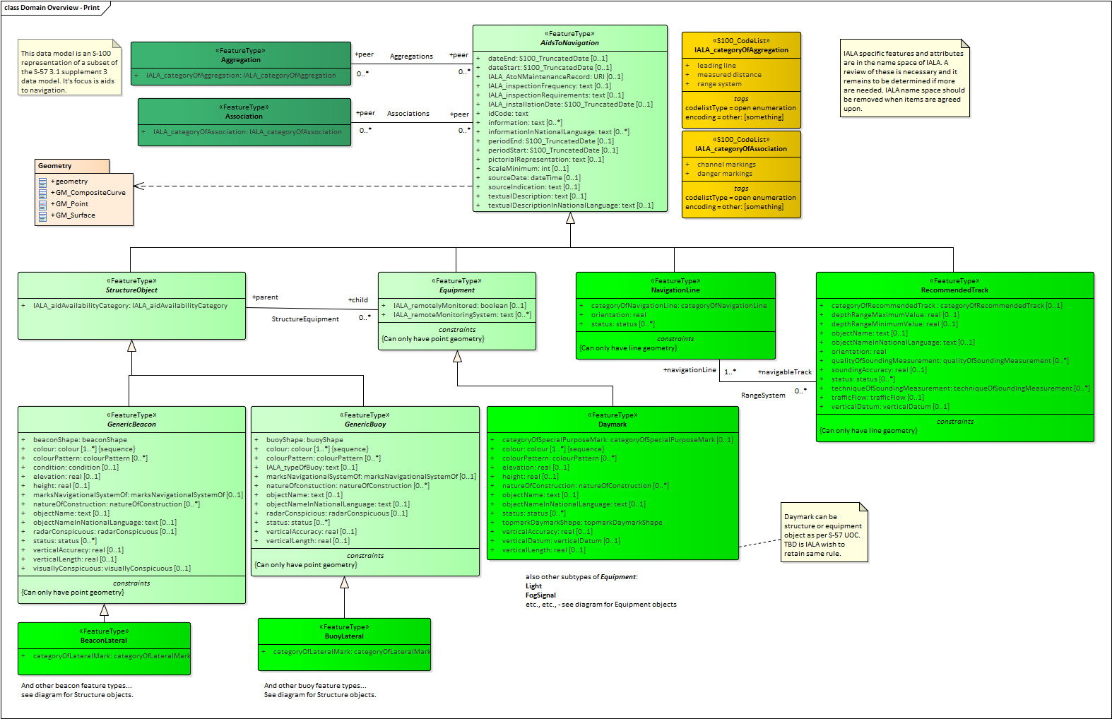
Figure 1. Overview
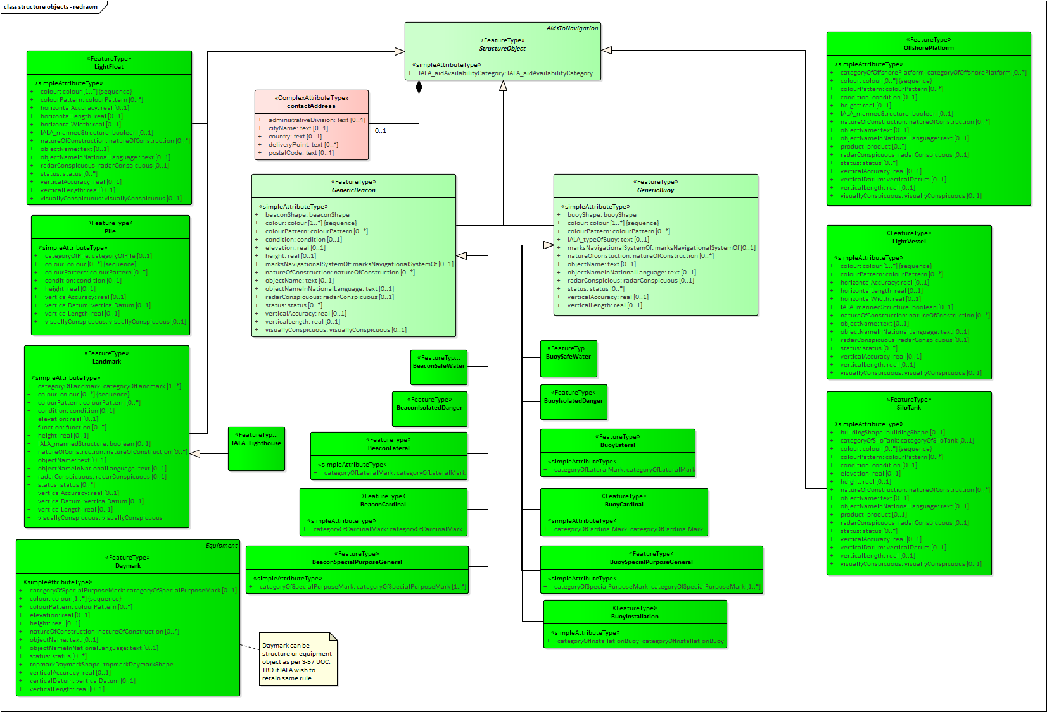
Figure 2. Structure Objects
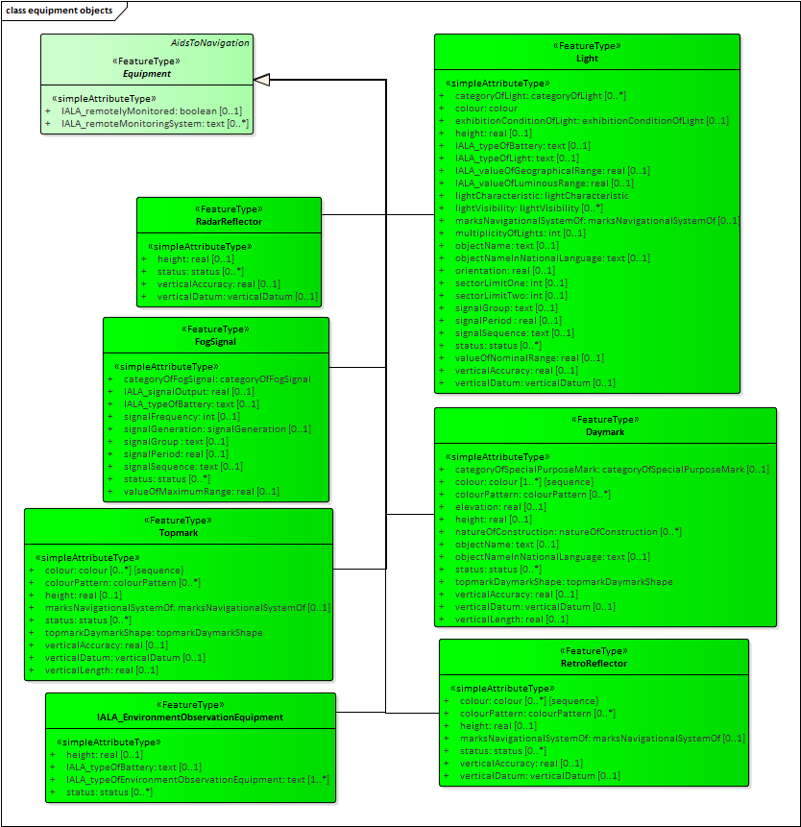
Figure 3. Equipment Objects
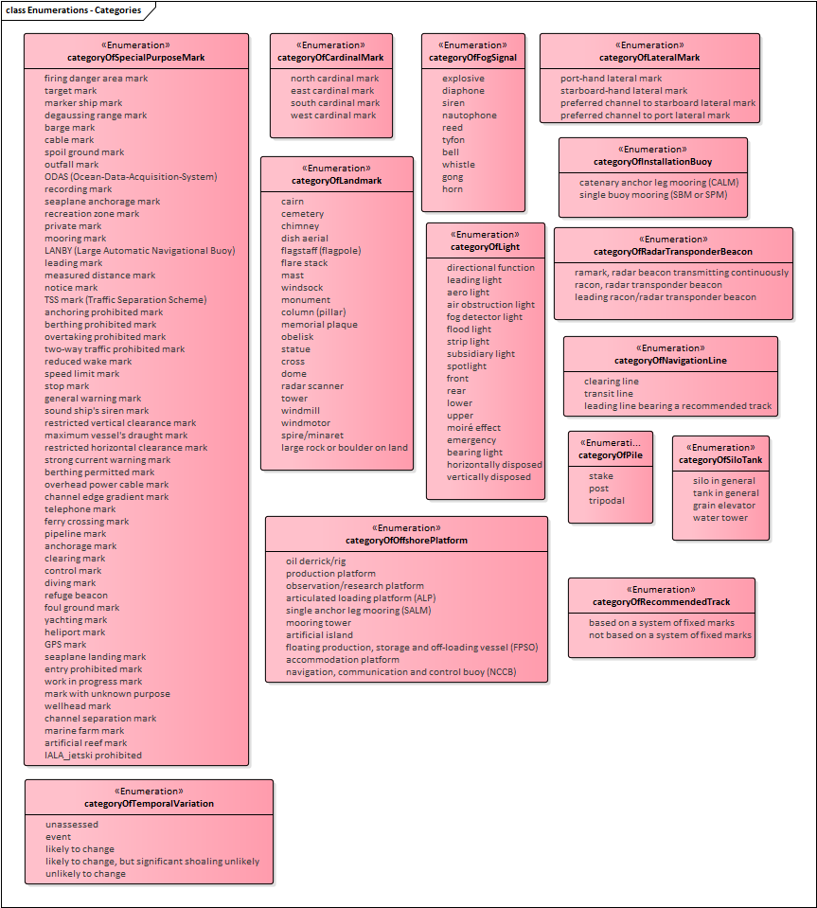
Figure 4. Enumerations – categories
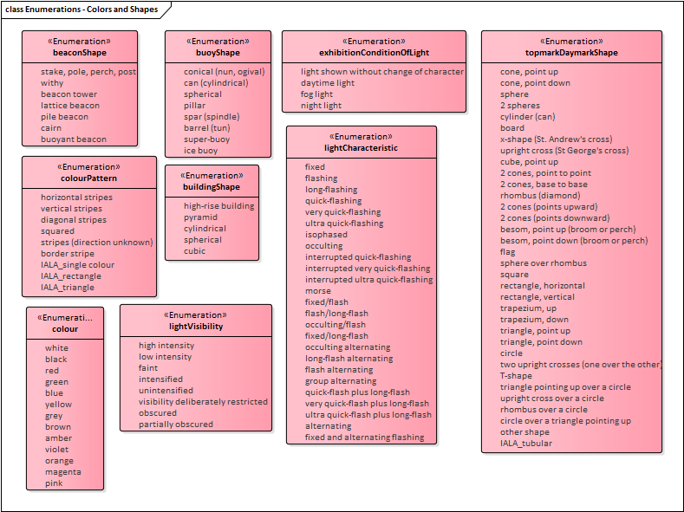
Figure 5. Enumerations – Color, characteristics, and shape enumerated attributes
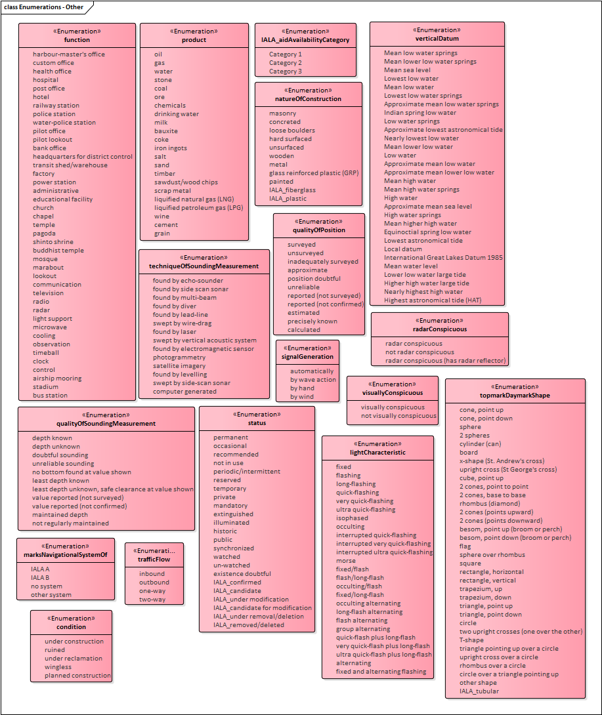
Figure 6. Enumerations - Other enumerated attributes
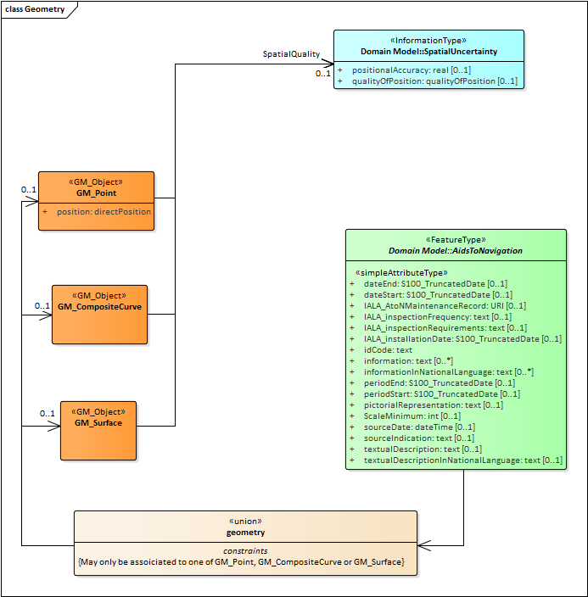
Figure 7. Spatial Attributes

Meta features application schema
Meta features include data coverage, data quality, datums and areas with established characteristics for navigational systems of marks (buoyage direction and system of marks). The application schema for meta-features is depicted in the diagram that follows.

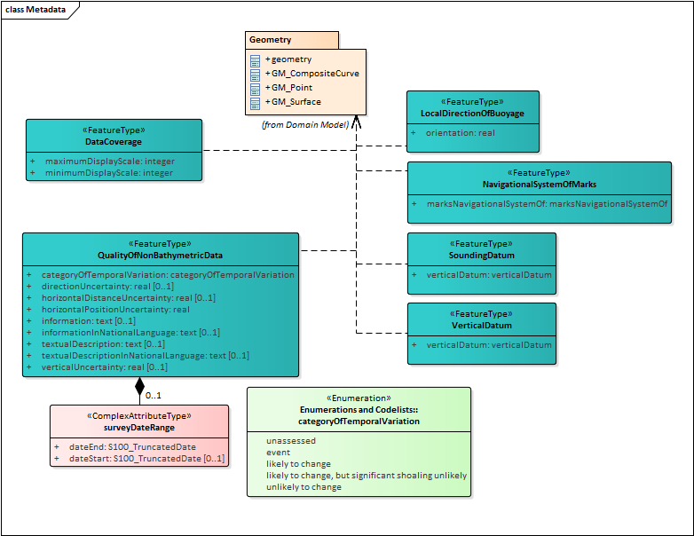
Figure 8. Meta features application schema

Feature Catalogue
The Feature Catalogue describes the feature types, information types, attributes, attribute values, associations and roles which may be used in the product. It also assigns the geometric primitives. The S-201 Feature Catalogue is available in an XML document which conforms to the S-100 XML Feature Catalogue Schema and can be downloaded from the IALA website (iala-aism.org). A printed version of the feature catalogue is provided in Annex D.
Name: Aids to Navigation Feature Catalogue
Scope: Ocean, Coastal, Ports, Harbors and Inland waters
Version Number: 0.0.6
Version Date: 2017-01-31
Producer:
IALA-AISM
10, rue des Gaudines
78100 Saint Germain en Laye, France
Telephone: +33 1 34 51 70 01 Fax: +33 1 34 51 82 05
URL : https://iala-aism.org
Language: English

Feature Types
Feature types contain descriptive attributes and do not contain any geometry (i.e. information about the shape and position of a real world entity). Features have two aspects – feature type and feature instance. A feature type is a class and is defined in a Feature Catalogue. A feature instance is a single occurrence of the feature type and represented as an object in a dataset. A feature instance is located by a relationship to one or more spatial instances. A feature instance may exist without referencing a spatial instance.
S-201 makes use of the following feature types:
Geographic (Geo) feature type – carries the descriptive characteristics of a real world entity.
Relationship feature type – A feature relationship links instances of one feature type with instances of the same or a different feature type.
Meta features – Meta features contain information about other features within a dataset. Information defined by meta features overrides the default metadata values defined by the dataset descriptive records. Meta attribution on individual features overrides attribution on meta features.

Data Product Types
A Dataset is a grouping of features, attributes, geometry and metadata which comprises a specific coverage. AtoN data is scale independent, but may use the scaleMinimum and scaleMaximum attributes of S100_GF_SpatialAttributeType to declutter the data in certain viewing scales. The use of scaleMinimum and scaleMaximum is at the discretion of the data producer.

Dataset rules
In order to facilitate the efficient processing and cataloguing of AtoN data the geographic coverage may be split into multiple datasets. There must be no overlapping datasets, except at the agreed adjoining national data limits, where, if it is difficult to achieve a perfect join, a 5 metre overlapping buffer zone may be used; and for this situation, there must be no gaps in data. The discovery metadata of a dataset must list all the Data Coverage features contained within that dataset.
Datasets are replaced by new editions that must be considered a whole replacement of the previous version. Delta change datasets are not permitted.
Datasets must not exceed 20MB.

Geometry
The specifications for S-201 geometry are the same as for S-101 geometry except that 3-D geometry is not permitted even for sounding features since these features are not part of the S-201 application schema. The relevant (modified) extract from the S-101 product specification is reproduced below.
The underlying geometry of an S-201 dataset is constrained to level 3a which supports 0, 1 and 2 dimensional features (points, curves and surfaces) as defined by S-100 Part 7 – Spatial Schema.
Level 3a is described by the following constraints:
- Each curve must reference a start and end point (they may be the same).
- Curves must not self intersect.
- Areas are represented by a closed loop of curves beginning and ending at a common point.
- In the case of areas with holes, all internal boundaries must be completely contained within the external boundary and the internal boundaries must not intersect each other or the external boundary. Internal boundaries may touch other internal boundaries or the external boundary tangentially (i.e. at one point).
- The outer boundary of a surface must be in a clockwise direction (surface to the right of the curve) and the curve orientation positive. The inner boundary of a surface must be in a counter-clockwise direction (surface to the right of the curve) and the curve orientation negative.

S-201 further constrains Level 3a with the following:
- Coincident linear geometry must be avoided when there is a dependency between features.
- The interpolation of GM_CurveSegment must be loxodromic.
- Linear geometry is defined by curves which are made of curve segments. Each curve segments contains the geographic coordinates as control points and defines an interpolation method between them. The distance between two consecutive control points must not exceed 0.3 mm at a display scale of 1:10000.
The following exception applies to S-201:
- The use of coordinates is restricted to two dimensions.
- Soundings features which use GM_Point or GM_Multipoint with three dimensional coordinates are not currently included in S-201.

Co-ordinate Reference Systems (CRS)

Introduction
The single coordinate reference system is separated into the horizontal and vertical components.

Horizontal Geodetic Datum
WGS84 (World Geodetic System of 1984) must be used for the horizontal reference system for spatial data. WGS84 must be used as the reference ellipsoid.

Vertical Datum
Vertical datum shall be selected from the list in verticalDatum enumeration. If the local datum value is used, additional information must be provided using the comment attribute in the metadata, or information attribute on the feature instance. Positive value is above vertical datum and negative is below vertical datum.

Units of Measure
Units of measure for S-201 datasets must be as follows,

For height, depth and vertical length it must be metres.
For range it must be nautical miles
For orientation it must be degrees
For signal duration it must be seconds
For audible signal output it must be decibel
For signal frequency it must be Hertz

Data Quality

Introduction
Data Quality is considered to be meta information and for S-201 it is divided into two parts:
- Compliance and integrity
- Uncertainty and lineage

Data Compliance and Integrity
S-201 datasets must be validated using the conformance checks that are listed in S-58. The data quality elements listed in S-100 Part 4C that are applicable to S-201 are indicated in the table of conformance checks listed in S-58.

Datasets must not be published unless they pass all the compliance checks designated as “Critical”.

The detailed results of applying compliance checks listed in S-58 are not required to be reported as part of the exchange set. They may be conveyed as support files or by separate arrangement.

Uncertainty and lineage information

Positional accuracy
S-201 positional accuracy data quality indicators do not use the model of data quality data quality elements defined in S-100 Part 4c.

However, positional accuracy must be evaluated and must be indicated in dataset metadata or spatial attribute metadata as provided in the application schema (Figure 7). This specification does not prescribe a specific required level of positional accuracy.

Lineage
Lineage and process step information elements are not required to be present in S-201 datasets distributed to end user. They may be included as extra metadata in exchange sets distributed to vendors and distributors.

Required source information about S-201 datasets is limited to the source and distribution information contained in discovery metadata described in S-100 Part 4a and Section 12 of this product specification.

Data Capture and Classification

The Data Capture and Classification (DCEG) is found in Annex A

Data Maintenance

Introduction
Datasets are replaced by new editions that must be considered a whole replacement of the previous version. Delta change datasets are not permitted. Each edition of a dataset shall have an edition number that is greater than the previous version by one. First edition of a dataset shall have edition number set to 1.

Maintenance and Update Frequency
Datasets are maintained as needed in accordance with data producer policy.

Data Product format (encoding)

Introduction
The GML encoding of S-201 datasets is based on the S-100 profile of GML 3.2.1. This is described in S-100 Edition 2.0.0 Part 10b.

Detailed documentation of the S-201 encoding schema is provided in Annex B of this document.

Format Name: GML, Specification: S-100 profile of GML Part 10b.
File Structure: S-201 (IALA AToN Product Specification), Annex B.

Encoding of Latitude and Longitude
Values of latitude and longitude must be expressed with a precision of 9 decimal places. Coordinates must be encoded as decimals in the format described below. The encoding is indicated by multiplication factor fields defined in the dataset identification record by the S-100 GML schemas.

Encoding of coordinates as decimals
Values should be coded as decimal numbers with 7 or fewer digits after the decimal. The normative encoding is in degrees, with an accuracy of 10⁻⁷ degrees, i.e., 7 digits after the decimal point.
The decimal point must be indicated by the “.” character.
Trailing zeroes after the decimal point (and the decimal point itself if appropriate) may be omitted at producer discretion, but the accuracy must still be as indicated (e.g., 10⁻⁷ degrees for coordinates of default accuracy).
Latitude and longitude multiplication factors held in the Dataset Structure Information field under [coordMultFactorX] and [coordMultFactorY] must be set to a value corresponding to the encoding, i.e., {1} for coordinates encoded in decimal degrees.
EXAMPLE 1 A longitude = 42.0000 is converted into X = longitude * coordMultFactorX = 42.0000 * 1 = 42.0000000.

Numeric Attribute Encoding
Floating point and integer attribute values must not contain leading zeros. Floating point attribute values must not contain non-significant trailing zeros.

Text Attribute Values
Character strings must be encoded using the character set defined in ISO 10646-1, in Unicode Transformation Format-8 (UTF-8).

Mandatory Attribute Values
There are four reasons why attribute values may be considered mandatory:
- They determine whether a feature is in the display base,
- Certain features make no logical sense without specific attributes,
- Some attributes are necessary to determine which symbol is to be displayed,
- Some attributes are required for safety of navigation.
All mandatory attributes are identified in the Feature Catalogue and summarised in Annex A – Data Classification and Encoding Guide.

Unknown Attribute Values
When a mandatory attribute code or tag is present but the attribute value is missing, it means that the producer wishes to indicate that this attribute value is unknown. Missing mandatory attributes must be “nilled” with a GML nilReason attribute giving the reason for omission.
Optional attributes must be omitted altogether if the value is unknown or missing. They must not be “nilled.”
EXAMPLE An isolated danger beacon feature has unknown color (mandatory attribute) and condition (optional attribute). The feature could be coded as:
<BeaconIsolatedDanger>
<beaconShape>beacon tower</beaconShape>
<colour nilReason=”unknown”/>
… other attributes…
… <condition> is NOT coded …
<BeaconIsolatedDanger>

Structure of dataset files

Sequence of objects
The order of data objects in each dataset file is described below:

Dataset Identification Information
Dataset structure information
Spatial records for by-reference geometries
Point
Multi point
Curve
Composite Curve
Surface
Information objects
Feature objects (Geometry may be encoded inline or by reference.)
Meta features
Geo features
S-201 Collection objects

Object identifiers
The “name” of feature records must provide a unique world-wide identifier of feature records. The “name” of the record is the combination of the subfields agency, featureObjectIdentifier, and featureIdentificationSubdivision elements of the featureObjectIdentifier element of the object.

Features, information types, collection objects, meta features, and geometries (inline or external) are all required by the schema to have a gml:id attribute with a value that is unique within the dataset. The gml:id values must be used as the reference for the object from another object in the same dataset or another dataset.

Dataset validation
Fields may be repeated or omitted as permitted by the XML schemas and the validation tests. Since XML schema cannot encode rules for conditional presence or attributes, these rules are checked by Schematron rules or other validation code.

Location of Data Product Format schema Files
The schema files are available from the locations given below.

File | Description | Version | Location
S100_gmlProfile (XSD file) | S-100 GML profile schema | 1.0 | TBD (IHO site)
S100_gmlProfileLevels (XSD file) | Compliance levels schema for the S-100 GML 3.2.1 Profile | 1.0 | TBD (IHO site)
S100_gmlBase (XSD file) | IHO TSMAD S-100 common components schema for S-100 GML data format | 1.0 | TBD (IHO site)
S100_gmlProfileExt (XSD file) | S-201 extensions to the IHO GML profile | 1.0 | TBD (IALA-AISM web site?)
S100_gmlBaseExt (XSD file) | S-201 extensions to the IHO GML common components | 1.0 | TBD (IALA-AISM web site?)
S201 (XSD file) | S100 XML/GML Schema for S-201 (IALA Aids To Navigation) | 0.1 | TBD (IALA-AISM web site?)
(Schematron files for dataset validation) | [To be developed] | TBD | TBD (IALA-AISM web site?)
S201-1.gml (XML/GML file) | S-201 example | 0.1 | TBD (IALA-AISM web site?)
OGC GML 3.2.1 schemas | OGC schemas for GML 3.2.1 | 3.2.1 | http://schemas.opengis.net/gml/3.2.1/

Detailed documentation of schema
The detailed documentation of the S-100 Profile of GML Part 10b schema is in Annex B (currently a separate document enclosed with this file).

Data Product Delivery
This clause specifies the encoding and delivery mechanisms for an S-201 dataset. Data which conforms to this product specification must be delivered by means of an exchange set.

Exchange set
S-201 datasets are grouped into exchange sets. Each exchange set consists of one or more AtoN datasets with an associated XML metadata file and a single Exchange Catalogue XML file containing metadata. It may also include one or more support files.

Units of Delivery: Exchange Set

Transfer Size: Unlimited

Medium Name: Digital data delivery

Other Delivery Information:

Each dataset must be contained in a physically separate, uniquely identified file on the transfer medium.
Each exchange set has a single exchange catalogue which contains the discovery metadata for each dataset and references to any support files.
Support files are supplementary information which are linked to the features and information types by attributes. The attributes containing these links are described in the application schema and feature catalogue.
An exchange set may be encapsulated into a form suitable for transmission by a mapping called a transmission encoding. An encoding translates each of the elements of the exchange set into a logical form suitable for writing to media and for transmission online. An encoding may also define other elements in addition to the exchange set contents (i.e., media identification, data extents etc…) and also may define commercial constructs such as encryption and compression methods.

If the data is transformed (e.g., for encryption or compression purposes) its content must not be changed.

This product specification does not define the transmission encoding which must be used as a default for transmission of data between parties.

The exchange set elements are as follows:

Mandatory Elements
- AtoN datasets – GML encoding of features/attributes and their associated geometry and metadata.
- Exchange Catalogue – the XML encoded representation of exchange set catalogue features [discovery metadata].

Optional Elements
- Supplementary files – These are contained within the exchange set as files and the map from the name included within the dataset and the physical location on the media is defined within the Exchange Catalogue.
- Feature Catalogue – If it is necessary to deliver the latest feature catalogue to the end user it may be done using the S-201 exchange set mechanism for datasets – i.e., include the updated feature catalogue in an exchange set.
- Portrayal Catalogue - If it is necessary to deliver the latest portrayal catalogue to the end user it may be done using the S-201 exchange set mechanism for datasets datasets – i.e., include the updated feature catalogue in an exchange set.

Dataset

Datasets
Datasets are distributed as files which are part of exchange sets structured as described in this specification. The distribution media are left to the discretion of the producer and distributor.
The following types of dataset files may be produced and contained within an exchange set:
- New dataset and new edition of a dataset (base dataset): Each new edition of a dataset must have the same name as the dataset that it replaces. A new edition can also be AtoN data that has previously been produced for this area. The encoding structure is located in Annex B.
- Cancellation: The dataset is cancelled and is deleted from the SYSTEM. The structure for a cancellation is described in clause 12.2.5.

Dataset size
Datasets must not exceed 20 MB.

Dataset file naming
Dataset files shall be named

CCXXXXXXXX_EEE.GML

The file name forms a unique identifier where:
- CC - the first two characters identify the issuing agency (mandatory) in accordance with IHO S-62..
- the third to tenth characters are optional and may be used in any way by the producer to provide the unique file name. The following characters are allowed in the dataset name, A to Z, 0 to 9 and the special character _ (underscore).
- EEE – new editions and re-issues use 000, and increment until a limit of 999 (mandatory).
- the maximum number of characters preceding _EEE is ten.
- GML – the character sequence “GML” or “gml”.

Cancellations
In order to cancel a dataset, a cancellation dataset is created for which the edition number must be set to 0. Dataset edition number is a field in exchange set metadata, class S100_DatasetDiscoveryMetadata (clause Metadata classes). The cancellation dataset file may contain no data objects (features, information types, etc.) and any data objects present it in are ignored. The cancellation dataset may be part of an exchange set which contains other datasets, e.g., a new edition of a different dataset. This method is only used to cancel a dataset. Where a dataset is cancelled and its name is reused at a later date, the issue date must be greater than the issue date of the cancelled dataset. When the dataset is cancelled it must be removed from the system.

Support Files
Dataset support files offer supplementary information that can be included in an ENC exchange set.
Text files must contain only general text as defined by this standard. (Extensible mark-up language (XML) supports UTF-8 character encoding).Text files may be (TXT), (XML), (HTM), JPEG files.
Support files may be in any of the support file formats defined in the S-100 enumeration S100_SupportFileFormat (defined in Part 4a-D-2.12) except that “Other” may not be used.

Support File Naming
All support files must have unique universal file identifiers. The file identifier of support information should not be used to describe the physical content of the file. The support file metadata that accompanies the file will inform the user of the name and purpose of the file (i.e. new, replacement and deletion).
In this encoding the support files are named according to the specifications given below:
CCXXXXXXXX.EEE
The main part forms an identifier where:
- the first two characters identify the issuing agency (mandatory)
- the third to tenth characters can be used in any way by the producer to provide the unique file name. The following characters are allowed in the support file name, A to Z, 0 to 9 and the special character _ (underscore)
- .EEE – support file extension. (Must conform to the file format.)
- the maximum number of characters is ten

Support file management
When a support file is created or a subsequent version is issued it must carry its own issue date and be supported with a digital signature which authenticates it against the producer’s public key included in the exchange set metadata.

The type of support file is indicated in the “purpose” field of the discovery metadata. Support files carrying the “deletion” flag must be removed from the system. When a feature pointing to a text, picture or application file is deleted or updated so that it no longer references the file, the system software must check to see whether any other feature referenced the same file, before that file is deleted.

Each support file must be used only once in the exchange set.

Support files should be stored in a separate folder within the exchange set.

Exchange Catalogue
The exchange catalogue acts as the table of contents for the exchange set. The catalogue file of the exchange set must be named S201_1_0_CAT.XML. No other file in the exchange set may be named S201_1_0_CAT.XML. The contents of the exchange catalogue are described in Clause 13.
XML schemas for the exchange catalogue are located at http://registry.iho.int/

Metadata

Introduction
The metadata description is based on the S-100 metadata document section, which is a profile of the ISO 19115 standard. These documents provide a structure for describing digital geographic data and define metadata elements, a common set of metadata terminology, definitions and extension procedures.
The realization of exchange set classes, the exchange set catalogue, and the structure of exchange sets are the same as in S-100. The relevant UML diagrams from S-100 are therefore reproduced here for reference.

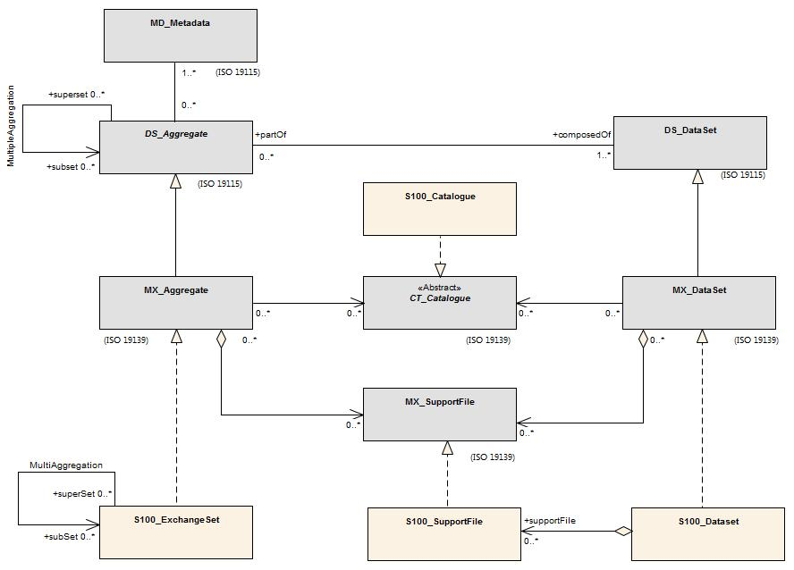
Figure 9. Realization of the Exchange Set Classes (from S-100)

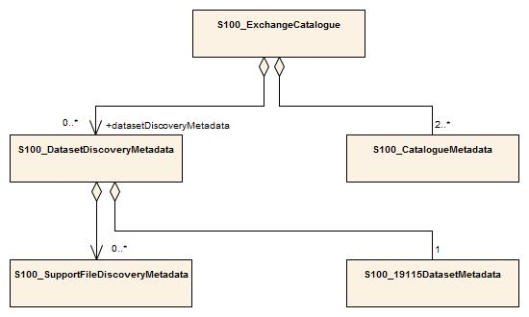
Figure 10. Exchange set catalogue and metadata (from S-100)
Since the class S100_DatasetDiscoveryMetadata aggregates ISO 19115 metadata (class S100_19115DatasetMetadata), metadata conforming to ISO 19115 is required to be included. Metadata for each support file is required if the exchange set contains support files.

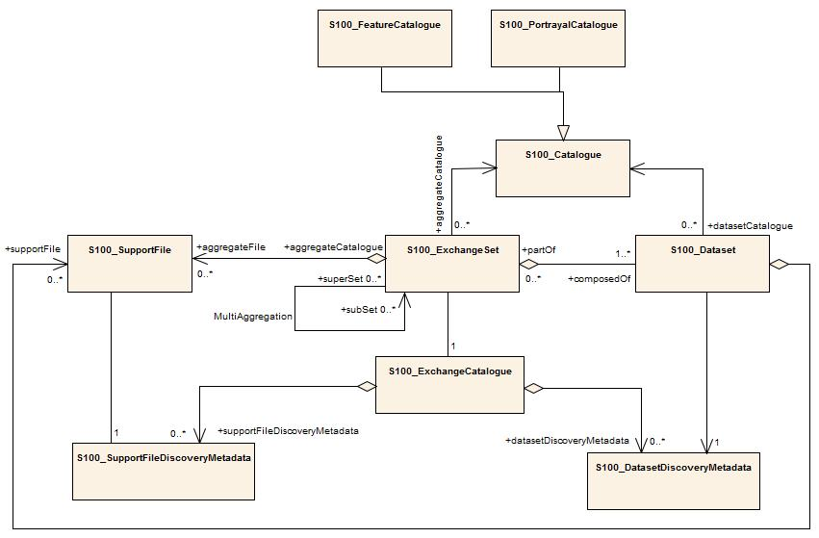
Figure 11. Exchange set including metadata (From S-100)
ISO 19115 metadata conforms to ISO 19115 with the additional constraints in S-100 Part 4A Appendix 4A-B.1 (Table B.1) which make the fileIdentifier element mandatory.

Metadata classes
Details for the S-100 metadata classes are depicted in the figure below.
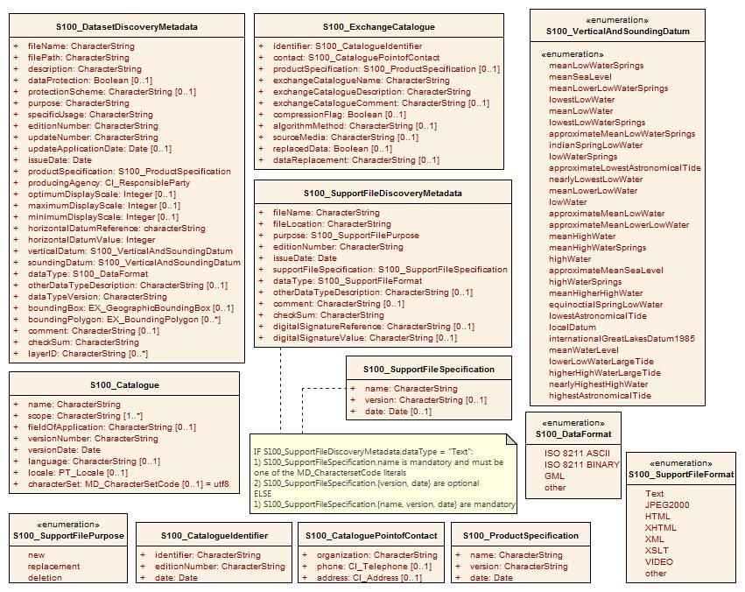
Figure 12. S-100 and S-201 metadata class details
[Refer to S-100 Edition 2.0.0 Part 4A-D.2 for detailed documentation of S-100 metadata. If S-201 differs, then the S-100 classes should be specialized by S-201 classes if possible and the differences indicated (e.g., figure 4a-2 in S-100 which depicts how S-100 constrains the fileIdentifier attribute of MD_Metadata to be mandatory).]

S100_ExchangeSet

S100_ExchangeCatalogue

S100_CatalogueIdentifier

S100_CataloguePointofContact

S100_Dataset

S100_DatasetDiscoveryMetadata

The class S100_DatasetDiscoveryMetadata is not directly used in S-201 metadata. Instead, its specialization S201_DatasetDiscoveryMetadata (clause Error: Reference source not found) is used.

Role Name | Name | Description | Mult | Type | Remarks
Class | S100_DatasetDiscoveryMetadata | Metadata about the individual datasets in the exchange catalogue | - | - | S-100 metadata class
Attribute | fileName | Dataset file name | 1 | CharacterString
Attribute | filePath | Full path from the exchange set root directory | 1 | CharacterString | Path relative to the root directory of the exchange set. The location of the file after the exchange set is unpacked into directory <EXCH_ROOT> will be <EXCH_ROOT>/<filePath>/<filename>
Attribute | description | Short description giving the area or location covered by the dataset | 1 | CharacterString | E.g. a harbour or port name, between two named locations etc.
Attribute | dataProtection | Indicates if the data is encrypted | 0..1 | Boolean | 0 indicates an unencrypted dataset  1 indicates an encrypted dataset
Attribute | protectionScheme | specification or method used for data protection | 0..1 | CharacterString | Eg S-63
Attribute | purpose | The purpose for which the dataset has been issued | 1 | MD_Identification>purpose  CharacterString | E.g. new, re-issue, new edition, update etc.
Attribute | specificUsage | The use for which the dataset is intended | 1 | CharacterString | E.g. in the case of ENCs this would be a navigation purpose classification.
Attribute | editionNumber | The edition number of the dataset | 1 | CharacterString | when a data set is initially created, the edition number 1 is assigned to it. The edition number is increased by 1 at each new edition. Edition number remains the same for a re-issue.
Attribute | updateNumber | Update number assigned to the dataset and increased by one for each subsequent update | 1 | CharacterString | Update number 0 is assigned to a new dataset.
Attribute | updateApplicationDate | this date is only used for the base cell files (i.e. new data sets, re-issue and new edition), not update cell files. All updates dated on or before this date must have been applied by the producer | 0..1 | Date
Attribute | issueDate | date on which the data was made available by the data producer | 1 | Date
Attribute | productSpecification | The product specification used to create this dataset | 1 | S100_ProductSpecification
Attribute | producingAgency | Agency responsible for producing the data | 1 | CI_ResponsibleParty
Attribute | optimumDisplayScale | The scale with which the data is optimally displayed | 0..1 | Integer | Example: A scale
Attribute | maximumDisplayScale | The maximum scale with which the data is displayed | 0..1 | Integer
Attribute | minimumDisplayScale | The minimum scale with which the data is displayed | 0..1 | Integer
Attribute | horizontalDatumReference | Reference to the register from which the horizontal datum value is taken | 1 | characterString | EPSG
Attribute | horizontalDatumValue | Horizontal Datum of the entire dataset | 1 | Integer | 4326
Attribute | verticalDatum | Vertical Datum of the entire dataset | 1 | S100_VerticalAndSoundingDatum
Attribute | soundingDatum | Sounding Datum of the entire dataset | 1 | S100_VerticalAndSoundingDatum
Attribute | dataType | The encoding format of the dataset | 1 | S100_DataFormat
Attribute | otherDataTypeDescription | Encoding format other than those listed. | 0..1 | CharacterString
Attribute | dataTypeVersion | The version number of the dataType. | 1 | CharacterString
Attribute | boundingBox | The extent of the cell limits | 0..1 | EX_GeographicBoundingBox
Attribute | boundingPolygon | A polygon which defines the actual data limit | 0..* | EX_BoundingPolygon
Attribute | comment | any additional information | 0..1 | CharacterString

Language
The exchange language must be English. Other languages may be used as a supplementary option. National geographic names can be left in their original national language using the complex attribute Feature Name.

Character strings must be encoded using the character set defined in ISO 10646-1, in Unicode Transformation Format-8 (UTF-8). A BOM (byte order mark) must not be used.
- Data Classification and Encoding Guide
[This is a placeholder. The detailed documentation of the S-201 XML schema is currently in a separate document enclosed with this file. See file S-201 Product Specification - draft 0.0.1 Annex A DCEG_rev4.doc]

- Data Product Format (Encoding)

Introduction
This data format conforms to the profile described in S-100 Part 10b, which is based on GML. Each dataset in the XML dataset format consists of a root element DataSet, whose structure is shown in the figure below. A Dataset contains of optional header information identifying the dataset (contained in element DatasetIdentificationInformation) and providing parameters (within element DatasetStructureInformation), followed by 0 or more spatial objects (points, curves, or surfaces – these replace the S100:Geometry box in the figure), then information and feature objects (within imember and member container elements respectively). Dataset, imember, and member elements are format constructs and not part of the application schema. Also, the root Dataset element is derived from gml:AbstractFeatureType (another GML data format idiom).
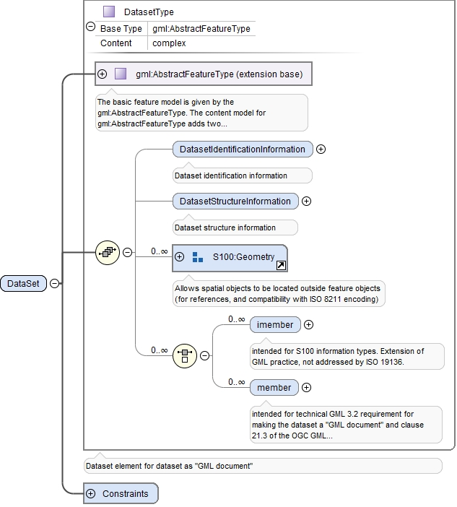
Figure 13. Dataset structure

An example of the structure of individual features is shown in the following figure.

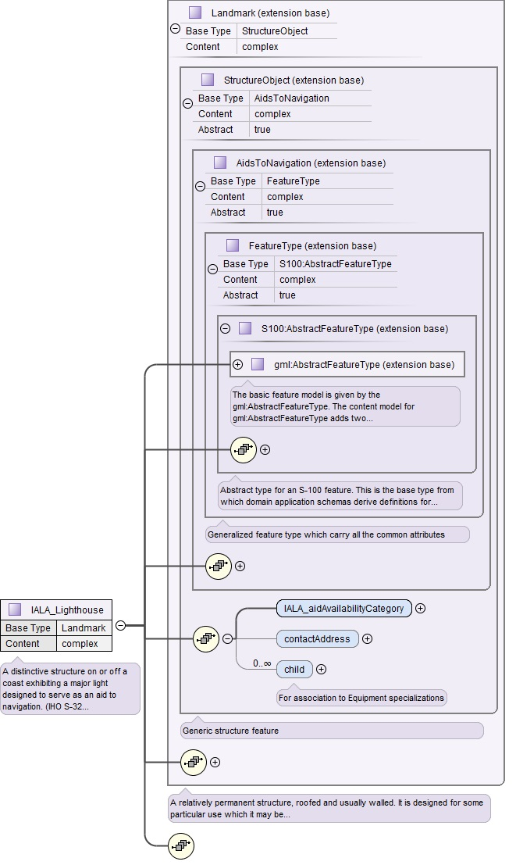
Figure 14. Structure of Lighthouse feature
The Lighthouse feature derives from Landmark, which in turn derives from StructureObject, which in turn derives from AidsToNavigation. AidsToNavigation derives from FeatureType which is a generic feature type defined in S-201, which itself derives from AbstractFeatureType defined in the the S-100 GML profile, which in turn derives from the basic feature model defined by GML as AbstractFeatureType. Most of these types define attributes and associations, which are inherited by their derived types.

The figure depicts the two attributes defined locally in StructureObject (attributes aidAvailabilityCategory and contactAddress) as well as one locally defined association (child). (Attributes and associations definitions in the other parts of the type hierarchy have been collapsed to limit the size of the figure.) This structure corresponds to the extract from the application schema depicted in the figure below. Note that FeatureType, AidsToNavigation, and StructureObject are abstract types and the dataset cannot contain objects corresponding to these types, only to their concrete derived types Landmark and Lighthouse. The derivation hierarchy implements following fragment extracted from the application schema. Feature Lighthouse inherits attributes and associations from Landmark, StructureObject, and AidsToNavigation.
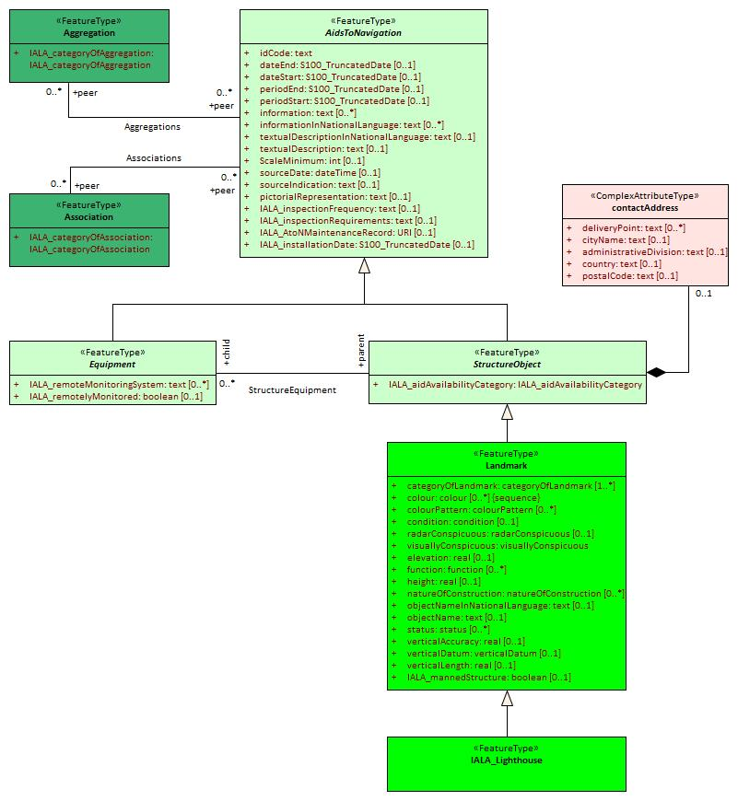
Figure 15. Application schema fragment showing the inheritance hierarchy of Lighthouse implemented by the XML data format

An example of a dataset is depicted in the following figure. The opening tag Dataset is followed by a bounding box (not required by the application schema, but useful for GML software). the only information type is a SpatialUncertainty (ID122). The figure depicts a Topmark (ID155) and its attributes. This Topmark feature is associated to an Association feature (tag <peer xlink:href=”#ID132”...). The peer tag also contains XML attributes whose values indicate the role (urn:IALA:S201:roles:peer) and the association label (title=Associations). These correspond to the Associations association between AidsToNavigation and the collection feature Association in the application schema (inherited by Topmark via Equipment – see the application schema in the main body of the product specification). This Association feature is in turn is associated to the Topmark and a Daymark (ID200).

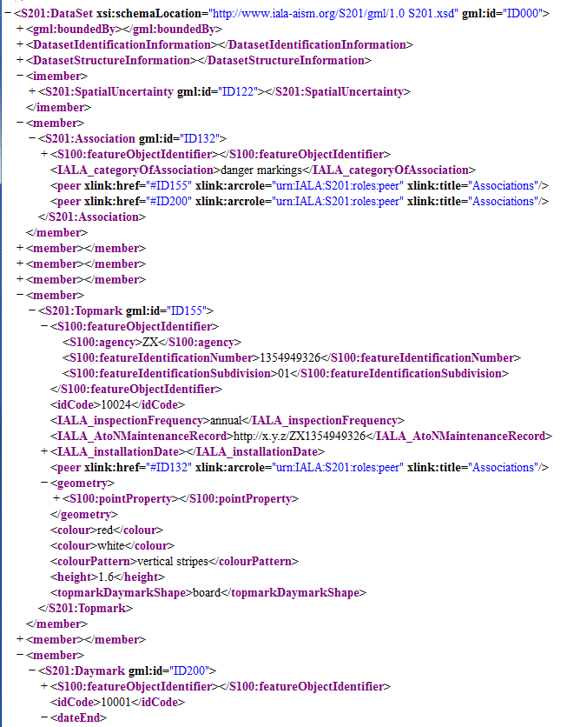
Figure 16. Extract of sample dataset
Data Integrity checkING
The XML schema defines internal constraints ensuring the uniqueness of featureObjectIdentifier attributes within the dataset. Uniqueness constraints for attribute idCode are currently not included because the corresponding check is designated in Appendix H (Validation checks) as a warning and not an error. Global uniqueness across datasets must be enforced in production systems and/or application software. Restrictions on the type of allowed geometry for the Lighthouse feature and additional basic integrity checks are defined as Schematron rules in a separate file which should accompany the XSD file and can be used by XML tools to check the internal integrity of datasets. The basic integrity checks include checking for the existence of internal references, verifying that end dates follow start dates in date ranges, etc. The validation checks in Appendix H and local restrictions on the permitted values of enumeration attributes defined in the DCEG (i.e., subsetting of permitted values within the scope of a specific feature type) are not currently implemented in the data format.

DETAILED Documentation
[This is a placeholder. The detailed documentation of the S-201 XML schema is currently in a separate document enclosed with this file. See files S-201 Product Specification - draft 0.0.1 Annex B.1-schemas-20150929.zip and S-201 Product Specification - draft 0.0.1 Annex B.2-schema document-20150929.zip]

- NORMATIVE IMPLEMENTATION GUIDANCE
IALA to determine if this annex is needed.

- FEATURE CATALOGUE
[See files S-201 Product Specification - draft 0.0.1 Annex D.1 Feature Catalogue.docx and S-201 Product Specification - draft 0.0.1 Annex D.2 Feature Catalogue for S-201 AtoN_0.0.1.xml]
- PORTRAYAL CATALOGUE
To be completed later.

- Application Schema Documentation Tables

- S-201 to S-57 conversion guideline
This annex contain specific guidance that should be followed when converting the S-201 data model to S-57 data model. The annex provides no guidance on converting the S-201 GML encapsulation into S-57 8211 encapsulation.

[insert text here…]

- S-201 dataset validation rules
[See separate document titled S-201 Product Specification - draft 0.0.1 Annex H data validation tests.docx]

? URNs in the example are tentative. As of the date this section was written, the structure of URN identifiers had not been specified. All identifiers, associations, and attribute values in the sample are only for illustrating the data format and may not encode valid domain semantics or requirements.

