IALA COUNCIL  70th session | 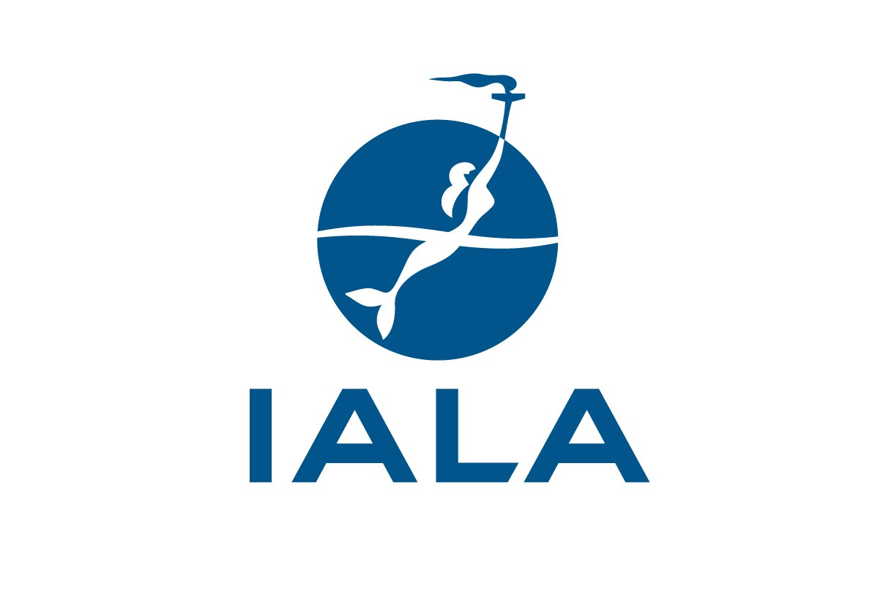 | 9-13 December 2019  Nouméa  New Caledonia

REGISTRATION FORM
(Please provide one form per delegate & accompanying person)
First Name
Family Name
Title
Organization
Position
E- mail:
First Name of accompanying person
Family Name of accompanying person
Arrival date
Departure date
Hotel
SPECIAL PROGRAMME AND EVENTS:
Strategy Workshop on Monday 9th 13:30 – 17:30

I will attend □ (No. of persons: ....) I will not attend □

Welcome reception on Monday 9th 18:00-22:00 venue: Château Royal
(partners are welcome) (at the terrace)
I /We will attend □ (No. of persons: ....) I /We will not attend □

Council Dinner on Thursday 12th 19:00-23:00 venue: Hotel Nouvata
(partners are welcome)
I /We will attend □ (No. of persons: ....) I /We will not attend □

Technical Visit on Thursday 12th 07:30-17:00 Amédee Lighthouse & Buoy Tender “Louis Henin”
(partners are welcome) (swimming recommendation in the afternoon)
I /We will attend □ (No. of persons: ....) I /We will not attend □

Friday 13th Lunch
(partners are welcome)
I /We will attend □ (No. of persons: ....) I /We will not attend □

Special dietary requirements for meals, if any:

GENERAL DATA PROTECTION REGULATION (GDPR):
I agree that IALA can publish my contact details in the Council Report:

YES □ NO □

SPOUSE PROGRAMME
A two-day spouse programme: on Tuesday 10 and Wednesday 11 by the Noumea Discovery Inbound will be available soon on the website. You are encouraged to visit the website: https://www.iala-aism.org/product/council70/ for more information

I will attend □ I will not attend □

-----------------------------------------------------------------------------------------------------------------------------------
Please return the form duly filled in by 1st December, 2019, by e-mail to lorraine.mbong@iala-aism.org

