VTS47-13.3.2

VTS
Product Specification

Draft 0.6.0 – Sep 2019

VTS Product Specification

Document Revisions
Revisions to the IALA Document are to be noted in the table prior to the issue of a revised document.
Date | Page / Section Revised | Requirement for Revision

Table of Contents
1 Overview 5
1.1 Introduction 5
2 References 5
3 Terms, definitions and abbreviations 6
3.1 Terms and definitions 6
3.2 Abbreviations 7
4 Product specification metadata 8
4.1 IALA Product Specification Maintenance 8
4.1.1 Introduction 8
4.1.2 New Edition 9
4.1.3 Revisions 9
4.1.4 Clarification 9
4.1.5 Version Numbers 9
5 Specification Scope 9
6 Data Product Identification 10
6.1 Dataset Identification 10
7 Data Content and structure 11
7.1 Introduction 11
7.2 Application Schema 12
7.2.1 Domain Model 13
7.2.2 Meta features application schema 17
7.3 Feature Catalogue 18
7.4 Feature Types 18
8 Co-ordinate Reference Systems (CRS) 18
8.1 Introduction 18
8.2 Horizontal Reference System 19
8.3 Projection 19
8.4 Vertical Coordinate Reference System 19
8.5 Temporal Reference System 19
8.6 VTS Information Service Data and Scale 19
9 Data Quality 19
10 Data Capture and Classification 19
11 Data Maintenance 20
12 Data Product format (encoding) 20
12.1 Introduction 20
12.2 Numeric Attribute Encoding 20
12.3 Text Attribute Values 20
12.4 Mandatory Attribute Values 20
12.5 Unknown Attribute Values 20
12.6 Structure of dataset files 20
12.7 Message object identifiers 21
12.8 Dataset validation 21
12.9 Location of Data Product Format schema Files 21
12.10 Detailed documentation of schema 22
13 Data Product Delivery 22
13.1 Message datasets 22
13.2 Collections 23
13.3 Dataset distribution 23
13.3.1 Datasets 23
13.3.2 Dataset size 23
13.3.3 Dataset file naming 23
13.4 Support Files 24
13.5 Exchange Catalogue 24
14 Metadata 24
15 Use of other standard documents in VTS-INS 25
16 Language 25
17 Acknowledgements 25
Annex A. Data Classification and Encoding Guide 26
Annex B. Data Product Format (Encoding) 27
Annex C. NORMATIVE IMPLEMENTATION GUIDANCE 28
Annex D. FEATURE CATALOGUE 29
Annex E. Application Schema Documentation Tables 30
Annex F. VTS-INS dataset validation rules 31

Overview

Introduction
This document is a S-100 vector product specification for encoding current and future VTS Digital Information Services.
According to IALA Guideline 1089 on Provision of Vessel Traffic Services provides guidance on the delivery of different types of services provided by a Vessel Traffic Service (VTS). VTS is a service implemented by a Competent Authority, designed to improve the safety and efficiency of vessel traffic and to protect the environment. The service should have the capability to interact with traffic and to respond to traffic situations developing in the VTS area.
VTS Digital Information Services should not be limited to information exchange between ship and shore but also other service providers. This document will include all digital information services that are relevant to VTS operations.

References
IMO Resolution A.857(20) Guidelines for Vessel Traffic Services
IALA Guideline 1089 Provision of Vessel Traffic Services, edition 1.0 (December 2012)
IALA Recommendation V-145 The Inter-VTS Exchange Format (IVEF) Srevice, edition 1 (June 2011)
IHO S-100 IHO Universal Hydrographic Data Model Edition 4.0.0 (December 2018).
IHO S-101 IHO Electronic Navigational Chart (ENC), Edition 1.0.0 – December 2018
IHO S-124 NAVIGATIONAL WARNINGS, Working Draft – 2.0.0– 2019-07-12
IHO S-127 MARINE TRAFFIC MANAGEMENT, Edition 1.0.0 – December 2018
IHO S-211 Port Call Message Format, [Edition]
IHO S-412 Weather Overlay, Edition and date TBC
IHO S-421 IEC Route Plan Exchange Format, Edition and date TBC
ISO 8601. 2004. Data elements and interchange formats - Information interchange - Representation of dates and times. 2004.
ISO 3166-1. 1997. Country Codes. 1997.
ISO 19101-2:2008 Geographic Information - Rules for Application Schema
ISO/TS 19103:2005 Geographic Information - Conceptual schema language
ISO 19106:2004 Geographic Information – Profiles
ISO 19107:2003 Geographic Information – Spatial schema
ISO 19109:2005 Geographic Information - Rules for Application Schema
ISO 19111:2003 Geographic Information - Spatial referencing by coordinates

ISO 19115-2:2009 Geographic Information - Metadata: Extensions for imagery and gridded data
ISO 19123:2005 Geographic Information - Schema for coverage geometry and functions
ISO 19129:2009 Geographic Information - Imagery gridded and coverage data framework
ISO 19131:2007 Geographic Information - Data product specifications

ISO 19136-2:2015, Geographic Information – Geography Markup Language.
ISO/TS 19139, Geographic Information – Metadata – XML schema implementation.

Terms, definitions and abbreviations

Terms and definitions
The S-100 framework is based on the ISO 19100 series of geographic standards. The terms and definitions provided here are used to standardize the nomenclature found within that framework, whenever possible. They are taken from the references cited in clause 2. Modifications have been made when necessary.

application schema
conceptual schema for data required by one or more applications (ISO 19101)

conceptual model
model that defines concepts of a universe of discourse (ISO 19101)

conceptual schema
formal description of a conceptual model (ISO 19101)

data product
dataset or dataset series that conforms to a data product specification

data product specification
detailed description of a dataset or dataset series together with additional information that will enable it to be created, supplied to and used by another party
NOTE: A data product specification provides a description of the universe of discourse and a specification for mapping the universe of discourse to a dataset. It may be used for production, sales, end-use or other purpose.

dataset
identifiable collection of data (ISO 19115)
NOTE: A dataset may be a smaller grouping of data which, though limited by some constraint such as spatial extent or feature type, is located physically within a larger dataset. Theoretically, a dataset may be as small as a single feature or feature attribute contained within a larger dataset. A hardcopy map or chart may be considered a dataset.

domain
well-defined set (ISO/TS 19103)
NOTE: Well-defined means that the definition is both necessary and sufficient, as everything that satisfies the definition is in the set and everything that does not satisfy the definition is necessarily outside the set.

feature
abstraction of real world phenomena (ISO 19101)
NOTE: A feature may occur as a type or an instance. Feature type or feature instance shall be used when only one is meant.

feature attribute
characteristic of a feature (ISO 19101)
NOTE 1: A feature attribute may occur as a type or an instance. Feature attribute type or feature attribute instance is used when only one is meant.
NOTE 2: A feature attribute type has a name, a data type and a domain associated to it. A feature attribute for a feature instance has an attribute value taken from the domain.

geographic data
data with implicit or explicit reference to a location relative to the Earth (ISO 19109)
NOTE: Geographic information is also used as a term for information concerning phenomena implicitly or explicitly associated with a location relative to the Earth.

metadata
data about data (ISO 19115)

model
abstraction of some aspects of reality (ISO 19109)

portrayal
presentation of information to humans (ISO 19117)

quality
totality of characteristics of a product that bear on its ability to satisfy stated and implied needs (ISO 19101)

Abbreviations
CRS Coordinate Reference System
DCEG Data Classification and Encoding Guide
ECDIS Electronic Chart Display and Information System
ENC Electronic Navigational Chart
GML Geography Markup Language
IALA International Association of Marine Aids to Navigation and Lighthouse Authorities
IHO International Hydrographic Organization
IMO International Maritime Organization
ISO International Organization for Standardization
UML Unified Modeling Language
URI Uniform Resource Identifier
URL Uniform Resource Locator
VTS Vessel Traffic Service System
VTS-INS VTS Information Service
WMS Web Map Service
WWW World Wide Web
XML Extensible Markup Language
XSLT eXtensible Stylesheet Language Transformations

Product specification metadata
Title | VTS Digital Information Service Product Specification
Version | 0.6.0
S-100 version | 4.0.0
Date | 01 September 2019
Language | English
Identifier | TBD
Classification: | 001 - unclassified
Contact: | TBD
URL: | TBD
Maintenance: | IALA

IALA Product Specification Maintenance
This chapter is for clarification only on PS Maintenance.

Introduction
Changes to a product specification will be released by IALA-AISM as a new edition, revision, or clarification.

New Edition
New editions of a product specification introduce significant changes. New editions enable new concepts, such as the ability to support new functions or applications, or the introduction of new constructs or data types.

Revisions
Revisions are defined as substantive semantic changes to a product specification. Typically, revisions will change a product specification to correct factual errors; introduce necessary changes that have become evident as a result of practical experience or changing circumstances. A revision must not be classified as a clarification. Revisions could have an impact on either existing users or future users of a product specification. All cumulative clarifications must be included with the release of approved corrections.
Changes in a revision are minor and ensure backward compatibility with the previous versions within the same edition. Newer revisions, for example, introduce new features and attributes. Within the same edition, a data product of one version could always be processed with a later version of the feature and portrayal catalogues.

Clarification
Clarifications are non-substantive changes to a product specification. Typically, clarifications: remove ambiguity; correct grammatical and spelling errors; amend or update cross references; insert improved graphics, spelling, punctuation and grammar. A clarification must not cause any substantive semantic change to a product specification.
Changes in a clarification are minor and ensure backward compatibility with the previous versions within the same edition. Within the same edition, a data product of one clarification version could always be processed with a later version of the feature and portrayal catalogues, and a portrayal catalogue can always rely on earlier versions of the feature catalogues.

Version Numbers
The associated version control numbering to identify changes (n) to a product specification must be as follows:
New editions denoted as n.0.0
Revisions denoted as n.n.0
Clarifications denoted as n.n.n

Specification Scope
This product specification describes one data product and therefore requires only one scope which is described below:

Scope ID: VTS Digital Information Service datasets.
Hierarchical level: MD_ScopeCode - 005
Hierarchical level name: dataset.
Level description: information applies to the dataset
Extent: EX_Extent.description: Global coverage of maritime areas

Data Product Identification

Dataset Identification
title | VTS Digital Information Service
abstract | According to IALA Guideline 1089 on Provision of Vessel Traffic Services provides guidance on the delivery of different types of services provided by a Vessel Traffic Service (VTS). VTS is a service implemented by a Competent Authority, designed to improve the safety and efficiency of vessel traffic and to protect the environment. The service should have the capability to interact with traffic and to respond to traffic situations developing in the VTS area.  VTS Digital Information Services should not be limited to information exchange between ship and shore but also other service providers.
content | Communication message with VTS, Such as ship state information, accident information, environmental information and warning information in VTS area
geographicDescription | EX_GeographicDescription: Examples: country; official name of region if any
spatialResolution | MD_Resolution>levelOfDetail (CharacterString): “All scales”
purpose | This PS is in support to the VTS Maritime Services to exchange data with VTS Digital Information Services and to create the means to reduce administrative burden and information overload, reduce miscommunication due to external interference, simplify work procedures, promote sustainable shipping, and increase navigational safety.  Details about digital information exchange could be published by the Competent Authority.
language | EN

Data Content and structure

Introduction
The VTS Digital Information Service product specification is based on the S-100 General Feature Model (GFM), and is a feature-based vector product. All VTS Digital Information Service features and information classes are derived from one of the abstract classes FeatureType and InformationType defined in the VTS Digital Information Service application schema, which realize the GFM meta-classes S100_GF_FeatureType and S100_GF_InformationType respectively.
VTS Digital Information Service features are encoded as vector entities which conform to S-100 geometry configuration level 3b (S-100 clause 7-5.3.5). VTS Digital Information Service further constrains Level 3a with the following:
- Coincident linear geometry must be avoided when there is a dependency between features.
- The interpolation of arc by centre point and circle by centre point curve segments must be circular arcs with centre and radius, as described in S-100 §§ 7-4.2.1, 7-4.2.20, and 7-4.2.21.
- The interpolation of other GM_CurveSegment must be loxodromic.
- Linear geometry is defined by curves which are made of curve segments. Each curve segment contains the geographic coordinates as control points and defines an interpolation method between them. The distance between two consecutive control points must not be less than 0.3 mm at a display scale of 1:10000.

The following exception applies to VTS-INS:
• The use of coordinates is restricted to two dimensions (DirectPosition is restricted to two coordinates).
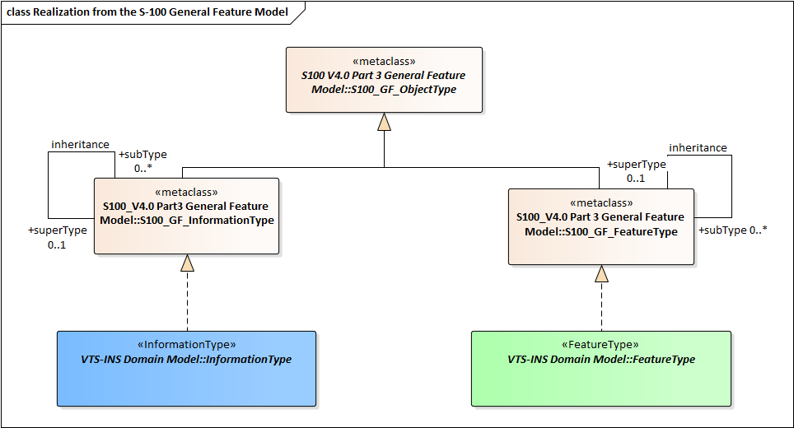
Figure 7-1 Realizations from the S-100 General Feature Model
This clause contains the Application Schema expressed in UML and an associated Feature Catalogue.

Application Schema
The UML models in this clause are segments of the overall VTS Digital Information Service application schema, and include overviews of the feature classes, information classes, spatial types, and the relationships between them.
This clause contains a general overview of the classes and relationships in the VTS Information Service application schema. Detailed information about how to use the feature types and information types to encode VTS-INS is provided in the VTS-INS Data Classification and Encoding Guide (DCEG).
The following conventions are used in the UML diagrams depicting the application schema:
- Standard UML conventions for classes, associations, inheritance, roles, and multiplicities apply. These conventions are described in Part 1 of S-100.
- Italic font for a class name indicates an abstract class.
- Feature classes are depicted with green background; the dark shade for abstract feature classes and the light shade for ordinary (non-abstract) feature classes.
- Information type classes are depicted with blue background; the dark shade for abstract information type classes and the light shade for ordinary information types.
- Complex attributes are depicted with a pink background.
- Enumeration lists and codelists are depicted with a tan background. The numeric code corresponding to each listed value is shown to its right following an ‘=’ sign.
- No significance attaches to the colour of associations. (Complex diagrams may use different colours to distinguish associations that cross one another.)
- Where the association role or name is not explicitly shown, the default rules for roles and names apply:
- The role name is ‘the<CLASSNAME>’ where <CLASSNAME> is the name of the class to which that association end is linked.
- The association name is ‘<CLASSNAME1>_<CLASSNAME2>’ where <CLASSNAME1> is the source and <CLASSNAME2> the target. In case of a feature/information association the feature is the source.
- For feature/feature or information/information associations without explicit names the source/target are indicated by an arrowhead.
- Subclasses inherit the attributes and associations of their superclasses at all levels, unless such inheritance is explicitly overridden in the subclass.

Domain Model

Overview of Domain Features and Information Types
The VTS Digital Information Service data product consists of information related to the vessel and the environment within the VTS Area, either delivered to the VTS Operator or made up of messages that the operator must deliver. The information related to the vessel is composed of static information of the vessel, dynamic information of the vessel, accident information of own ship, and status of navigational equipment. The information in the VTS Area consists of status information within the VTS Area and Warning information.
The figure 7-2 shows the overview picture of the feature and information type of the VTS Information Service domain model.
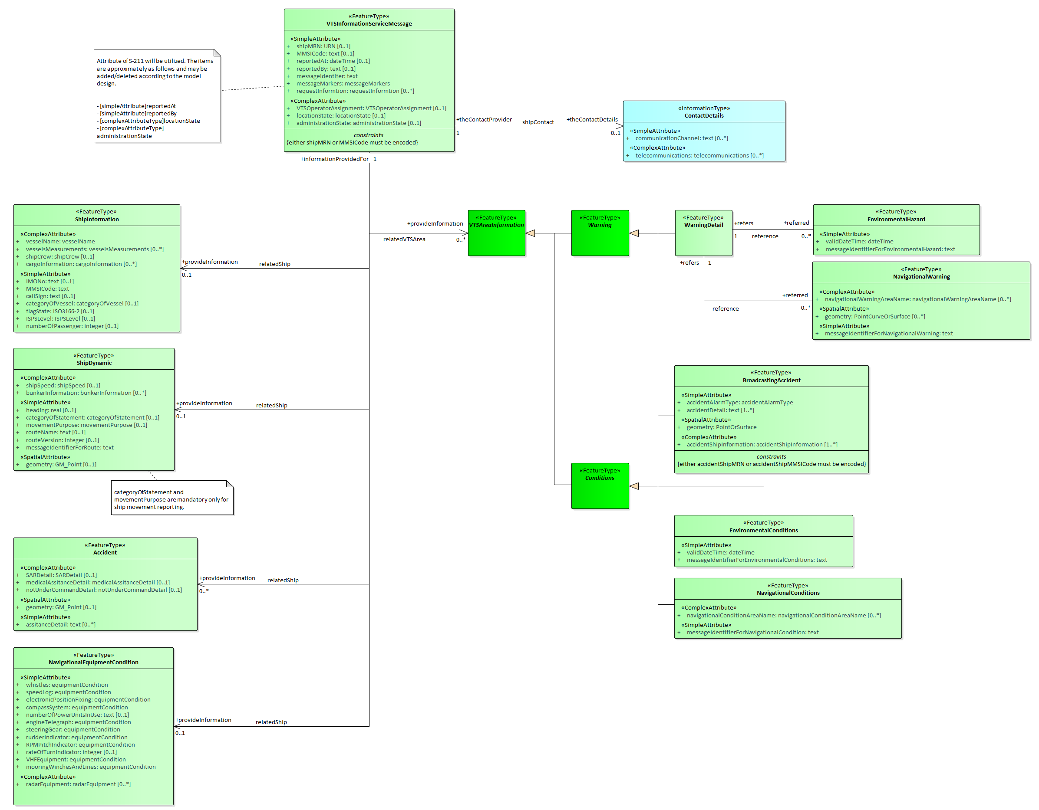
Figure 7-2 Overview of VTS-INS Feature and Information Types

- VTSInformationServiceMessage is a feature type. Classes for distinguishing information that is sent. Manage requests, responses to requests, and results of service requests, or distinguish which information is transmitted from broadcasting information. Ships can be reported to VTS in this class and transmitted with requested information, while VTS can transmit with answer information in this class.
- ShipInformation is a feature type. Static information/information that does not change when a ship is operated in one voyage.
- ShipDynamic is a feature type. Dynamic information/information that may change or change when a ship is operated in one voyage.
- Accident is a feature type. Class to communicate own vessel accident information. The purpose of this class is to provide emergency information about ship accidents prior to VTS communication.
- NavigationalEquipmentCondition is a feature type. Mechanical defects/An item to manage the condition of items to determine whether mechanical defects that can affect the normal operation of a ship are present.
- BroadcastingAccident is a feature type. Class that contains information to inform the surrounding vessel of accident information or information about the vessel requesting assistance.
- VTSareaInformation is an abstract type that collects properties common to Warning and Condition within the VTS Area, while Warning and Condition are abstract types that collect common properties of Warning and Status information within the VTS Area, respectively.
- NavigationalWarning is a feature type. Navigation warning in the VTS Area from VTS Operator. Use S-124 to get information.
- EnvironmentalHazard is a feature type. Environmental hazard Information in the VTS Area from VTS Operator. Use S-412 to get information.
- EnvironmentalConditions is a feature type. Environmental condition Information in the VTS Area from VTS Operator. Use S-412 to get information.
- NavigationalConditions is a feature type. Navigation conditions in the VTS Area from VTS Operator. Use S-127 to get information.
- ContactDetails is an information type. Information on how to reach a person or organisation by postal, internet, telephone, telex and radio systems.
- VTS Information Service Message-related Ship Information associations are modelled by the association labelled relatedShip, between classes VTSInformationServiceMessage and ShipInformation, ShipDynamic, Accident, NavigationalEquipmentCondition in Figure 7-2.
- VTS Information Service Message-related VTS Area Information associations are modelled by the association labelled relatedVTSArea, between classes VTSInformationServiceMessage and VTSAreaInformation in Figure 7-2.

VTS-INS Complex Attributes
The complex attributes in the VTS Information Service domain are provided in Figures 7-3.
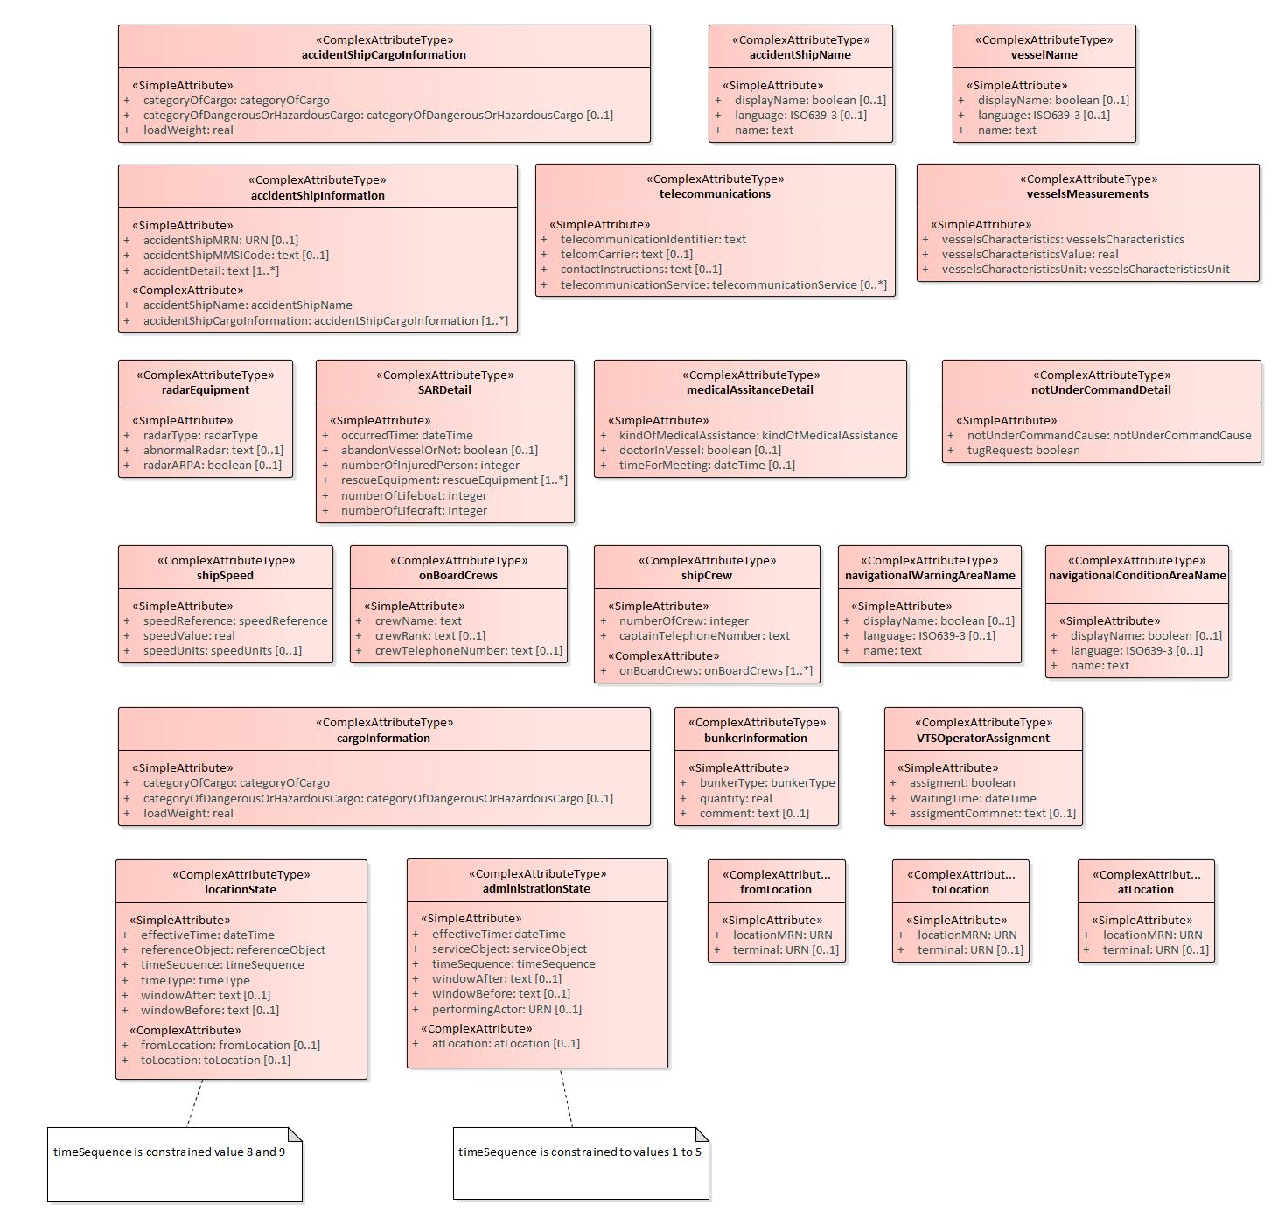
Figure 7-3 VTS-INS Complex Attributes

VTS-INS Enumerations and Codelists
For completeness, the enumerations and codelists in the VTS Information Service domain are provided in Figures 7-4.
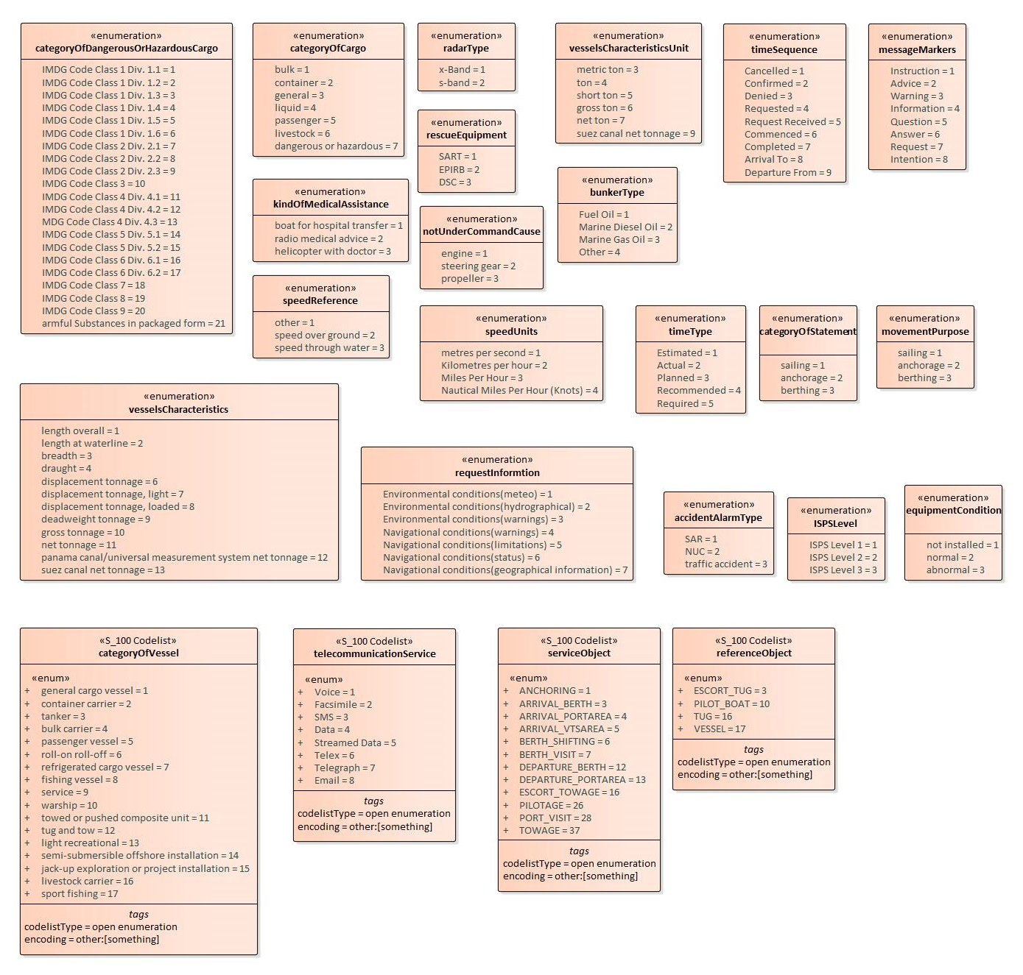
Figure 7-4 VTS-INS enumerations and codelists

Meta features application schema
This data product does not make use of meta-features.

Feature Catalogue
The Feature Catalogue describes the feature types, information types, attributes, attribute values, associations and roles which may be used in the product. The VTS Information Service Feature Catalogue is available in an XML document which conforms to the S-100 XML Feature Catalogue Schema. A printed version of the feature catalogue is provided in Annex #(TBD).

Feature Types
Feature types contain descriptive attributes and do not contain any geometry (i.e. information about the shape and position of a real-world entity). Features have two aspects – feature type and feature instance. A feature type is a class and is defined in a Feature Catalogue. A feature instance is a single occurrence of the feature type and represented as an object in a dataset. A feature instance is located by a relationship to one or more spatial instances. A feature instance may exist without referencing a spatial instance.
VTS-INS makes use of the following feature types:
Geographic (Geo) feature type – carries the descriptive characteristics of a real world entity.
Relationship feature type – A feature relationship links instances of one feature type with instances of the same or a different feature type.

Co-ordinate Reference Systems (CRS)

Introduction
The location of an object in the S-100 standard is defined by means of coordinates which relate a feature to a position. The coordinate reference system used for this product specification is World Geodetic System 1984 (WGS 84) which is defined by the European Petroleum Survey Group (EPSG) code 4326.
Spatial data are expressed as latitude (φ) and longitude (λ) geographic coordinates. Latitude values are stored as a negative number to represent a position south of the Equator. Longitude values are stored as a negative number to represent a position west of the Prime Meridian. Coordinates are expressed as real value, degree / degree decimal format. Datasets conforming to this product specification are not projected.
Horizontal coordinate reference system: WGS 84
Projection: None
Vertical coordinate reference system: None
Temporal reference system: Gregorian calendar
Coordinate reference system registry: EPSG Geodetic Parameter Registry
Date type (according to ISO 19115-1): 002 - publication

Horizontal Reference System
Positional data is expressed in latitude and longitude geographic coordinates to one of the reference horizontal reference systems defined in the HORDAT attribute. Unless otherwise defined, the World Geodetic System 84 (WGS 84) will be used for VTS-INS data products.

Projection
VTS-INS data products are un-projected.

Vertical Coordinate Reference System
VTS-INS data products do not provide detailed vertical information.

Temporal Reference System
Time is measured by reference to Calendar dates and Clock time in accordance with ISO 19108:2002 Temporal Schema clause 5.4.4.

VTS Information Service Data and Scale
VTS Information Service data must be compiled in the best applicable scale. The use of the data itself is "scale independent". That means that the data can be used at any scale. S-100 allows the association of multiple spatial attributes to a single feature instance. In principle, each of these spatial attributes can be qualified by maximum and minimum scales.
For example, it is possible, within one dataset, to have a single instance of a feature that has more than one area geometry. Each of these geometries has different scale max/min attributes. Moreover, due to cluttering in smaller scales, the scale minimum attribute may be used to turn off portrayal of some features at smaller scales.

Data Quality
VTS Information Service datasets must be validated using the conformance checks that are listed in Annex #(TBD). Prior to release by the data producer. The data producer must review the check results and address any issues to ensure sufficient quality of the data products. The checks are a mix of data format validation checks, conformance to standard checks and logical consistency checks.

Data Capture and Classification
The Data Capture and Classification (DCEG) is found in Annex #(TBD).

Data Maintenance

Data Product format (encoding)

Introduction
Detailed documentation of the VTS-INS encoding schema is provided in Annex #(TBD) of this document.
Format Name: XML, Specification: custom.
File Structure: (VTS-INS Product Specification), Annex #(TBD).

Numeric Attribute Encoding
Floating point and integer attribute values must not contain leading zeros. Floating point attribute values must not contain non-significant trailing zeros.

Text Attribute Values
Character strings must be encoded using the character set defined in ISO 10646-1, in Unicode Transformation Format-8 (UTF-8).

Mandatory Attribute Values
Some attribute values are considered mandatory for the following reasons:
- Certain messages make no logical sense without specific attributes,
- Some attributes are necessary to determine which symbol is to be displayed,
All mandatory attributes are identified in the Feature Catalogue and summarised in Annex #(TBD) – Data Classification and Encoding Guide.

Unknown Attribute Values
It is an error for a mandatory attribute value to be missing. Mandatory attributes cannot be “nilled”.
Optional attributes must be omitted altogether if the value is unknown or missing.

Structure of dataset files
A ‘dataset’ in this product is a message that consists of a single object encoded as an XML element VTSInformationServiceMessage.
This product references datasets from other standard documents (S-124, S-127, S-412, and S-421). Datasets of other standard documents do not exist separately in several files. They are nested in VTS-INS Dataset as shown in Figure 12-1 using Attributes that can function as Message Identifier.
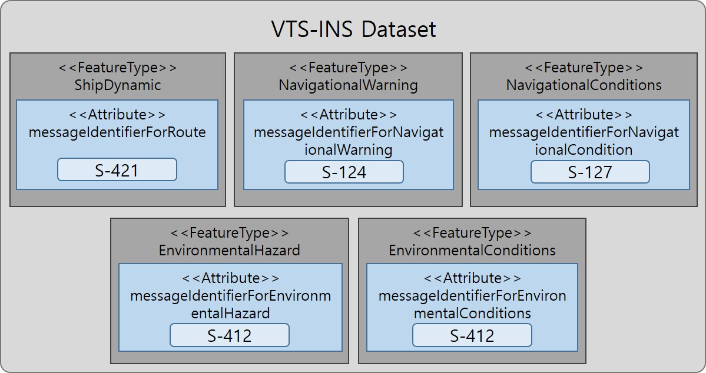
Figure 12-1 VTS-INS Dataset with Other Standard Documents
Collections of objects may be wrapped. This wrapping is out of the scope of this product specification.

Message object identifiers
Each message object is identified by a messageIdentifier based on URN format, in accordance with RFC 4122. This allows us to assign message identifiers in a distributed manner with no centralised id management and still be guaranteed that all message identifiers are globally unique. As a result, any message that is sent has an identifier. Since a VTS-INS dataset consists of a single message, the ID of the single message object in a dataset is the same as the ID of the dataset.
GML geometric primitives (inline or external) are required to have a gml:id attribute with a value that is unique within the file (dataset or collection). The gml:id values must be used as the reference for the object from another object in the same dataset or another dataset. Applications must therefore take care to generate a unique gml:id for each point encoded as coordinates.

Dataset validation
Fields may be repeated or omitted as permitted by the XML schemas and the validation tests. Since XML schema cannot encode rules for conditional presence or attributes, these rules must be checked by other validation code in the implementation.
Schematron rules are another possibility for validation code, but are not defined in this specification since the ability of implementations to integrate Schematron validation is unknown. Implementers may create and implement their own Schematron validation rules.

Location of Data Product Format schema Files
The schema file will provide a future location and is available from that location.

Detailed documentation of schema
The detailed documentation of the schema is in Annex #(TBD) (currently a separate document enclosed with this file).

Data Product Delivery
This clause specifies the encoding and delivery mechanisms for a VTS-INS dataset. Data which conforms to this product specification must be delivered by means of an exchange set.
There are only two delivery modes for VTS-INS data – single messages and collections. In either delivery mode, the content may be encapsulated into a form suitable for transmission by a mapping called a transmission encoding. An encoding translates each of the elements of the content (e.g., exchange set) into a logical form suitable for writing to media and for transmission online. An encoding may also define other elements in addition to the exchange set contents (i.e., media identification, etc…) and also may define commercial constructs such as encryption and compression methods.
Examples: REST; MIME-encoded email; zip files.
If the data is transformed (e.g., for encryption or compression purposes) its content must not be changed.
This product specification does not define the transmission encoding which must be used as a default for transmission of data between parties.

Message datasets
VTS-INS Datasets are delivered as single messages transmitted to a service broker via an appropriate delivery mechanism, e.g., REST API.
Units of Delivery: Message
Transfer Size: 10kb maximum
Medium Name: Digital data delivery
Other Delivery Information:
Each delivery packet must contain a single VTS-INS Message.
Exchange catalogues are not included.
The allowed components are as follows:
Mandatory Elements
- VTS-INS Message – XML encoding of single VTS-INS Message.
Optional Elements: None.

Collections
VTS-INS Collections are transferred as collections of messages transmitted via an appropriate delivery mechanism, e.g., REST API.
Units of Delivery: Collection
Transfer Size: 20MB
Medium Name: Digital data delivery
Other Delivery Information:
Each collection may contain zero or more VTS-INS objects.
Exchange catalogues are not included.
The allowed components are as follows:
Mandatory Elements
- VTS-INS Message– XML encoding of VTS-INS features/attributes and their associated geometry and metadata.
- Collection wrapper – as specified by the service broker API.
Optional Elements: None

Dataset distribution

Datasets
Datasets are distributed as files as described in this specification. The distribution media are left to the discretion of the producer and distributor.
The VTS Information Service product specification does not mandate implementation of the API or service broker.

Dataset size
Single messages must not exceed 10kb. Collections must not exceed 20 MB.

Dataset file naming
If VTS-INS data is communicated in the form of dataset files containing a single VTS-INS message in each file, the files shall be named <MESSAGEIDENTIFIER>.XML
Where <MESSAGEIDENTIFIER> must be upper case.

NOTE: The letter cases of the file name and the messageIdentifier encoded within the message are not guaranteed to be the same. E.g., the internal messageIdentifier may use lower case letters, or mixed case, or may have only some letters in uppercase, etc.

Support Files
The supported file types allowed for VTS-INS are files for the transfer of Route, Navigation Warning, Navigational Conditions, Environmental Hazard, and Environmental Conditions. These files are identified within the VTS-INS data set by the following attribute:
Type | Attribute Name | Attribute in Standard Documents
Simple Attribute | routeName | Using the value of S-421.Route.routeInfoName
Simple Attribute | routeVersion | Using the value of S-421.RouteHistory.routeHistoryEditionNo
Simple Attribute | validDateTime | Using the value of S-412.S412_FeatureType.validDateTime
Complex Attribute | navigationalConditionAreaName | Using the value of S-127.FeatureType.featureName
Complex Attribute | navigationalWarningAreaName | Using the value of S-124.S124_FeatureType.featureName

Exchange Catalogue
The exchange catalogue prescribed by S-100 is not used in the VTS-INS specification and is not transmitted with VTS-INS messages. This is to reduce demands on bandwidth and the complexity of generation and handling of VTS-INS.

Metadata
Metadata prescribed by S-100 is not transmitted with VTS-INS messages. This is to reduce demands on bandwidth and the complexity of generation and handling of VTS-INS.
For this reason there is no metadata defined in this specification.

Use of other standard documents in VTS-INS
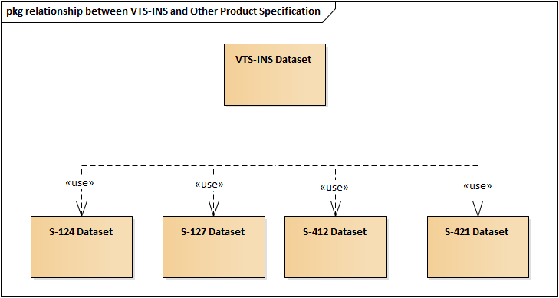
Figure 15-1 relationship between VTS-INS and Other Product Specification
The VTS Information Service uses S-421 to transmit route information and S-412 to transmit weather and environmental information within the VTS Area. And S-124 is used to transmit navigation warning and S-127 to transmit navigational conditions.
Figure 15-1 shows the relationship between VTS-INS and S-124, S-127, S-412, and S-421.

Language
The exchange language must be English. Other languages may be used as a supplementary option. National geographic names can be left in their original national language using the complex attribute Feature Name.
Character strings must be encoded using the character set defined in ISO 10646-1, in Unicode Transformation Format-8 (UTF-8). A BOM (byte order mark) must not be used.

Acknowledgements

- Data Classification and Encoding Guide
[To be developed in the next version]

- Data Product Format (Encoding)
[To be developed in the next version]
- NORMATIVE IMPLEMENTATION GUIDANCE
IALA to determine if this annex is needed.

- FEATURE CATALOGUE
[To be developed in the next version.]

- Application Schema Documentation Tables
[To be developed in the next version.]

- VTS-INS dataset validation rules
[To be developed in the next version.]

Currently being revised
To be revised
A product specification (S-210) has to be created

