Southern Positioning Augmentation Network (SouthPAN)
A Satellite-Based Augmentation System (SBAS) for the Australia and New Zealand region

Pro-forma information on SouthPAN’s L1 SBAS Open Service
(as per IALA Recommendation R.1022 (Provision of GNSS Augmentation Services for Maritime Navigation Applications, Annex B).

Date: 3 October 2023 Service Name: SouthPAN L1 SBAS Open Service
Brief Service Description: The SouthPAN L1 SBAS Open Service is intended to provide improved Position, Navigation, and Timing (PNT) capabilities to end-users in the Australia and New Zealand region. These capabilities are available to SBAS-enabled GNSS receivers.
For maritime users, the SouthPAN L1 SBAS Open Service supports navigation in ocean and harbour entrances, harbour approaches and coastal waters.
More information on the service, including a fact sheet, is available at:
Australia
https://www.ga.gov.au/scientific-topics/positioning-navigation/positioning-australia/services-and-tools
New Zealand
https://www.linz.govt.nz/southpan
Service Providers Names
Geoscience Australia and Toitū Te Whenua, Land Information New Zealand
Service Providers Addresses
Corner Jerrabomberra Ave and Hindmarsh Drive, Symonston ACT 2609, Australia
and
Level 7, 155 The Terrace, Wellington 6011 (or PO Box 5501, Wellington 6145), New Zealand
Contact Number: 1800 800 173 (Australia) and 0800 665 463 or + 64 7 974 5595 (New Zealand)
Contact e-mail: clientservices@ga.gov.au and southpan@linz.govt.nz
☒ We confirm that the service offered is operational and available for use by maritime stakeholders (mariners, maritime authorities and other relevant parties).
☒ We confirm that the service is intended to be provided in a continuous way until further notice.
☒ We confirm that any future changes in the GNSS augmentation service should not affect legacy users of the service.
☒ We will confirm our commitment to update the information provided should any change occurs that modifies the characteristics of the service and/or requires mariners to update their equipment.
Information relating to the commitment of the service provider (to include the service area and level of availability, accuracy, continuity, integrity etc.) can be found at
SouthPAN Service Definition Document for Open Services, which is available at https://www.ga.gov.au/southpan or https://www.linz.govt.nz/southpan
Terms and conditions to access the service can be found at
SouthPAN Service Definition Document for Open Services, which is available at https://www.ga.gov.au/southpan or https://www.linz.govt.nz/southpan refer to pages 2 and 3.
The service complies with the following specifications and/or requirements
ICAO Annex 10 Volume I, RTCA DO-229F

Service provision characteristics
GNSS and frequencies supported
US NAVSTAR GPS L1 Coarse/Acquisition (C/A) code.
The service is available within the following geographic service area:
- For navigation applications meeting the operational requirements of IMO Resolution A.1046(27) in ocean waters, the L1 SBAS Open Service area is defined by the satellite footprint shown in the diagram below.
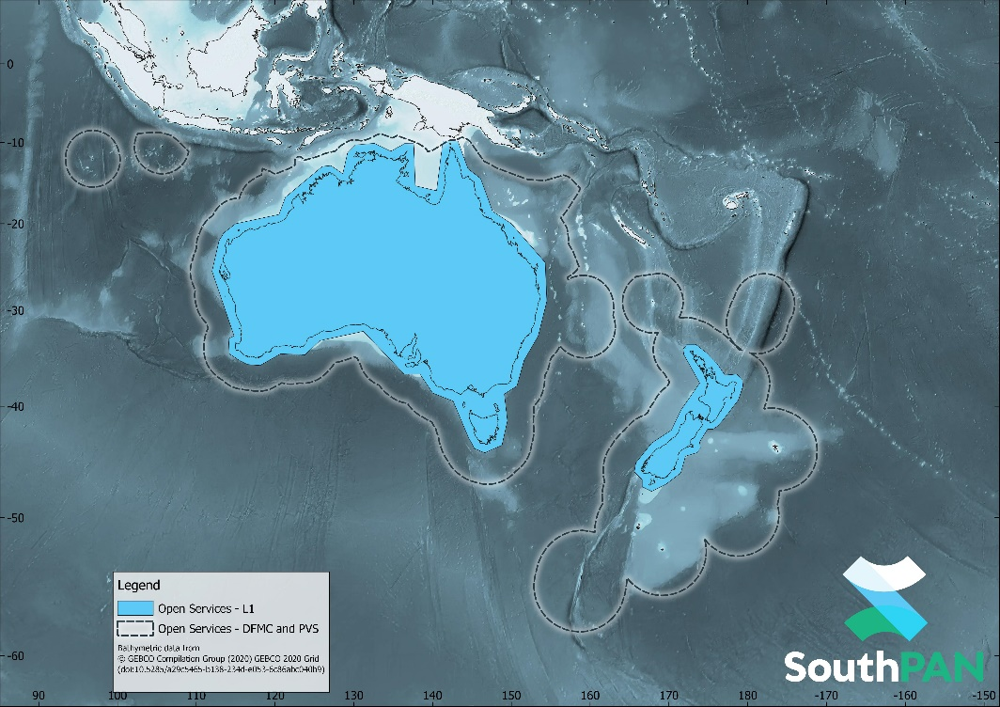
- For navigation applications meeting the operational requirements of IMO Resolution A1046(27) in harbour entrances, harbour approaches and coastal waters, the L1 SBAS Open Service area is defined by the coastline and 50 nautical miles off the coastline of mainland Australia, Tasmania and New Zealand.
The expected performance in terms of accuracy, availability, continuity and integrity along with any applicable performance specifications or requirements (i.e IMO A.1046(27)):
Horizontal accuracy (95%) better than 3 metres, vertical accuracy (95%) better than 4 metres, service availability better than 95%.
SouthPAN is designed to meet aviation (ICAO) performance standards. Suitably equipped maritime receivers should be able to receive and use SouthPAN’s messages for integrity warnings. At this stage, there are no commitments for service continuity.
These performance requirements can be met with an SBAS-enabled GNSS receiver that conforms to RTCA DO-229F.
Augmentation data is provided in the following format(s) and corresponding communication method
Message format in accordance with ICAO Annex 10 Volume I and RTCA DO-229F, with deviations as described in the SouthPAN Service Definition Document for Open Services.
SouthPAN’s L1 SBAS navigation signal is broadcast from a single satellite payload in Geostationary Earth Orbit located at 143.5°E, transmitting with the Pseudo Random Noise code of 122.
Information regarding service outages, degraded performance or planned maintenance periods will be/is made available to mariners within the service area by the following method(s) (provide details on the communications and/or MSI channels)
Refer to any Maritime Safety Information issued by the Australian Maritime Safety Authority (AMSA) for NAVAREA X
https://www.amsa.gov.au/safety-navigation/navigation-systems/maritime-safety-information-database
or
Maritime New Zealand for NAVAREA XIV
https://www.maritimenz.govt.nz/navigational-warnings
Any other information relevant to the general use of the service
The L1 SBAS Open Service is currently not available for use in safety-of-life applications. Safety-of-Life Services are anticipated to be available in 2028.
Please refer to the SouthPAN Service Definition Document for Open Services or contact Geoscience Australia or LINZ for further information.
*****

