From: DTEC | DTEC1-12.3.1.2
To: VTS | 5 October 2023

LIAISON NOTE

VTS Digital Services Architecture Development

INTRODUCTION
DTEC received a draft digital service architecture from VTS Committee - with the purpose of getting DTEC's view/opinion on the architecture, which incorporates several guidelines developed in DTEC (ENAV).

VTS digital services architecture
DTEC was presented and discussed - and the following points were made:
- Specify that referencing to SECOM includes both the security aspects and the SECOM API
- Notice that the wireless domain might be between equipment on the ship and SECOM service for the ship
- Explain the coloured arrows - or change arrows to be in the same colour. Preferably use the same colour in order to reduce the complexity of the drawing.
- Connect or join the two blue boxes named 'VTS navigational services for MASS' and 'VTS navigational services for ECDIS/MASS', since the navigational MASS services are merely an extension of the set of services to ECDIS.
- Consider clarifying the role and naming of the Platform services as enablers for the Digital delivery of VTS Information
- Consider splitting the (rather complicated) drawing into two:
  - A technical architecture – Focusing on the technical components (Services for ECDIS/MASS, other ship systems, non-standard services...)
  - Specification oriented drawing - Derived from technical architecture and highlights the role of different types of specifications related to various architectural elements (Product specifications, technical services, SECOM, MCP specifications...)
- Consider leaving digital delivery for External stakeholders out of the technical architecture drawing to make it less complex “Digital delivery of VTS Information for Ships” – or create separate drawing highlighting the digital delivery with External stakeholders
Below is a proposed updated drawing - which would be the technical architecture view in the document:
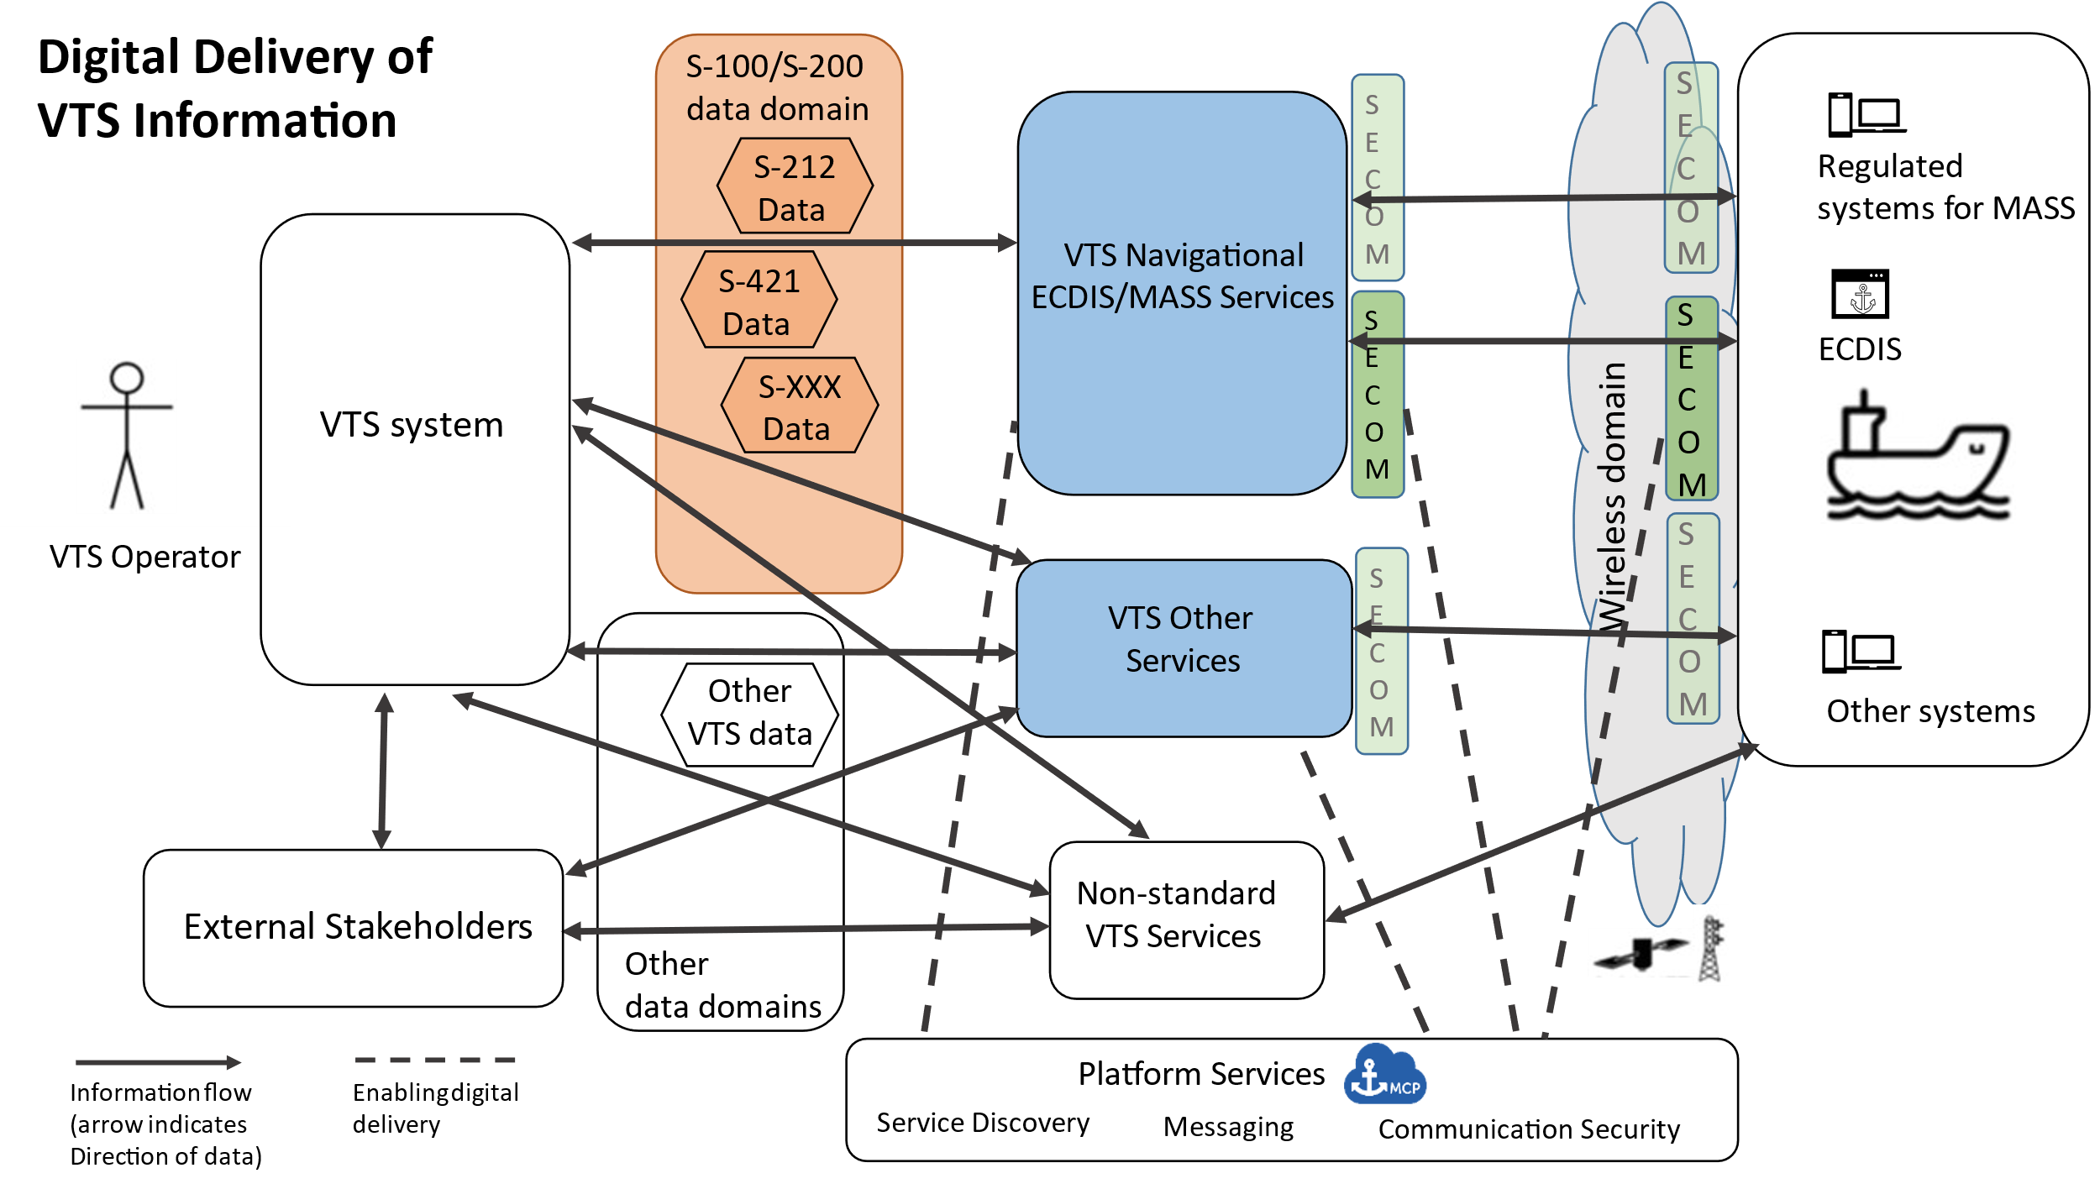

ACTION REQUESTED
VTS is encouraged to update the architecture document, taking the comments above into account.

