IALA Guideline

Gnnnn
Guideline ON Inter-VTS Data Exchange

Edition x.x
Date (of approval by Council)

urn:mrn:iala:pub:gnnnn
Revisions to this document are to be noted in the table prior to the issue of a revised document.
Date | Details | Approval

1. SECTION 1 – HEADING 1 STYLE 2
1.1. Section 1.1 – Heading 2 style 2
1.1.1. Section 1.1.1 – Heading 3 style 2
2. SECTION 2 – HEading 1 style 2
2.1. Section 2.1 – Heading 2 style 2
3. Section 3 – Heading 1 Style 2
3.1. Section 3.1 – Heading 2 style 2
3.2. Section 3.2 – Heading 2 style 2
3.3. Section 3.3 – Heading 2 style 2
3.3.1. Equations 2
4. DEFINITIONS 2
5. abbreviations 2
6. references 2
7. Further reading 2
APPENDIX 1 Example of appendix Title (Head 1) style 2
ANNEX A Example of Annex title (Head 1) style 2

List of Tables
Table 1 Example of table with row headers 2
Table 2 Example of table with column headers 2

List of Figures
Figure 1 Example of wrapping in line with text 2
Figure 2 Example of wrapped square 2
Figure 3 Example of how to achieve right justified equation number 2

Introduction

The IVEF Service is intended to provide a common framework for the exchange of vessel traffic image information between shore-based e-Navigation systems, such as VTS systems, e-Navigation stakeholders and relevant external parties.
Figure 1 shows such a situation, where VTS centres share information about the common operational area and also to relevant other users and authorities.

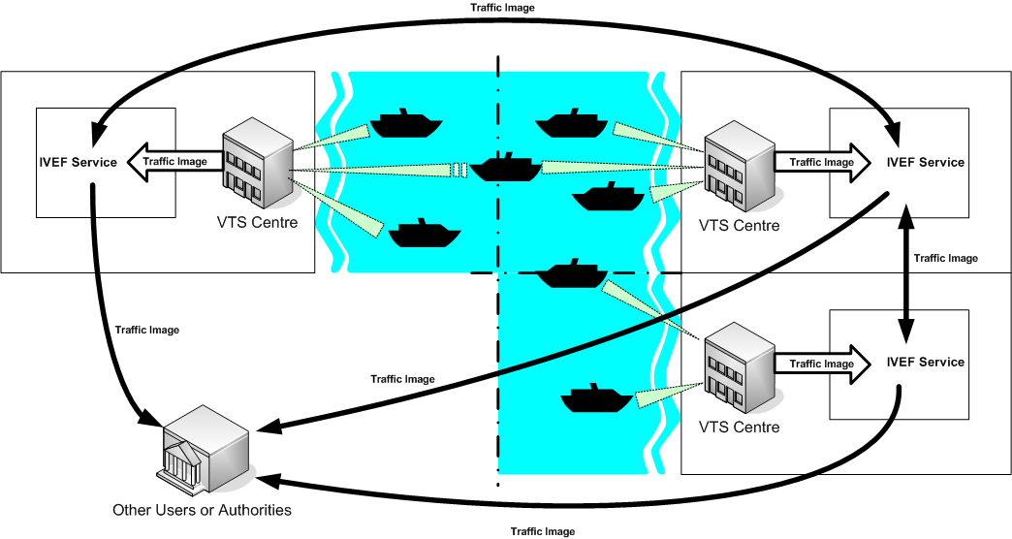
- The IVEF Service in operation
The IVEF Service is client/server-based. Clients make a connection to a server, running the IVEF Service and receive traffic image data according to their specific preferences and authorisations (Figure 2). Different clients may specify different data requirements, such as the area of interest, the update frequency and the particular traffic objects that are relevant to them. Based on the client credentials, the IVEF Service will enforce restrictions on the data that is being served to the client. These restrictions can be specified by the data provider.
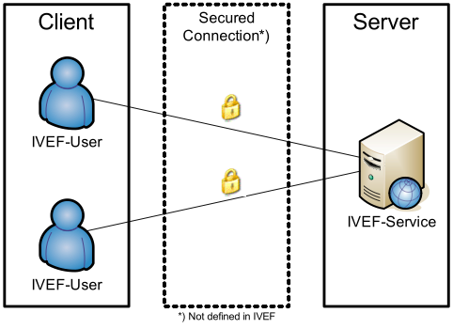
- The IVEF Service Client/Server Model

The IVEF Service as described by other IALA Recommendations

The IVEF Service is a gateway service, as contained in the general description of the common shore-based system architecture in the ‘IALA Recommendation on Shore-based e-Navigation System Architecture’ [see reference [1]]. Such a gateway service is specialised in data exchange shore-to-shore. It interfaces to other e-Navigation systems and to external systems of ‘third parties’. These systems may request the IVEF service to forward relevant data to them. A IVEF service can interface shore-based systems locally, nationally, regionally, and globally.

Service Model of the IVEF Service

Overview

The IVEF Service provides the link between technical e-Navigation Services and VTS as the shore-based front-end of Maritime Services in the context of e-Navigation. IVEF can also be used to provide other stakeholders with a maritime surface picture.

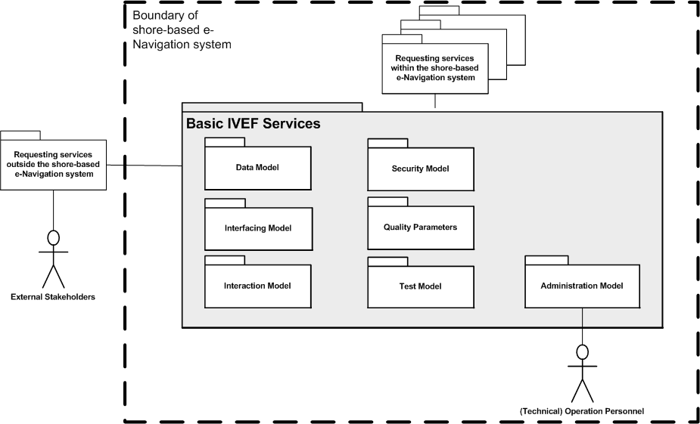
- The IVEF Service Model
R0145 is the top-level document for the IVEF service referring to this guideline and the relevant product specifications under S-210. This guideline provides all the information needed to deploy the service.
The IALA Product Specification S-210 describes the interface aspects as follows:
Data Model: the abstract descriptions of the data, provided by the IVEF Service, are part of the S-200 registry. It unambiguously defines the data types and data objects of the IVEF Service.
Interaction Model: the dynamics of the interaction of individual components of the IVEF Service (data flow and protocol).
Interfacing Model: the data encoding and interface protocols between the provider of the IVEF Service and the clients, requesting data from the service.
Security Model: control of access to the IVEF Service (filtering and access rights).
Quality Parameters: performance and reliability considerations of the IVEF Service.
Test Model: test and validation of the IVEF service.
Administration Model: the technical administration and maintenance aspects of the IVEF Service.
A full description of all these aspects follows in the remainder of this document.

Capabilities of the IVEF Service for the Shore-based e-Navigation System

Introduction
The IVEF Service is an optional part of a shore-based e-Navigation system. Its basic purpose is to provide a vessel traffic image to related vessel traffic service systems, to e-Navigation stakeholders and to relevant external parties. Any IVEF Service provides, at least, the so-called Basic IVEF Services (BIS). A particular characteristic of the IVEF Service is that these services are only rendered on request of another e-Navigation system or of an external system, i.e. the IVEF Service follows the client/server model as already described in the introduction of this specification (Figure 3).

Basic IVEF Services (BIS)
There is only one basic IVEF service, which is
Vessel Traffic Image Data Exchange Service – deliver vessel traffic situation data, according to a specific service profile. Such a service profile determines e.g. the data items delivered, the area of interest and the update rate.
The IVEF Service is part of the e-Navigation Client/Server-based architecture. A general way of describing communication architectures is via the ISO/OSI reference model [3], which describes communication between applications through a layered model. Each higher-level layer in this model increases the level of abstraction. The communication between client and server is described here at the so-called ‘application layer’ in the reference model. The implementation of the lower layers is not discussed here. It is only suggested to use a secured and reliable link between the client and server.

General Use Cases
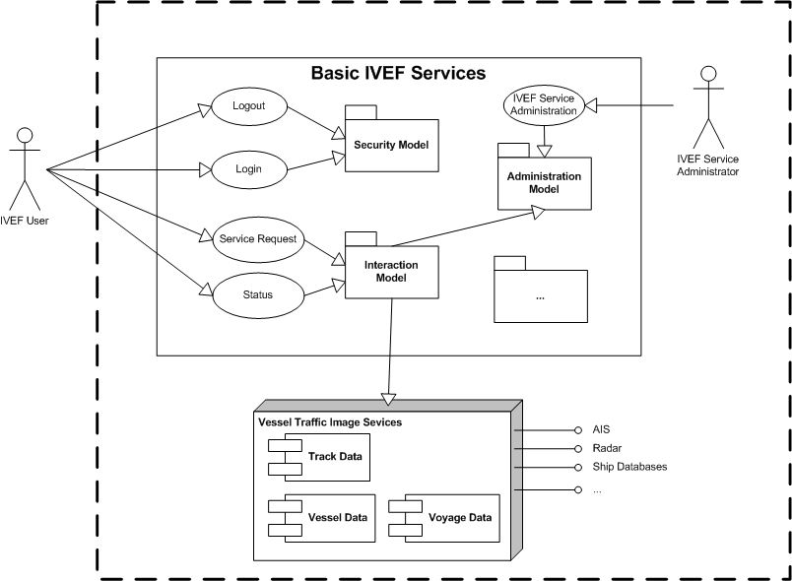
- IVEF Service Primary Use Case

Data Model of the IVEF Service

Introduction
The Data Model of the IVEF Service will be part of the IALA Universal Maritime Data Model (IALA UMDM), as described in [1]. It provides the well-structured and abstract (functional) description of the data that is exchanged through the IVEF Service.
The Data Model itself does not contain data encoding information which is required to create an actual implementation of the service. Separating the data encoding from the Data Model of the IVEF Service provides flexibility in selecting an encoding technique as deemed appropriate by the competent authority. A portfolio of suitable encoding techniques for data objects of the IVEF Service is given in section 3.6 on the Interfacing Model.

The Place of the IVEF Service in the e-Navigation Architecture
Figure 5 illustrates the place of the IVEF Service in the e-Navigation architecture as described by IALA Recommendation on the e-Navigation Architecture – the Shore Perspective [1]. It clearly identifies the co-operative nature of the shore-based IVEF Service. Note that the IVEF Service shares the dependencies of the e-Navigation architecture.

Shore-based e-Navigation system

IVEF
Service
VTS 1
Integrated
Bridge

Wireless
Communication
Ship’s
sensors
Shipboard
Applications

Sensor
Data

VTS
Application 2
Application 3
Application 4
- The Place of the IVEF Service within the e-Navigation architecture
There may be many client-server-relationships, since the ‘gateway services’ of the shore-based e-Navigation system may be requested by other e-Navigation services within that system, there can be identified. These client-server-relationships can be combined into a hierarchy within the shore-based e-Navigation system (see Figure 6, which is derived from reference [1], Figure 5).

- Client-server relationships of the IVEF Service with other shore-based e-Navigation service (see reference [1], Figure 5)

Interaction Model of the IVEF Service

Context
IVEF Service Interfaces are point-to-point connections between e-Navigation Gateways. One Gateway acts as an information source whereas the other Gateway acts as an information sink.
Note that the IVEF Service by itself has no provisions for data compression and encryption. IVEF describes the data exchange format between e-Navigation applications; it relies on transport layers underneath to convert between physical, electrical and network interfaces. Additional transport layers may add data compression and encryption, depending on the system requirements (see Figure 7).

eNav Gateway
Information Source
eNav Gateway
Information Sink
IVEF
Service
IVEF
Client
Compression
e.g. ZLIB
Decompression

Encryption
e.g. TLS/SSL
Decryption
Transport
e.g. TCP/IP
- The Communications Stack
The justification for this approach is the fact that these transport layers are already well-defined and standardised. Furthermore, standard compression and encryption algorithms are readily available.

See section 6 - Definitions.

