IALA Guideline

GXXX

Human Factors and Ergonomics in VTS

Edition x.x
Date (of approval by Council)

Revisions to this IALA document are to be noted in the table prior to the issue of a revised document.
Date | Details | Approval
 |  | Council xx

1. INTRODUCTION 4
1.1. BACKGROUND 4
1.2. AIMS AND OBJECTIVES 4
2. VTS as socio-technical systems 4
2.1. Characterisics of a socio-technical system 5
3. Human factors and ergonomics 6
3.1. Human - Technology - Organization (HTO) 7
4. Human Factors in VTS operations 7
5. What can we do and how 9
5.1. How to do it 9
5.1.1. Methods and measures? 9
6. DEFINITIONS 10
7. ACRONYMS 10
8. References 11

List of Tables
Table 1 Characteristics of a socio-technical system (adopted from Vicente, 1999) applied to VTS 6
Table 2 Human factors in VTS 8

List of Figures
Figure 1 VTS Operator in northern European VTS centre 5
Figure 2 Three main areas of human factors and ergonomics (adopted from IEA) 6
Figure 3 Figure 3: Potential enefits of HTO-approach (adopted from ??) 7

List of Equations [List of Figures]
Equation 1 (insert editable equation) 5
Equation 2 (insert editable equation) 5

INTRODUCTION

BACKGROUND

IALA conducted a workshop on Human Factors and Ergonomics in VTS at Chalmers University of Technology in Gothenburg, Sweden (12 - 16 October 2015), in conjunction with Chalmers University of Technology, the Dutch VTS Operator Training Foundation and the Port of London Authority. A conclusion of that workshop highlighted the need for guidance on raising awareness about safety culture and human factors, including incorporating the work into existing and developing IALA documentation.
The IALA VTS Committee has been tasked with developing guidance on human factors and ergonomics in VTS. The objective of this task is to provide awareness regarding the role of the human factor in the performance of a VTS to competent authorities and VTSOs. In addition, this guidance would support the implementation of human factors in the training cycle of initial training, sector training, recurrent training, updating training and adaptation training.
This document builds upon previous work to further develop VTS guidance on human factors and ergonomics. Within the scope of this work the VTS is identified and understood as a complex socio-technical system where operators, organization and technology and the interactions between them play a crucial role for quality, safety and efficiency of VTS services. Human factors and ergonomics here is understood as a framework that can help to categorise information about work and work settings, how to collect information about a work setting, what to do to make it better, and how to explain and measure the possible benefits to the change.

AIMS AND OBJECTIVES

This Guideline provides awareness regarding the role of the human factor in the performance of a VTS to competent authorities and VTSOs. Furthermore, this guideline provides guidance in implementing human factors in the training cycle of initial training, sector training, recurrent training, updating training and adaptation training.
[Body text] [To discuss – any further text required for the aims and objectives? Note past discussion on fatigue and impact on human performance – is this suitable for this document? Fatigue shows up in the human factors table in this document, but there is no further information on fatigue or fatigue management. ]
[Further information/definition on what human factor is?
What else do users expect from this guideline:
Include procedures for new developments for:
- Software design: user experience testing/exercise
- Ergonomics
- Eye-tracking devices:
Fatigue mgmt:
- Fatigue is directly related to people’s health => need for medical and physical examination
- Max of hours behind a desk
- Max of hours of a shift
- Max amount of sequent shifts
- How do changes influences fatigue or mental fatigue
- Impact of Mental fatigue: mental effort to remain alert could lead to more
- Differences in age may influence performances or getting used to changes
Stress management
- How will this affect the operational performance and increase their fatigue or psychological health?
- Impact of traumatic experiences: lasting impact of incidents if they are not being dealt with. This may cause a higher amount of stress. Critical Incident Stress Management (Teams). Its counselling, 1/1, helps immediate processing. Is separated from the general incident investigation?
- Stressful environment in VTS

VTS as socio-technical systems

Traditionally, technological advancements have been a driver for research and development activities in the VTS domain. Thus, many activities have foremost focused on the development of technical equipment and information sources within the domain. However, in the past 15 years an increasing body of work has taken a human factors approach rooted in a socio-technical systems perspective to increase the understanding for interactions across operators, technology and organization. In recent years, an increased focus on future VTS operation and the potential of human-autonomy interactions within shore operation centers has developed.
VTS can be considered as a socio-technical system where operators provide services to a larger variety of customers. While staffing and local organization might differ, VTS is very often, but not always, part of a port system including VTS, pilot, tugs, ship/s and crew/s. Studies have shown that all the actors in this system need the same information but perhaps at different levels of granularity. Thus, coordination and cooperation among the different actors within the port system becomes a key for the service’s quality, and the overall safety and efficiency of traffic movements within the area.
Figure 1 draws attention to the complexity of the work environment for VTS operators. The operator provides information services in an area that is located on the port entrance of one of northern Europe’s largest ports. Within the center the operator is collocated with operators for the pilotage ordering service and the port. Thus, information for service provision can be gained both through the decision support system, VHF radio and from other services.
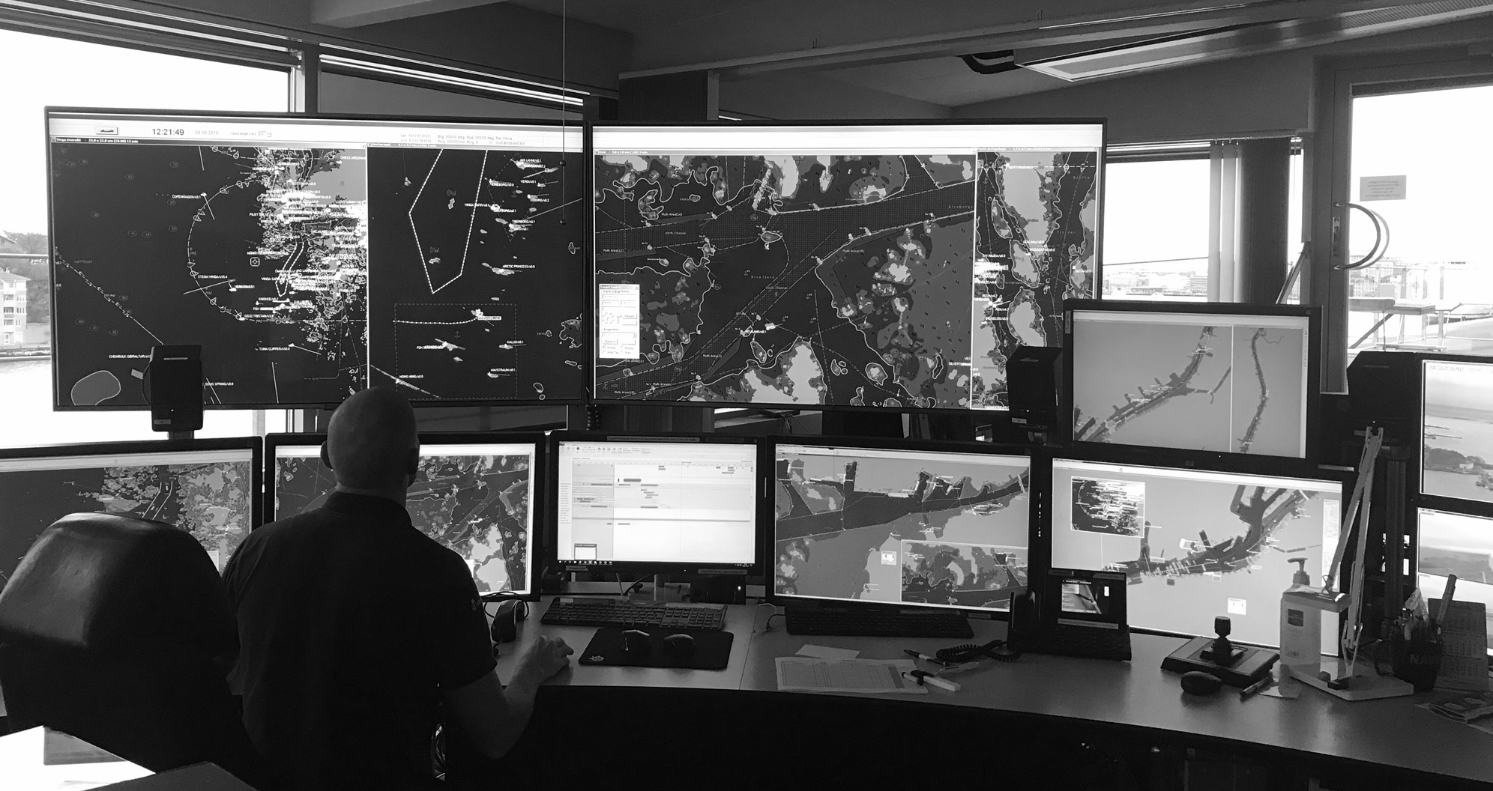
- VTS Operator in northern European VTS centre

For the service provision to the vessels, the information from all the different sources available are merged by the operator thus drawing attention to both physical, such as proximity to other services or workstation layout, and cognitive aspects, e.g. decision making, interpretation of current traffic picture in the VTS area, of VTS everyday work. Therefore, the operator’s expertise and experience based on technical and non-technical skills become crucial for the service provision . In addition to the physical and cognitive aspects of the work, the organizational framework of the VTS, including training, service and staffing levels, operational procedures and integration with other services, also shape the precondition of work.

Characterisics of a socio-technical system

Table 1 presents an overview of the characteristics of VTS as a socio-technical system. As there are many different organizational, human and technical aspects to the VTS operations, human factors and ergonomics become an important facilitator to design a system that is able to balance quality, safety, efficiency and economic aspects of operations.

- Characteristics of a socio-technical system (adopted from Vicente, 1999) applied to VTS
Characteristic | VTS
Interactions of various layers | VTS interactions with vessels, allied services, agents
Large problem space | Complexity of everyday work based on uncountable number of variables (ship-related, environmental, geographical etc.)
Dependence on communication and coordination | VHF as main means of coordination through communication between vessels and shore services
Distributed | Ship-side and shore-side important as vessel are autonomous in their navigation
Dynamic | VTS is evolving (e-Navigation, push towards MASS)
Mediated communication | VHF, mobile phones, email, decision support system
Couplings | Complex net of technical, human and organisational functions
Automation | Increased automation based on strategies pushing technical innovation, i.e. e-Navigation, Sea Traffic Management, MASS

Human factors and ergonomics

Human factors and ergonomics (HF/E) describe the scientific discipline and domain of practice concerned with the understanding of interactions among humans and other elements of a system, and the profession that applies theory, principles, data, and methods to design in order to optimize human well-being and overall system performance (https://iea.cc/what-is-ergonomics/).
Hence, HF/E is a systems approach to understand human work in complex environments. Human factors and ergonomics as terms are used interchangeably, with the first one often referred to in American settings, while the latter is more commonly used within Europe. As approach, HF/E is holistic and concerns the design and evaluation of tasks, jobs, products, environments, and systems (https://iea.cc/what-is-ergonomics/) taking physical, cognitive and organisational factors into concern (fig 2). Work and work settings are analysed taking human operators, systems and work environment into concern.
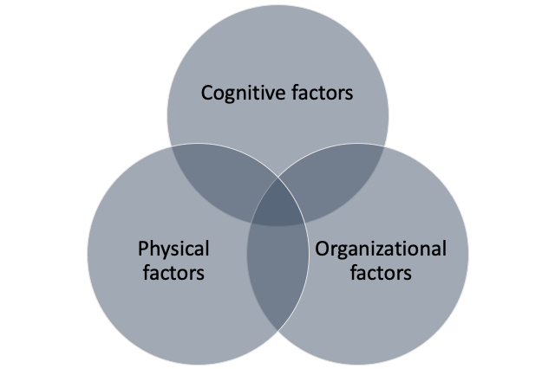
- Three main areas of human factors and ergonomics (adopted from International Ergonomics Association ( IEA)

Cognitive factors of ergonomics and human factors concern functions related to perception, memory, reasoning and motor responses, human-computer interaction, communication, and teamwork. Physical aspects refer to human anatomy, physiology, anthropometrics and biomechanics, while organizational factors address participation, cooperation and the environment in which the socio-technical system is operating.
The HF/E model is good for reminding us of all the aspects of a system. However, what was frequently underspecified is the overlapping areas - the indications of interactions between the parts of a system.

Human - Technology - Organization (HTO)

The human-technology-organization is an analytical framework within the human factors domain. The approach is rooted within the nuclear power domain. It was in the late 1990s as a response to the increasing need to create a deeper understanding for the complex interplay between human operators, technology and organization in safety critical operations . The HTO perspective emphasizes the importance of understanding the interactions and interdependencies between a sociotechnical system’s human, technical and organizational parts. Since the late 1990s this perspective has gained an increased acknowledgement and is now applied across many different industries.
Within this document, we suggest adopting a H-T-O perspective with specific focus on system performance can be understood and support operator well-being. The benefits of applying an HTO-perspective to system design and analysis are exemplified in figure 3. The figure shows potential improvements in three categories; Human, Technology and Organisation.

Human:
- Improved wellbeing of staff
- Improved effectiveness of personnel
- Improved communication
- Safety work conditions (physical and psychological
Technology:
- Support tasks – effectiveness and efficiency
- Increased efficiency in equipment and tool use
- Improved training and procedures
- Fewer errors
Organisation:
- Increased productivity and effectiveness
- Improved management of risk
- Reduced costs for training and service provision
- Increased safety

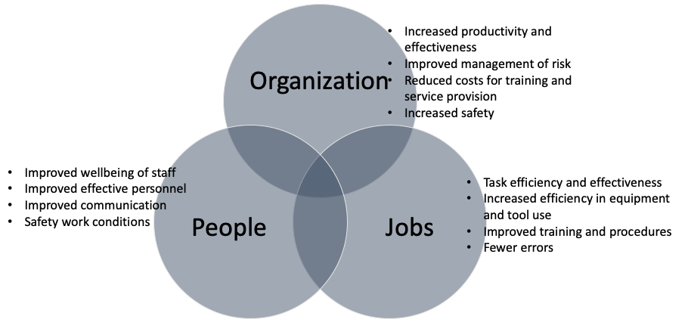
- Figure 3: Potential benefits of HTO-approach (adopted from ??)

Adopting an HTO to the VTS, may help to structure discussions on how (work) environment, technology, operator and organization are coupled to each other and emphasize the need to acknowledge the interactions and interdependencies among these shape the precondition for safe and efficient service provision in the VTS domain.

Human Factors in VTS operations

As aforementioned, VTS can be considered as a complex socio-technical system. There are multiple aspects, which may affect operator work, system performance and operator well-being. The following table presents key areas to address within the design, evaluation and assessment of VTS systems based on the HTO framework.
To acknowledge the difference between VTS systems world-wide, a fourth category, Environment, has been added to the list below as service provision, service level and demands may vary.
These factors are taken into consideration noting the VTS Operational area, including the area specific aspects of the fairway, traffic, meteorological and hydrographic elements.

- Human factors in VTS
Category | Key Areas to Address
Human | - Performance measures and shaping factors (workload, stress, fatigue)  - Attitudes and commitment  - Technical (expertise/operational experience, e.g. conflict detection and management, service provision) and non-technical skills (communication, decision-making, situation awareness/sensemaking, leadership, teamwork, task management, problem solving, creativity)
Technology | - Human-centered design  - User needs  - Information presentation/representation  - Level of automation and human-automation interaction  - Information structure and integration of sensors within the VTS system
Organization | - Preconditions for work (work schedule, staffing, selection criteria)  - Resilience/High Reliability  - Procedures – SOPs etc.  - Training provision  - Training needs analysis  - Assessment and evaluation techniques  - On the job training  - Safety and quality management  - Appraisal procedures  - Reporting system (e.g. incidents/accidents) and follow-up procedures including organizational learning  - Workplace design  - Workstation design  - Physical workstation arrangements/spatial design  - Light, noise, temperature  - Operational environment/ service integration within port system

What can we do and how

[text]
Doing the best you can with limited resources and time…
Task analysis,
Match the HTO table, assessing the H part; the T part; the O part.
Do references to the literature
Provide practical tools
Generic text about interviewing / start with how the job is conducted (start with the users)
Medical and physical examinations
Fatigue management
Critical Incident Stress Management (in order to help VTS personnel after an accident)
Install Change management (in order to help VTS personnel through changes in their environment)
Mental health
Drug and alcohol policies
Policy around the use (for private matters) of smartphones, portables, tablets, …

How to do it

•Multi-disciplinary design teams.
•Active involvement of users
•A clear understanding of task requirements;
•Iteration of design solutions and evaluations;
[summary of the human centered design concept]

Methods and measures?

•Efficiency, effectiveness, user satisfaction (KPIs?)
Connect to PJO model?

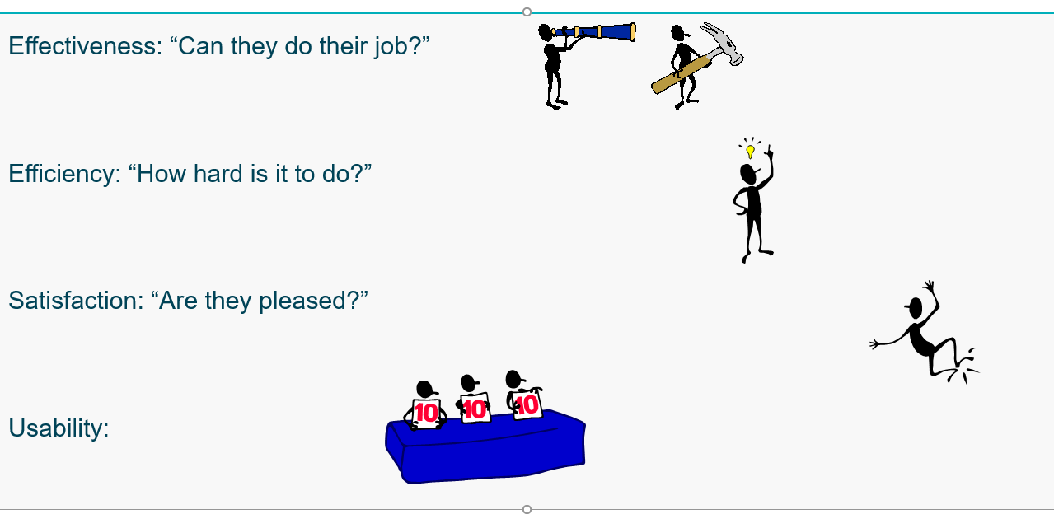

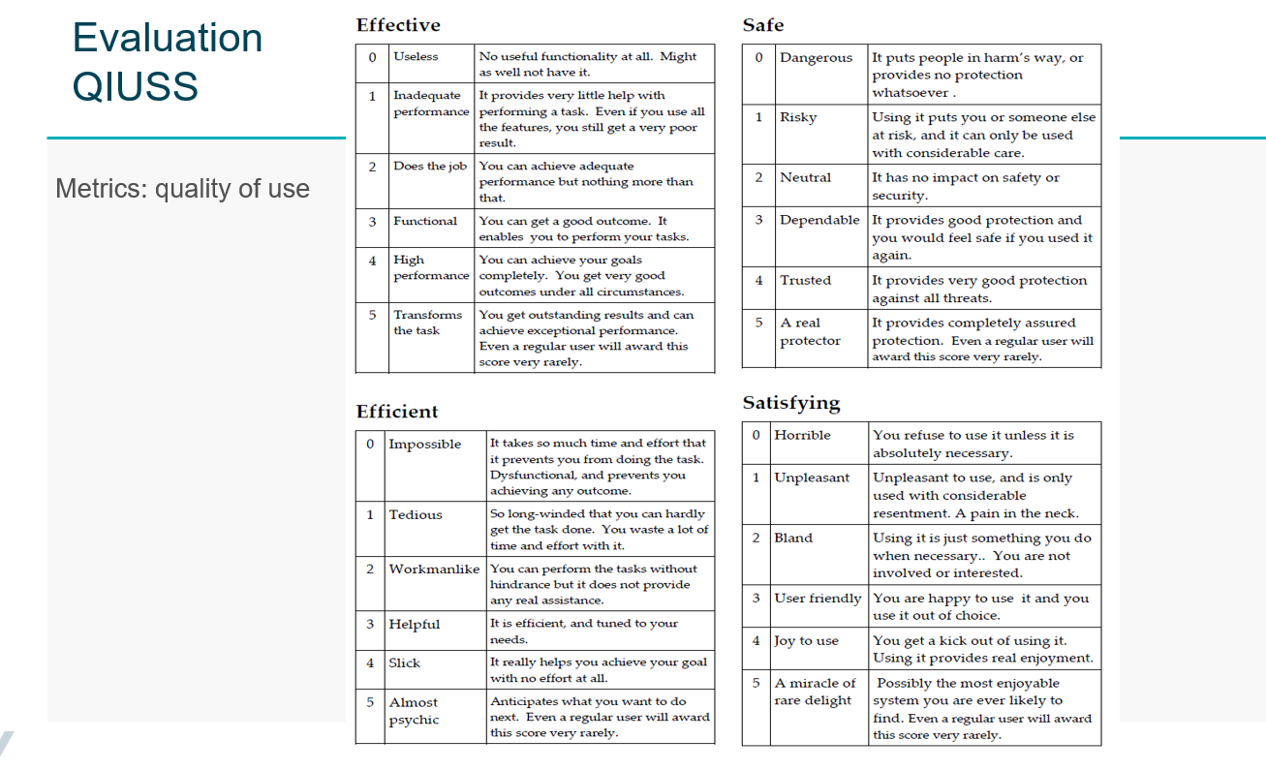
Quality in use scoring scale – Brian Sherwood-Jones

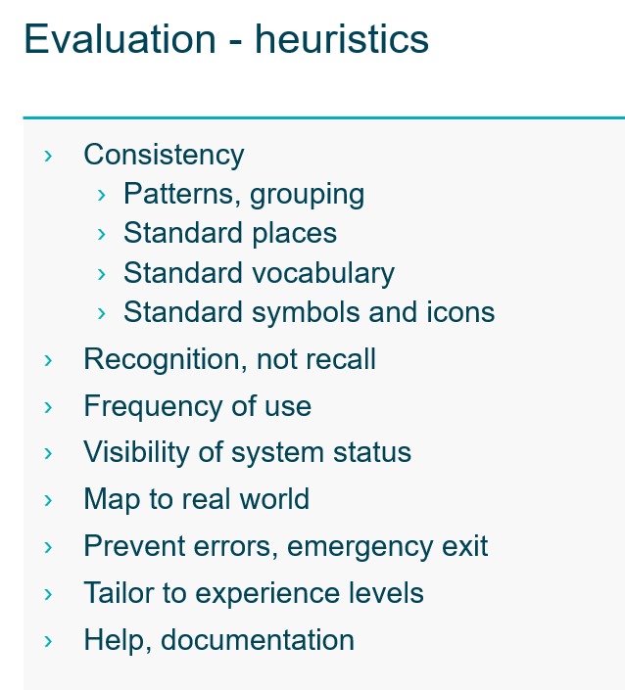

DEFINITIONS

The definitions of terms used in this Guideline can be found in the International Dictionary of Marine Aids to Navigation (IALA Dictionary) at http://www.iala-aism.org/wiki/dictionary and were checked as correct at the time of going to print. Where conflict arises, the IALA Dictionary should be considered as the authoritative source of definitions used in IALA documents.

ACRONYMS

[Acronym] [Acronym]
[Acronym] [Acronym]
… …

References

- Brodje, A., Lundh, M., Jenvald, J. et al. Exploring non-technical miscommunication in vessel traffic service operation. Cogn Tech Work 15, 347–357 (2013). https://doi.org/10.1007/s10111-012-0236-5
- Costa, N.A., Lundh, M. & MacKinnon, S.N. Non-technical communication factors at the Vessel Traffic Services. Cogn Tech Work 20, 63–72 (2018). https://doi.org/10.1007/s10111-017-0448-9
- International Ergonomics Association () What is ergonomics? https://iea.cc/what-is-ergonomics/ ; retrieved 2020-08-20
- Karltun, A., Karltun, J., Berglund, M., & Eklund, J. (2017). HTO – A complementary ergonomics approach. Applied Ergonomics, 59, 182–190. https://doi.org/10.1016/j.apergo.2016.08.024
- Mansson, J., Lutzhoft, M., & Brooks, B. (2017). Joint Activity in the Maritime Traffic System: Perceptions of Ship Masters, Maritime Pilots, Tug Masters, and Vessel Traffic Service Operators. Journal of Navigation, 70(3), 547-560. doi:10.1017/S0373463316000758
- Praetorius, G., Hollnagel, E., Dahlman, J. (2015). Modelling Vessel Traffic Service to understand resilience in everyday operations. Reliability Engineering & System Safety. 141. 10-21.
- Relling, T., Praetorius, G., Hareide, O.S. (2019). A socio-technical perspective on the future Vessel Traffic Services. Necesse. 4. 112-129
- van Westrenen, F., Praetorius, G. (2014). Maritime traffic management: a need for central coordination?. Cognition, Technology & Work. 16. 59-70.

