Blue Sky Thinking - future work for VTS / VTS WG3

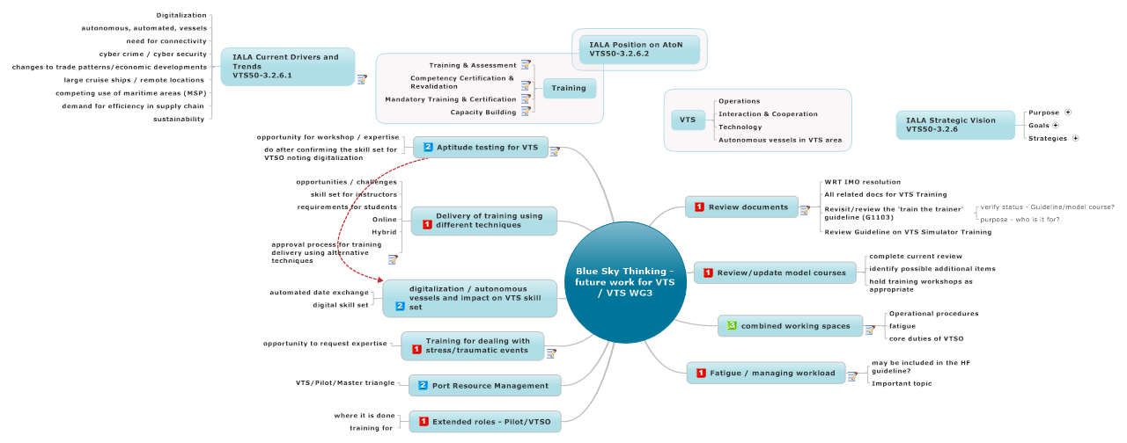

1.  Review documents

* Note work that is ongoing
* Barry is Task Leader

* 1. WRT IMO resolution
  2. All related docs for VTS Training
  3. Revisit/review the 'train the trainer' guideline (G1103)
     1. verify status - Guideline/model course?
     2. purpose - who is it for?
  4. Review Guideline on VTS Simulator Training

1.  Review/update model courses
   1. complete current review
   2. identify possible additional items
   3. hold training workshops as appropriate
2.  combined working spaces

Stefaan Priem thoughts:

* pilot services
* port operations services
* Role of Pilot/VTS
* training for the Pilot/VTS personnel
  1. Operational procedures
  2. fatigue
  3. core duties of VTSO

1.  Fatigue / managing workload

* May be covered in Human Factors Guideline
  1. may be included in the HF guideline?
  2. Important topic

1.  Extended roles - Pilot/VTSO
   1. where it is done
   2. training for
2.  Port Resource Management
   1. VTS/Pilot/Master triangle
3.  Training for dealing with stress/traumatic events

* VTS Operators dealing with high stress event
* VTS as first responders
* Note - opportunity to learn from other organisations - ATC; Soldier On; RUOK
  1. opportunity to request expertise

1.  digitalization / autonomous vessels and impact on VTS skill set
   1. automated date exchange
   2. digital skill set
2.  Delivery of training using different techniques
   1. opportunities / challenges
   2. skill set for instructors
   3. requirements for students
   4. Online
   5. Hybrid
   6. approval process for training delivery using alternative techniques

Any implications for G104

1.  Aptitude testing for VTS

See also: digitalization / autonomous vessels and impact on VTS skill set

* Noting the changes in digital/digitalization
* what are the aptitudes required for VTSO of the future
* Overview of aptitude testing in use
* Canada - math, spatial reasoning, data interpretation (5 set aptitudes tested for)
* Finland - also do
* Role of aptitude testing - need for expertise - opportunity for a workshop, include experts on expertise for aptitude
  1. opportunity for workshop / expertise
  2. do after confirming the skill set for VTSO noting digitalization