VTS Digital Information Service
Product Specification

Draft 0.6.5– April 2022

VTS Digital Information Service Product Specification

Document Revisions
Revisions to the IALA Document are to be noted in the table prior to the issue of a revised document.
Date | Page / Section Revised | Requirement for Revision
15 October 2019 | -- | Initial draft
01 September 2020 | Various
04 October 2020 | Page 6/9/22/23/26/27/34 | Revised according to VTS49-9.3.4
25 March 2021 | Page 5 | Revised according to VTS50-10.3.2
26 October 2021 | Page 5/6/9/16 | Revised according to VTS51-10.3.3
7 April 2022 | Page 5/6/8/9/10/11/13/26/29 | Revised according to VTS52-10.3.1

Table of Contents
1 Overview 5
1.1 Introduction 5
2 References 5
3 Terms, definitions and abbreviations 6
3.1 Terms and definitions 6
3.2 Abbreviations 7
4 Product specification metadata 8
4.1 IALA Product Specification Maintenance 8
4.1.1 Introduction 8
4.1.2 New Edition 9
4.1.3 Revisions 9
4.1.4 Clarification 9
4.1.5 Version Numbers 9
5 Specification Scope 9
6 Data Product Identification 10
6.1 Dataset Identification 10
7 Data Content and structure 11
7.1 Introduction 11
7.2 The Scenario of the VTS Digital Information Service 12
7.2.1 Map Scenario for VTS Digital Information Service 15
7.3 Application Schema 18
7.3.1 Domain Model 19
7.3.2 Meta features application schema 23
7.4 Feature Catalogue 24
7.5 Feature Types 24
8 Co-ordinate Reference Systems (CRS) 24
8.1 Introduction 24
8.2 Horizontal Reference System 25
8.3 Projection 25
8.4 Vertical Coordinate Reference System 25
8.5 Temporal Reference System 25
8.6 VTS Digital Information Service Data and Scale 25
9 Data Quality 25
10 Data Capture and Classification 25
11 Data Maintenance 26
12 Data Product format (encoding) 26
12.1 Introduction 26
12.2 Numeric Attribute Encoding 26
12.3 Text Attribute Values 26
12.4 Mandatory Attribute Values 26
12.5 Unknown Attribute Values 26
12.6 Structure of dataset files 26
12.7 Message object identifiers 27
12.8 Dataset validation 27
12.9 Location of Data Product Format schema Files 27
12.10 Detailed documentation of schema 28
13 Data Product Delivery 28
13.1 Message datasets 28
13.2 Collections 28
13.3 Dataset distribution 29
13.3.1 Datasets 29
13.3.2 Dataset size 29
13.3.3 Dataset file naming 29
13.4 Support Files 29
13.5 Exchange Catalogue 30
14 Metadata 30
15 Use of other standard documents in VTS-DIS 31
16 Language 31
17 Acknowledgements 31
Annex A. Data Classification and Encoding Guide 32
Annex B. Data Product Format (Encoding) 33
Annex C. NORMATIVE IMPLEMENTATION GUIDANCE 34
Annex D. FEATURE CATALOGUE 35
Annex E. Application Schema Documentation Tables 36
Annex F. VTS-DIS dataset validation rules 37
Annex G. Portrayal Catalogue 38

Overview

Introduction
This document is a vector product specification for encoding VTS Digital Information Service (VTS-DIS).
IALA Guideline 1089 on Provision of Vessel Traffic Services (INS, TOS, NAS) provides guidance on the delivery of the three different types of services provided by a Vessel Traffic Service (VTS): Information Service (INS), Traffic Organization Service (TOS) and Navigational Assistance Service (NAS).
According to resolution A.857(20) on Guidelines for Vessel Traffic Services, an information service provided by a VTS is defined as “a service to ensure that essential information becomes available in time for on-board navigational decision-making.”
Resolution A.857(20) also states that “the information service is provided by broadcasting information at fixed times and intervals or when deemed necessary by the VTS or at the request of a vessel, and may include for example reports on the position, identity and intentions of other traffic, waterway conditions, weather, hazards, or any other factors that may influence the vessel's transit.”
IALA Guideline G1089 “Provision of Vessel Traffic Services (VTS)” provides guidance for the provision of VTS to participating ships in a harmonized manner in accordance with internationally approved guidelines and IALA Standards.
IMO Resolution A.1158(32) states that:
“The purpose of VTS is to contribute to the safety of life at sea, improve the safety and efficiency of navigation and support the protection of the environment within a VTS area by mitigating the development of unsafe situations through:
- providing timely and relevant information on factors that may influence ship movements and assist onboard decision-making.
- monitoring and managing ship traffic to ensure the safety and efficiency of ship movements.
- responding to developing unsafe situations.

It is based on the IHO S-100 framework specification and the ISO 19100 series of standards.
VTS Digital Information Service datasets describe the Navigational situation(including traffic and route information), Navigational warning, Meterorology, Meterorology warning, Hydrography, Electronic navigational aids, Other information(Port Information, Cargo Information and so on), VTS or ships provide information with fixed time and time difference when requested.

References
IHO S-97 Guidelines for Creating S-100 Product Specifications Edition 1.1.0–June 2020
IHO S-98 Data Product Interoperability in S-100 Navigation Systems Draft Edition.1.0.0–March 2022
IHO S-100 IHO Universal Hydrographic Data Model Draft Edition 5.0.0–March 2022
IHO S-101 IHO Electronic Navigational Chart (ENC), Edition 1.0.0– December 2018
IHO S-111 Surface Current Product Specification Edition 1.0.0–December 2018

IHO S-121 Maritime Limits and Boundaries Product Specification, Edition 1.0.0-October 2019
IHO S-122 Marine Protected Areas, Edition 1.0.0-Jannuary 2019
IHO S-123 Marine Radio Services, Edition 1.0.0-Jannuary 2019
IHO S-124 Navigational Warnings Working Draft Edition 2.0.0–July 2019
IHO S-127 Marine Traffic Management, Edition 1.0.0– December 2018
IHO S-129 Under Keel Clearance Management, Edition 1.0.0-June 2019
IHO S-131 Marine Habour Infrastructure, Draft Edition 0.2-January 2022
IALA S-211 Port Call Message d Draft Edition 1.0.0-March 2019

WMO S-411 JCOMM Ice Information Product Specification, Edition 1.1.0-June 2014
WMO S-412 Weather and Wave Hazards, Draft Edition 0.1.0-November,2018
WMO S-413 Weather and Wave Conditions Edition and date TBC
WMO S-414 Weather and Wave Observations Edition and date TBC
IEC S-421 Route Plan Edition 1.0.0–June 2021
ISO 8601. 2004. Data elements and interchange formats - Information interchange - Representation of dates and times. 2004.
ISO 3166-1. 1997. Country Codes. 1997.
ISO 19101-2:2008 Geographic Information - Rules for Application Schema
ISO/TS 19103:2005 Geographic Information - Conceptual schema language
ISO 19106:2004 Geographic Information – Profiles
ISO 19107:2003 Geographic Information – Spatial schema
ISO 19109:2005 Geographic Information - Rules for Application Schema
ISO 19111:2003 Geographic Information - Spatial referencing by coordinates
ISO 19115:2003+Corr1 (2006) Geographic Information - Metadata
ISO 19115-2:2009 Geographic Information - Metadata: Extensions for imagery and gridded data
ISO 19123:2005 Geographic Information - Schema for coverage geometry and functions
ISO 19129:2009 Geographic Information - Imagery gridded and coverage data framework
ISO 19131:2007 Geographic Information - Data product specifications
ISO 19136:2007 Geographic Information – Geography Markup Language
ISO 19136-2:2015, Geographic Information – Geography Markup Language.
ISO/TS 19139, Geographic Information – Metadata – XML schema implementation.
IALA G1088 INTRODUCTION TO PREPARING S‐100
PRODUCT SPECIFICATIONS Edition1.0.0 – December 2012

Terms, definitions and abbreviations

Terms and definitions
The S-100 framework is based on the ISO 19100 series of geographic standards. The terms and definitions provided here are used to standardize the nomenclature found within that framework, whenever possible. They are taken from the references cited in clause 2. Modifications have been made when necessary.

application schema
conceptual schema for data required by one or more applications (ISO 19101)

conceptual model
model that defines concepts of a universe of discourse (ISO 19101)

conceptual schema
formal description of a conceptual model (ISO 19101)

data product
dataset or dataset series that conforms to a data product specification

data product specification
detailed description of a dataset or dataset series together with additional information that will enable it to be created, supplied to and used by another party
NOTE: A data product specification provides a description of the universe of discourse and a specification for mapping the universe of discourse to a dataset. It may be used for production, sales, end-use or other purpose.

dataset
identifiable collection of data (ISO 19115)
NOTE: A dataset may be a smaller grouping of data which, though limited by some constraint such as spatial extent or feature type, is located physically within a larger dataset. Theoretically, a dataset may be as small as a single feature or feature attribute contained within a larger dataset. A hardcopy map or chart may be considered a dataset.

domain
well-defined set (ISO/TS 19103)
NOTE: Well-defined means that the definition is both necessary and sufficient, as everything that satisfies the definition is in the set and everything that does not satisfy the definition is necessarily outside the set.

feature
abstraction of real world phenomena (ISO 19101)
NOTE: A feature may occur as a type or an instance. Feature type or feature instance shall be used when only one is meant.

feature attribute
characteristic of a feature (ISO 19101)
NOTE 1: A feature attribute may occur as a type or an instance. Feature attribute type or feature attribute instance is used when only one is meant.
NOTE 2: A feature attribute type has a name, a data type and a domain associated to it. A feature attribute for a feature instance has an attribute value taken from the domain.

geographic data
data with implicit or explicit reference to a location relative to the Earth (ISO 19109)
NOTE: Geographic information is also used as a term for information concerning phenomena implicitly or explicitly associated with a location relative to the Earth.

metadata
data about data (ISO 19115)

model
abstraction of some aspects of reality (ISO 19109)

portrayal
presentation of information to humans (ISO 19117)

quality
totality of characteristics of a product that bear on its ability to satisfy stated and implied needs (ISO 19101)

Abbreviations
CRS Coordinate Reference System
DCEG Data Classification and Encoding Guide
ECDIS Electronic Chart Display and Information System
ENC Electronic Navigational Chart
GML Geography Markup Language
IALA International Association of Marine Aids to Navigation and Lighthouse Authorities
IHO International Hydrographic Organization
IMO International Maritime Organization
ISO International Organization for Standardization
UML Unified Modeling Language
URI Uniform Resource Identifier
URL Uniform Resource Locator
VTS Vessel Traffic Service System
VTS-DIS VTS Digital Information Service
WMS Web Map Service
WWW World Wide Web
XML Extensible Markup Language
XSLT eXtensible Stylesheet Language Transformations

Product specification metadata
Title | VTS Digital Information Service Product Specification
Version | 0.6.5
S-100 version | 5.0.0
S-100 Compliance Category:  S-100 Interoperability  S-100 Technology Readiness Level | Category 3 - IHO S-100 compliant with standard encoding  Level 3-4
Date | 01 April 2022
Language | English
Identifier | TBD
Classification: | 001 - unclassified
Contact: | TBD
URL: | TBD
Maintenance: | TBD

IALA Product Specification Maintenance
This chapter is for clarification only on PS Maintenance.

Introduction
Changes to a product specification will be released by IALA-AISM as a new edition, revision, or clarification.

New Edition
New editions of a product specification introduce significant changes. New editions enable new concepts, such as the ability to support new functions or applications, or the introduction of new constructs or data types.

Revisions
Revisions are defined as substantive semantic changes to a product specification. Typically, revisions will change a product specification to correct factual errors; introduce necessary changes that have become evident as a result of practical experience or changing circumstances. A revision must not be classified as a clarification. Revisions could have an impact on either existing users or future users of a product specification. All cumulative clarifications must be included with the release of approved corrections.
Changes in a revision are minor and ensure backward compatibility with the previous versions within the same edition. Newer revisions, for example, introduce new features and attributes. Within the same edition, a data product of one version could always be processed with a later version of the feature and portrayal catalogues.

Clarification
Clarifications are non-substantive changes to a product specification. Typically, clarifications: remove ambiguity; correct grammatical and spelling errors; amend or update cross references; insert improved graphics, spelling, punctuation and grammar. A clarification must not cause any substantive semantic change to a product specification.
Changes in a clarification are minor and ensure backward compatibility with the previous versions within the same edition. Within the same edition, a data product of one clarification version could always be processed with a later version of the feature and portrayal catalogues, and a portrayal catalogue can always rely on earlier versions of the feature catalogues.

Version Numbers
The associated version control numbering to identify changes (n) to a product specification must be as follows:
New editions denoted as n.0.0
Revisions denoted as n.n.0
Clarifications denoted as n.n.n

Specification Scope
This product specification describes one data product and therefore requires only one scope which is described below:

Scope ID: VTS Digital Information Service datasets.
Hierarchical level: MD_ScopeCode - 005
Hierarchical level name: dataset.
Level description: information applies to the dataset
Extent: EX_Extent.description: Global coverage of maritime areas

Data Product Identification

Dataset Identification
title | VTS Digital Information Service
abstract | Resolution A.1158(32) Guidelines for Vessel Traffic Services defines VTS as states that “A service implemented by a Government with the capability to interact with vessel traffic and respond to developing situations within a vessel traffic service area to improve the safety and efficiency of navigation, contribute to safety of life at sea and support the protection of the environment.  The VTS Digital Information Service is used in conjunction with Route Plan (S-421) and Navigation Warnings (S-124), Weather and Wave Hazards (S-412) and Marine Traffic Management (S-127), as required, to assist in safe navigation of ships passing or approaching within the VTS Area.
content | Communication message with VTS, Such as ship state information, accident information, environmental information and warning information in VTS area
geographicDescription | EX_GeographicDescription: Examples: country; official name of region if any
spatialResolution | MD_Resolution>levelOfDetail (CharacterString): “All scales”
purpose | The purpose of this Maritime Service is to provide data in a digital format to support VTS Digital Information Service (DIS) and to create the means to reduce administrative burden and information overload, reduce miscommunication due to external interference, simplify work procedures, promote sustainable shipping, and increase navigational safety.  Information provided in a digital format could complement and/or replace verbal/voice communication. The steps to achieve this transition to digital information exchange may vary in different areas and for different types of vessels. Details about digital information exchange should be published by the VTS authority.
language | EN

Data Content and structure

Introduction
The VTS Digital Information Service product is based on the S-100 General Feature Model (GFM), and is a feature-based vector product. All VTS Digital Information Service features and information classes are derived from one of the abstract classes FeatureType and InformationType defined in the VTS Digital Information Service application schema, which realize the GFM meta-classes S100_GF_FeatureType and S100_GF_InformationType respectively.
VTS Digital Information Service (VTS-DIS) features are encoded as vector entities which conform to S-100 geometry configuration level 3b (S-100 clause 7-5.3.5). VTS-DIS further constrains Level 3a with the following:
- Coincident linear geometry must be avoided when there is a dependency between features.
- The interpolation of arc by centre point and circle by centre point curve segments must be circular arcs with centre and radius, as described in S-100 §§ 7-4.2.1, 7-4.2.20, and 7-4.2.21.
- The interpolation of other GM_CurveSegment must be loxodromic.
- Linear geometry is defined by curves which are made of curve segments. Each curve segment contains the geographic coordinates as control points and defines an interpolation method between them. The distance between two consecutive control points must not be less than 0.3 mm at a display scale of 1:10000.

The following exception applies to VTS-DIS:
• The use of coordinates is restricted to two dimensions (DirectPosition is restricted to two coordinates).
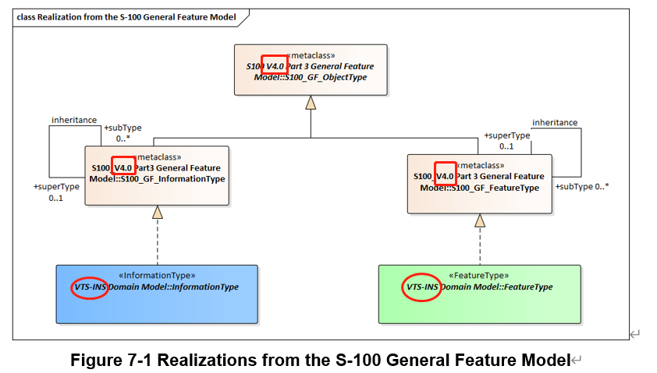
Figure 7-1 Realizations from the S-100 General Feature Model
This clause contains the Application Schema expressed in UML and an associated Feature Catalogue.

The Scenario of the VTS Digital Information Service
The VTS Digital Information Service is based on the following scenarios. Actors in this scenario consist of ships that can communicate with the VTS Center and the VTS Center, and can cover 6 cases.
- Enter VTS Area: Prior to arriving at the next port, the vessel is required to obtain permission to enter into each stakeholder's required entry clearance, Pilotage, Escort Towage, Towage and Mooring Operation. Pilotage, escort towage, and towage that you applied in advance are actually implemented. Obtain permission from the VTS to allow the ship to enter the Traffic Area and request prior permission to board the terminal. Once the pilotage and towage of the vessel are completed and the mooring operation is started and the berthing is completed, it is communicated to the stakeholders that the berth is completed.
- Vessel within VTS Area: When vessels entering VTS Area want to move within VTS Area for any reason, report their movements to VTS.
- Request VTS Area Information: The vessel requests information from the VTS for information in the VTS Area and receives the information.
- Report Accident: In the event of an accident, the vessel sends information about the accident to the VTS, followed by a request for medical assistance, a search and rescue request, and a request for the rescue of the vessel, respectively.
- Sending Accident Information in VTS Area: VTS Center broadcasts environmental & navigational warning warning and other vessel accident information in the VTS Area when vessels operating in the VTS Area need to know.
- Ship Navigational Assistance: When a vessel is unsafe in the VTS Area, the vessel may receive VTS's support for navigation. The following are the cases in which a ship is deemed unsafe.
  - A ship unsure of its route or position
  - A ship deviating from the route
  - A ship requiring guidance to an anchoring position
  - A ship that has defects or deficiencies, such as navigation or maneuvering equipment failure
  - Severe meteorological conditions
  - A ship at risk of grounding or collision
  - Emergency response or support to emergency services
  - Vessel deviating from the VTS passage plan
  - Assistance to a vessel to support the unexpected incapacity of a key member of the bridge team.
In this case, it may be requested by the ship or requested first by the vessel under the judgment of VTS.

The overall workflow of the VTS Digital Information Service is limited to the scope of the figure 7-2 below.
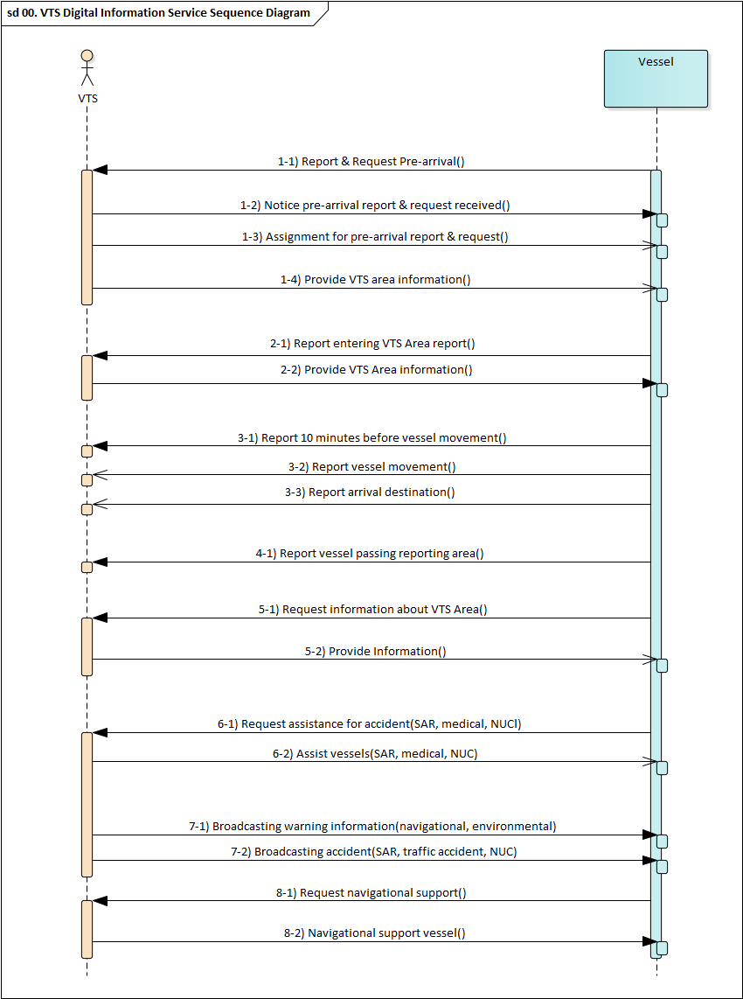
Figure 7-2 Overall workflow of VTS Digital Information Service

Map Scenario for VTS Digital Information Service
This part is intended to help you understand the VTS Digital Information Service in each scenario. Objects(Class, Attributes) that can be utilized in each case are marked.
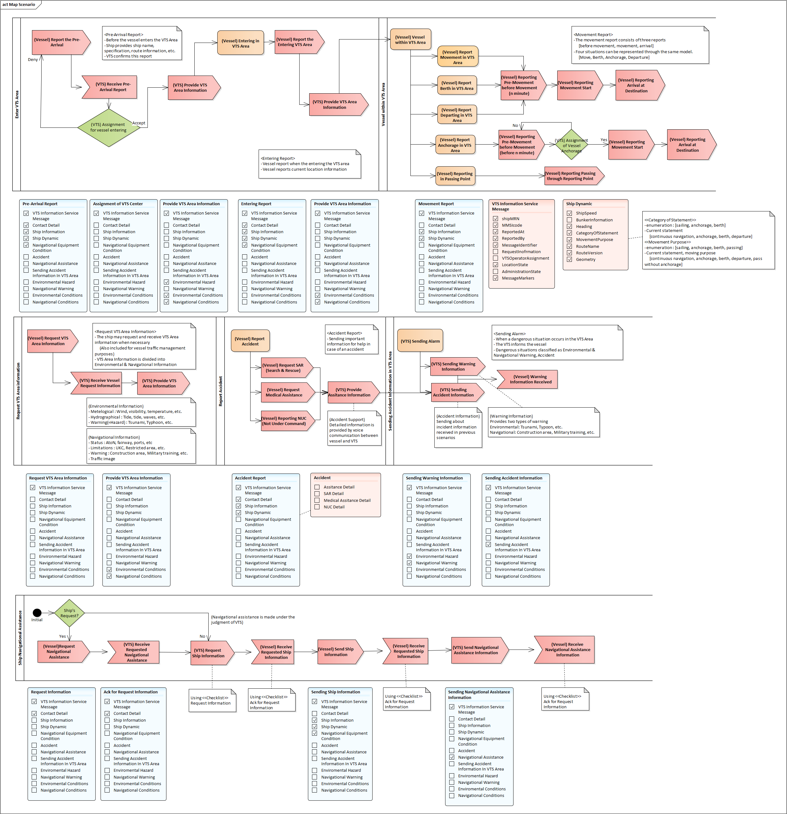
Figure 7-3 Overall Map Scenario for VTS Digital Information Service

A detailed look at each case is as follows.
- Enter VTS Area
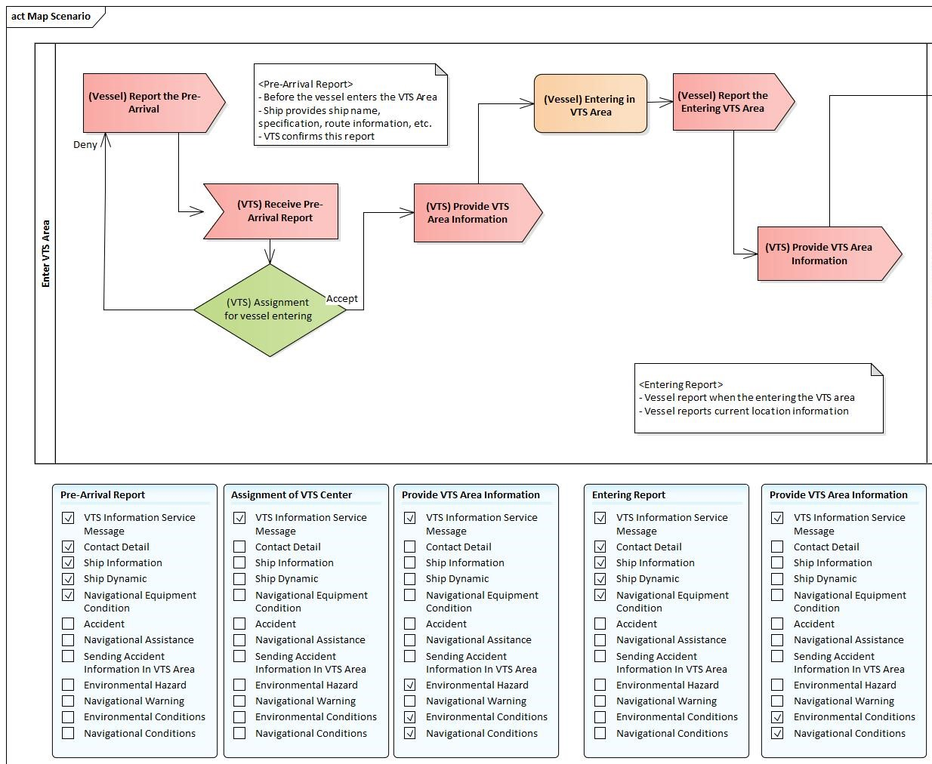
- Vessel within VTS Area
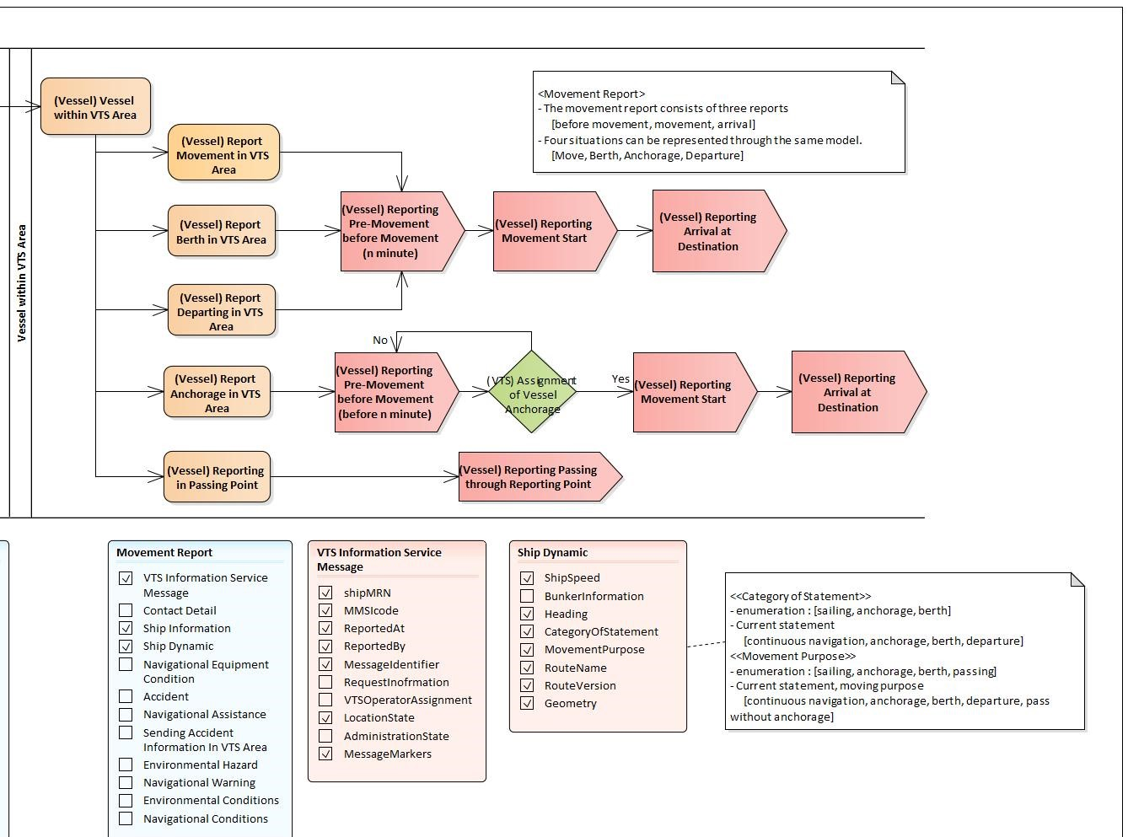
- Request VTS Area Information
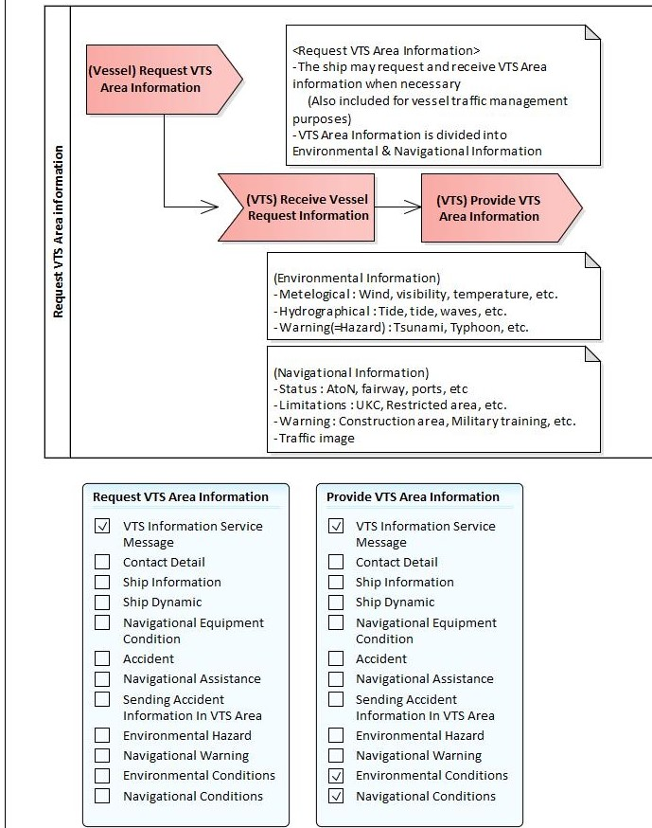
- Report Accident
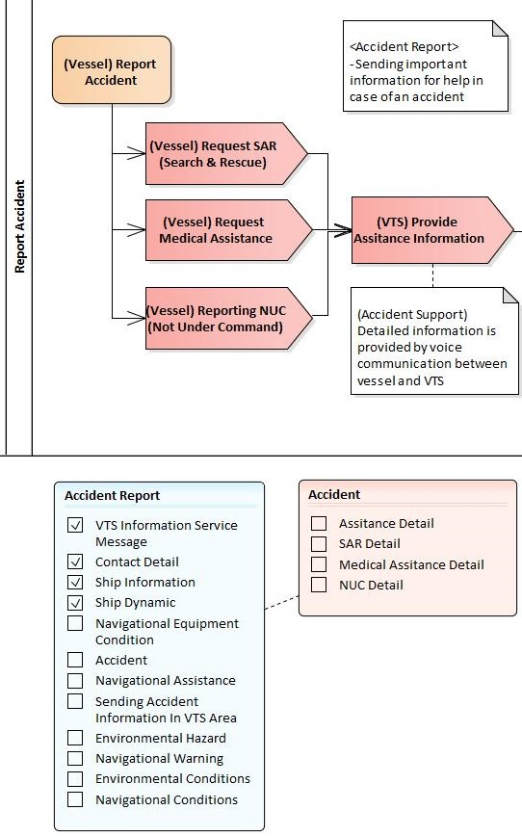
- Sending Accident Information in VTS Area
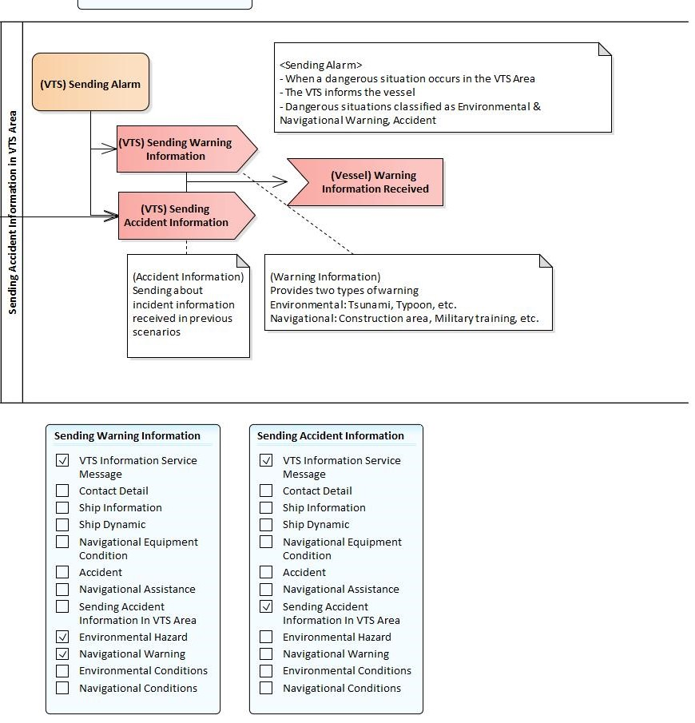
- Ship Navigational Assistance
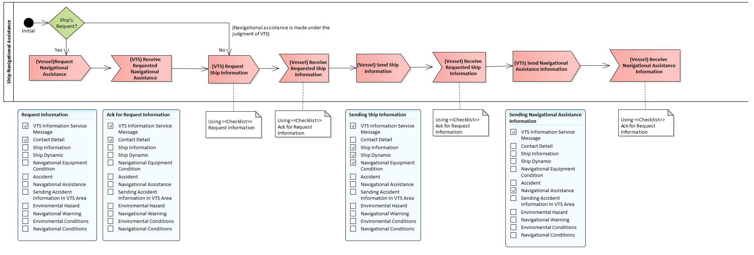

Application Schema
The UML models in this clause are segments of the overall VTS Digital Information Service application schema, and include overviews of the feature classes, information classes, spatial types, and the relationships between them.
This clause contains a general overview of the classes and relationships in the VTS Digital Information Service application schema. Detailed information about how to use the feature types and information types to encode VTS-DIS is provided in the VTS-DIS Data Classification and Encoding Guide (DCEG).
The following conventions are used in the UML diagrams depicting the application schema:
- Standard UML conventions for classes, associations, inheritance, roles, and multiplicities apply. These conventions are described in Part 1 of S-100.
- Italic font for a class name indicates an abstract class.
- Feature classes are depicted with green background; the dark shade for abstract feature classes and the light shade for ordinary (non-abstract) feature classes.
- Information type classes are depicted with blue background; the dark shade for abstract information type classes and the light shade for ordinary information types.
- Complex attributes are depicted with a pink background.
- Enumeration lists and codelists are depicted with a tan background. The numeric code corresponding to each listed value is shown to its right following an ‘=’ sign.
- No significance attaches to the colour of associations. (Complex diagrams may use different colours to distinguish associations that cross one another.)
- Where the association role or name is not explicitly shown, the default rules for roles and names apply:
- The role name is ‘the<CLASSNAME>’ where <CLASSNAME> is the name of the class to which that association end is linked.
- The association name is ‘<CLASSNAME1>_<CLASSNAME2>’ where <CLASSNAME1> is the source and <CLASSNAME2> the target. In case of a feature/information association the feature is the source.
- For feature/feature or information/information associations without explicit names the source/target are indicated by an arrowhead.
- Subclasses inherit the attributes and associations of their superclasses at all levels, unless such inheritance is explicitly overridden in the subclass.

Domain Model

Overview of Domain Features and Information Types
The VTS Digital Information Service data product consists of information related to the vessel and the environment within the VTS Area, either delivered to the VTS Operator or made up of messages that the operator must deliver. The information related to the vessel is composed of static information of the vessel, dynamic information of the vessel, accident information of own ship, and status of navigational equipment. The information in the VTS Area consists of status information within the VTS Area and Warning information.
The figure 7-2 shows the overview picture of the feature and information type of the VTS Digiatal Information Service domain model.
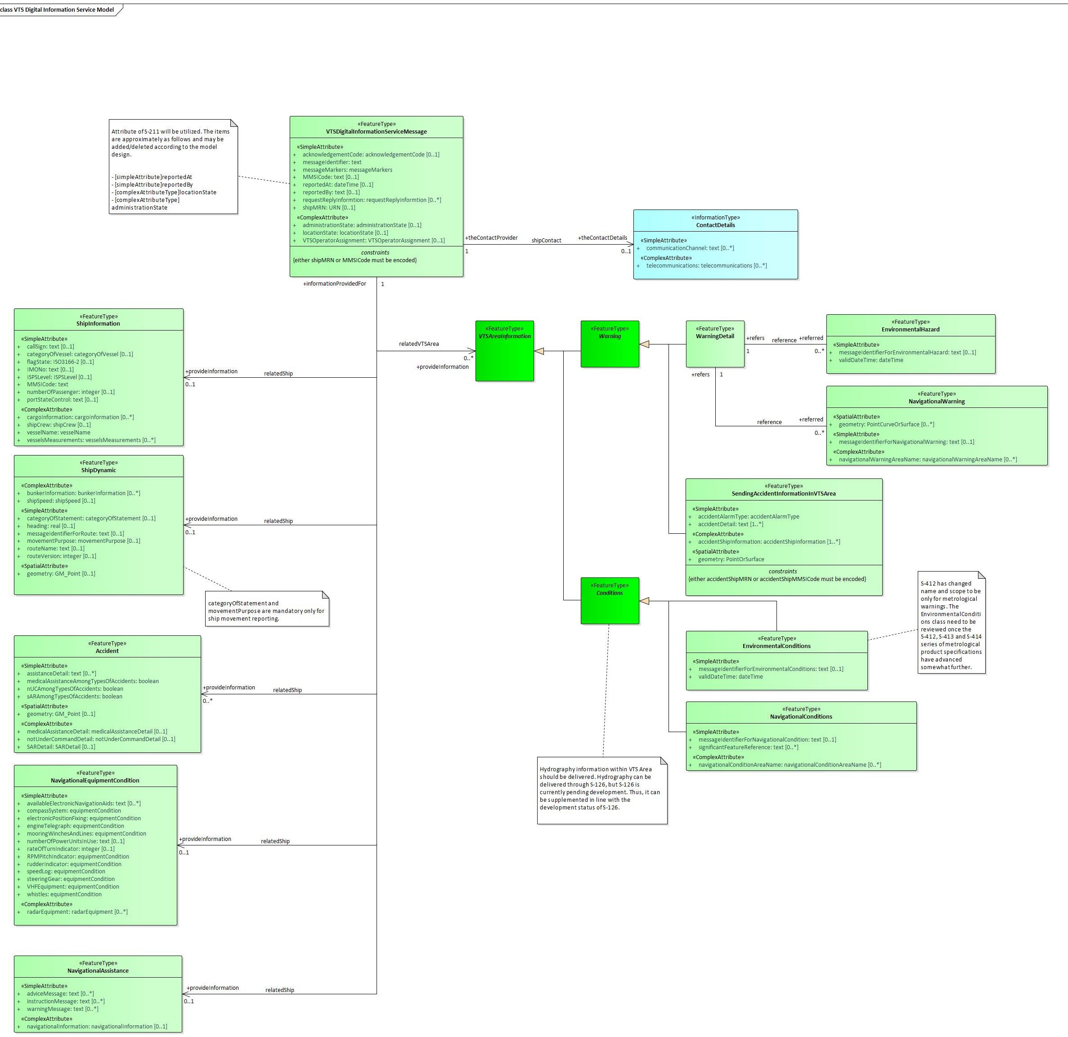
Figure 7-4 Overview of VTS-DIS Feature and Information Types

- VTSDigitalInformationServiceMessage is a feature type. Classes for distinguishing information that is sent. Manage requests, responses to requests, and results of service requests, or distinguish which information is transmitted from broadcasting information. Ships can be reported to VTS in this class and transmitted with requested information, while VTS can transmit with answer information in this class.
- ShipInformation is a feature type. Static information/information that does not change when a ship is operated in one voyage.
- ShipDynamic is a feature type. Dynamic information/information that may change or change when a ship is operated in one voyage.
- Accident is a feature type. Class to communicate own vessel accident information. The purpose of this class is to provide emergency information about ship accidents prior to VTS communication.
- NavigationalEquipmentCondition is a feature type. Mechanical defects/An item to manage the condition of items to determine whether mechanical defects that can affect the normal operation of a ship are present.
- NavigiationalAssistance is a feature type. This class is intended to send navigation support results, A Navigational Assistance is a service that provides essential and timely navigational information to assist in the on board navigational decision-making process and to monitor its effects.
- SendingAccidentInformationInVTSArea is a feature type. Class that contains information to inform the surrounding vessel of accident information or information about the vessel requesting assistance.
- VTSareaInformation is an abstract type that collects properties common to Warning and Condition within the VTS Area, while Warning and Condition are abstract types that collect common properties of Warning and Status information within the VTS Area, respectively.
- NavigationalWarning is a feature type. Navigation warning in the VTS Area from VTS Operator. Use S-124 to get information.
- Environment warning is a feature type. Environmental hazard Information in the VTS Area from VTS Operator. Use S-412 to get information.
- EnvironmentalConditions is a feature type. Environmental condition Information in the VTS Area from VTS Operator. Use S-412 to get information.
- NavigationalConditions is a feature type. Navigation conditions in the VTS Area from VTS Operator. Use S-127 to get information.
- ContactDetails is an information type. Information on how to reach a person or organisation by postal, internet, telephone, telex and radio systems.
- Space allocation is a feature type. Information about space allocation of vessels in VTS area from VTS operator.
- Navigation or manoeuvring equipment failure is a feature type. Information about navigation or maneuvering equipment failure in VTS area from VTS operator or vessels.
- Traffic clearances is a feature type. Information about traffic clearances in VTS area from VTS operator.
- Ice Service Information is a feature type. Which contains the information of Ice routing, Ice conditions / chart, Icebreaker operations, Dynamic No-go areas and Iceberg bulletins.
- Navigational Hazard Information is a feature type. Which contains the information of Construction works, Temporary Restricted Areas, Speed reduction areas, Newly Discovered Hazards, Bridge air gap, Cables air gap, Status of AtoN and Diving operations.
- Security Information is a feature type. Which contains the information of ISPS and Piracy .
- Traffic and Route Information is a feature type. Which contains the information of Voyage Plan, Anchorage assignment, Berthing assignment, Route advisories, Notice to shipping, Suspension or change of routes and reporting.
- Navigational advice Information is a feature type. Which contains the advice or instruction related to navigation .
- VTS Digital Information Service Message-related Ship Information associations are modelled by the association labelled relatedShip, between classes VTSDigitalInformationServiceMessage and ShipInformation, ShipDynamic, Accident, NavigationalEquipmentCondition, NavigiationalAssistance in Figure 7-2.
- VTS Digital Information Service Message-related VTS Area Information associations are modelled by the association labelled relatedVTSArea, between classes VTSDigitalInformationServiceMessage and VTSAreaInformation in Figure 7-2.

VTS-DIS Complex Attributes
The complex attributes in the VTS Digital Information Service domain are provided in Figures 7-3.
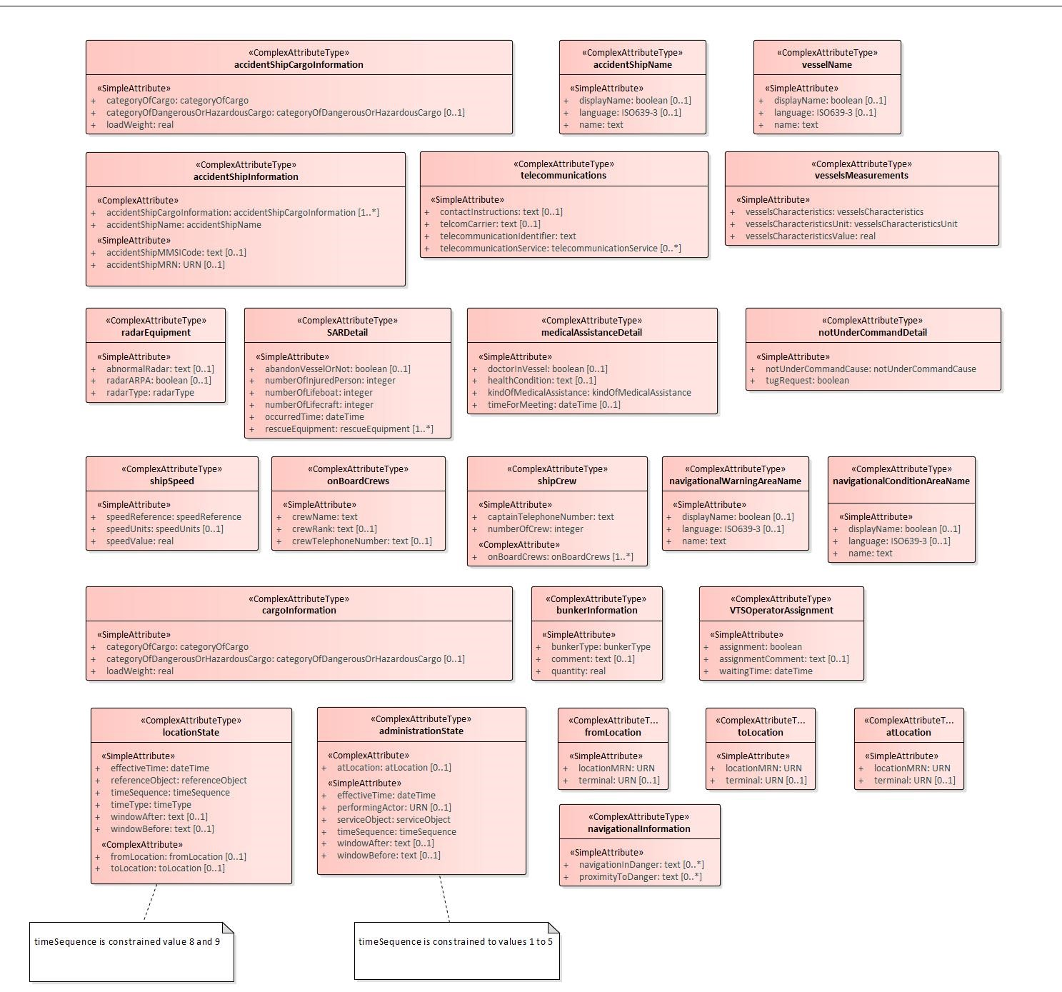
Figure 7-5 VTS-DIS Complex Attributes

VTS-DIS Enumerations and Codelists
For completeness, the enumerations and codelists in the VTS Digital Information Service domain are provided in Figures 7-4.
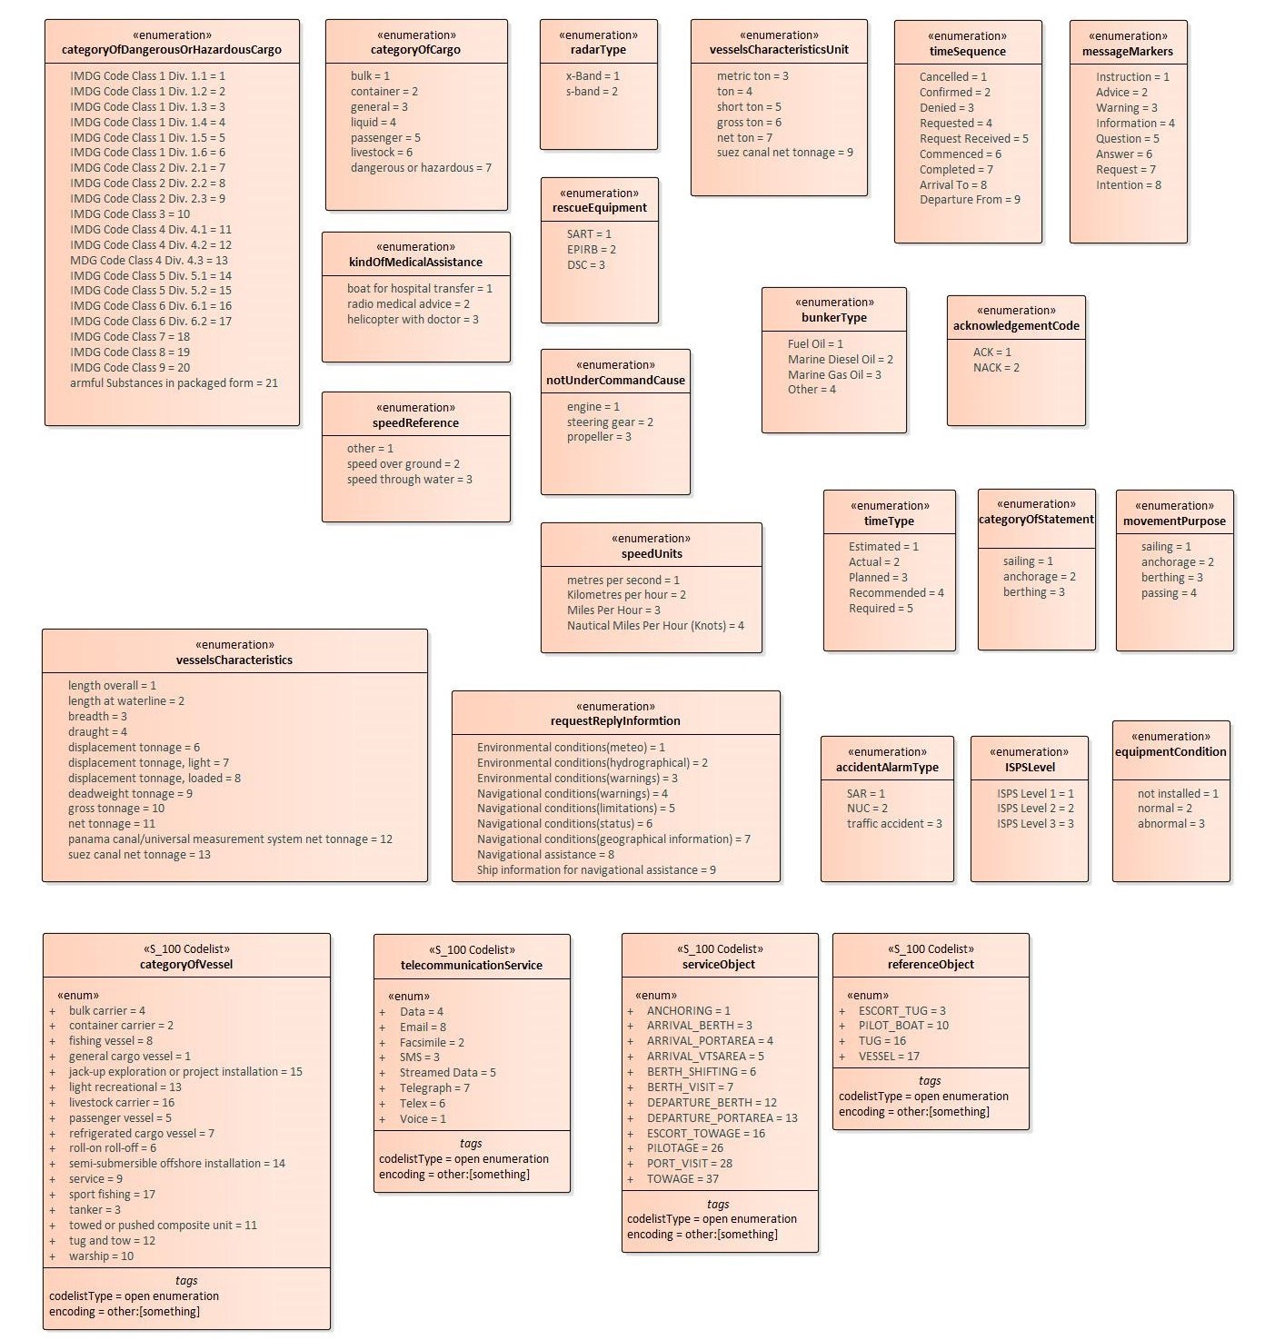
Figure 7-6 VTS-DIS enumerations and codelists

Meta features application schema
This data product does not make use of meta-features.

Feature Catalogue
The Feature Catalogue describes the feature types, information types, attributes, attribute values, associations and roles which may be used in the product. The VTS Digital Information Service Feature Catalogue is available in an XML document which conforms to the S-100 XML Feature Catalogue Schema. A printed version of the feature catalogue is provided in Annex D.

Feature Types
Feature types contain descriptive attributes and do not contain any geometry (i.e. information about the shape and position of a real-world entity). Features have two aspects – feature type and feature instance. A feature type is a class and is defined in a Feature Catalogue. A feature instance is a single occurrence of the feature type and represented as an object in a dataset. A feature instance is located by a relationship to one or more spatial instances. A feature instance may exist without referencing a spatial instance.
VTS-DIS makes use of the following feature types:
Geographic (Geo) feature type – carries the descriptive characteristics of a real world entity.
Relationship feature type – A feature relationship links instances of one feature type with instances of the same or a different feature type.
7.6 The requirements of the portrayal of information ashore and the presentation of information on board
7.6.1 The requirements of the portrayal of information ashore
It is recommended to portrayal all the relevant information involved in the "
VTS51-13.3.1.3 WP Appendix 1 MS 1-3_merged revised WG 1 (VTS51-9.1.6.1) " as comprehensively as possible on the shore-based system.
7.6.2 The requirements of the presentation of information on board
It is recommended to portrayal such relevant information involved in the " VTS51-13.3.1.3 WP Appendix 1 MS 1-3_merged revised WG 1 (VTS51-9.1.6.1) " on the ship-based system:
- Environmental Information, including the information of Weather Warnings and MetArea.
- Hydrographical Information, including the information of Tide, Water level and Current.
- Ice Service Information, including the information of Ice routing, Ice conditions / chart, Icebreaker operations, Dynamic No-go areas and Iceberg bulletins.
- Navigational Hazard Information, including the information of Construction works, Temporary Restricted Areas, Speed reduction areas, Newly Discovered Hazards, Bridge air gap, Cables air gap, Status of AtoN and Diving operations.
- Waterway Information, including the information of Locks and bridges, Fairway, Port and Special Area.
- Security Information, including the information of ISPS and Piracy.
- Traffic and Route Information, including the information of Notice to shipping, Suspension or change of routes and reporting.
- Navigational Warning Information, including the information of diverging from the recommended route towards.
- In addition, the following information is recommended for auditory display to reduce the impact on ship manoeuvring and collision avoidance:
- Traffic and Route Information, including the information of Anchorage assignment, Berthing assignment, Route advisories.
- Navigational Information, including the information of Relative Position, Destination and Actual vessel track.
- Navigational advice Information, including the advice or instruction related to navigation, such as alter course, alter speed, keep clear from area/position/other vessel, increase / decrease distance from other vessel.
- Request Information, including the information of Identification, Dynamic vessel information and Voyage Plan/ Route.
- Waterway Management Information, including the information of provide advice or instruction related to navigation, diverging from the recommended route towards, Traffic clearance, Anchorage.
- Enforcement Information, including the information of Identification, Dynamic vessel .

Co-ordinate Reference Systems (CRS)

Introduction
The location of an object in the S-100 standard is defined by means of coordinates which relate a feature to a position. The coordinate reference system used for this product specification is World Geodetic System 1984 (WGS 84) which is defined by the European Petroleum Survey Group (EPSG) code 4326.
Spatial data are expressed as latitude (φ) and longitude (λ) geographic coordinates. Latitude values are stored as a negative number to represent a position south of the Equator. Longitude values are stored as a negative number to represent a position west of the Prime Meridian. Coordinates are expressed as real value, degree / degree decimal format. Datasets conforming to this product specification are not projected.
Horizontal coordinate reference system: WGS 84
Projection: None
Vertical coordinate reference system: None
Temporal reference system: Gregorian calendar
Coordinate reference system registry: EPSG Geodetic Parameter Registry
Date type (according to ISO 19115-1): 002 - publication

Horizontal Reference System
Positional data is expressed in latitude and longitude geographic coordinates to one of the reference horizontal reference systems defined in the HORDAT attribute. Unless otherwise defined, the World Geodetic System 84 (WGS 84) will be used for VTS-INS data products.

Projection
VTS-DIS data products are un-projected.

Vertical Coordinate Reference System
VTS-DIS data products do not provide detailed vertical information.

Temporal Reference System
Time is measured by reference to Calendar dates and Clock time in accordance with ISO 19108:2002 Temporal Schema clause 5.4.4.

VTS Digital Information Service Data and Scale
VTS Digital Information Service data must be compiled in the best applicable scale. The use of the data itself is "scale independent". That means that the data can be used at any scale. S-100 allows the association of multiple spatial attributes to a single feature instance. In principle, each of these spatial attributes can be qualified by maximum and minimum scales.
For example, it is possible, within one dataset, to have a single instance of a feature that has more than one area geometry. Each of these geometries has different scale max/min attributes. Moreover, due to cluttering in smaller scales, the scale minimum attribute may be used to turn off portrayal of some features at smaller scales.

Data Quality
VTS Digital Information Service datasets must be validated using the conformance checks that are listed in Annex F(TBD). Prior to release by the data producer. The data producer must review the check results and address any issues to ensure sufficient quality of the data products. The checks are a mix of data format validation checks, conformance to standard checks and logical consistency checks.

Data Capture and Classification
The Data Classification and Encoding Guide (DCEG) is found in Annex A.

Data Maintenance

Data Product format (encoding)

Introduction
Detailed documentation of the VTS-DIS encoding schema is provided in B of this document.
Format Name: XML, Specification: custom.
File Structure: (VTS-DIS Product Specification), Annex B.

Numeric Attribute Encoding
Floating point and integer attribute values must not contain leading zeros. Floating point attribute values must not contain non-significant trailing zeros.

Text Attribute Values
Character strings must be encoded using the character set defined in ISO 10646-1, in Unicode Transformation Format-8 (UTF-8).

Mandatory Attribute Values
Some attribute values are considered mandatory for the following reasons:
- Certain messages make no logical sense without specific attributes,
- Some attributes are necessary to determine which symbol is to be displayed,
All mandatory attributes are identified in the Feature Catalogue and summarised in Annex A – Data Classification and Encoding Guide.

Unknown Attribute Values
It is an error for a mandatory attribute value to be missing. Mandatory attributes cannot be “nilled”.
Optional attributes must be omitted altogether if the value is unknown or missing.

Structure of dataset files
A ‘dataset’ in this product is a message that consists of a single object encoded as an XML element VTSDigitalInformationServiceMessage.
This product references datasets from other standard documents (S-124, S-127, S-412, and S-421). Datasets of other standard documents do not exist separately in several files. They are nested in VTS-DIS Dataset as shown in Figure 12-1 using Attributes that can function as Message Identifier.
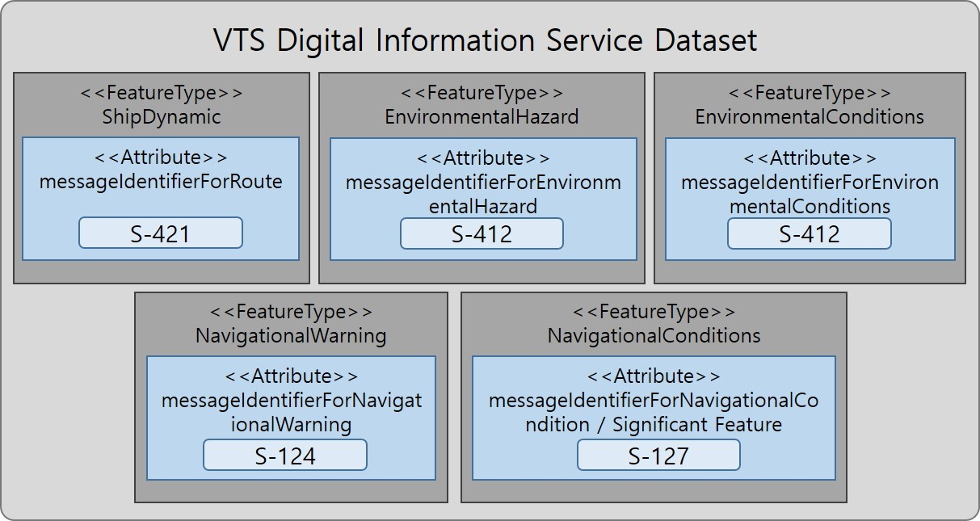
Figure 12-1 VTS-DIS Dataset with Other Standard Documents
Collections of objects may be wrapped. This wrapping is out of the scope of this product specification.

Message object identifiers
Each message object is identified by a messageIdentifier based on URN format, in accordance with RFC 4122. This allows us to assign message identifiers in a distributed manner with no centralised id management and still be guaranteed that all message identifiers are globally unique. As a result, any message that is sent has an identifier. Since a VTS-DIS dataset consists of a single message, the ID of the single message object in a dataset is the same as the ID of the dataset.
GML geometric primitives (inline or external) are required to have a gml:id attribute with a value that is unique within the file (dataset or collection). The gml:id values must be used as the reference for the object from another object in the same dataset or another dataset. Applications must therefore take care to generate a unique gml:id for each point encoded as coordinates.

Dataset validation
Fields may be repeated or omitted as permitted by the XML schemas and the validation tests. Since XML schema cannot encode rules for conditional presence or attributes, these rules must be checked by other validation code in the implementation.
Schematron rules are another possibility for validation code, but are not defined in this specification since the ability of implementations to integrate Schematron validation is unknown. Implementers may create and implement their own Schematron validation rules.

Location of Data Product Format schema Files
The schema file will provide a future location and is available from that location.

Detailed documentation of schema
The detailed documentation of the schema is in Annex B(currently a separate document enclosed with this file).

Data Product Delivery
This clause specifies the encoding and delivery mechanisms for a VTS-DIS dataset. Data which conforms to this product specification must be delivered by means of an exchange set.
There are only two delivery modes for VTS-DIS data – single messages and collections. In either delivery mode, the content may be encapsulated into a form suitable for transmission by a mapping called a transmission encoding. An encoding translates each of the elements of the content (e.g., exchange set) into a logical form suitable for writing to media and for transmission online. An encoding may also define other elements in addition to the exchange set contents (i.e., media identification, etc…) and also may define commercial constructs such as encryption and compression methods.
Examples: REST; MIME-encoded email; zip files.
If the data is transformed (e.g., for encryption or compression purposes) its content must not be changed.
This product specification does not define the transmission encoding which must be used as a default for transmission of data between parties.

Message datasets
VTS-DIS Datasets are delivered as single messages transmitted to a service broker via an appropriate delivery mechanism, e.g., REST API.
Units of Delivery: Message
Transfer Size: 10kb maximum
Medium Name: Digital data delivery
Other Delivery Information:
Each delivery packet must contain a single VTS-DIS Message.
Exchange catalogues are not included.
The allowed components are as follows:
Mandatory Elements
- VTS-DIS Message – XML encoding of single VTS-DIS Message.
Optional Elements: None.

Collections
VTS-DIS Collections are transferred as collections of messages transmitted via an appropriate delivery mechanism, e.g., REST API.
Units of Delivery: Collection
Transfer Size: 20MB
Medium Name: Digital data delivery
Other Delivery Information:
Each collection may contain zero or more VTS-DIS objects.
Exchange catalogues are not included.
The allowed components are as follows:
Mandatory Elements
- VTS-DIS Message– XML encoding of VTS-DIS features/attributes and their associated geometry and metadata.
- Collection wrapper – as specified by the service broker API.
Optional Elements: None

Dataset distribution

Datasets
Datasets are distributed as files as described in this specification. The distribution media are left to the discretion of the producer and distributor.
The VTS Digital Information Service product specification does not mandate implementation of the API or service broker.

Dataset size
Single messages must not exceed 10kb. Collections must not exceed 20 MB.

Dataset file naming
If VTS-DIS data is communicated in the form of dataset files containing a single VTS-DIS message in each file, the files shall be named <MESSAGEIDENTIFIER>.XML
NOTE: The letter cases of the file name and the messageIdentifier encoded within the message are not guaranteed to be the same. E.g., the internal messageIdentifier may use lower case letters, or mixed case, or may have only some letters in uppercase, etc.

Support Files
The supported file types allowed for VTS-DIS are files for the transfer of Route, Navigation Warning, Navigational Conditions, Environmental Hazard, and Environmental Conditions. These files are identified within the VTS-DIS data set by the following attribute:
a | Attribute Name | Attribute in Standard Documents
Simple Attribute | routeName | Using the value of S-421.Route.routeInfoName
Simple Attribute | routeVersion | Using the value of S-421.RouteHistory.routeHistoryEditionNo
Simple Attribute | validDateTime | Using the value of S-412.S412_FeatureType.validDateTime
Simple Attribute | message identifier for Route | Attribute for include of S-421 IEC Route Plan Exchange Format.
Simple Attribute | Message identifier for Navigational Warning | Attribute for include of S-124 Navigational Warning.
Simple Attribute | Message identifier for Environmental Hazard | Attribute for include environmental hazard information of S-412 Weather Overlay.
Simple Attribute | Message identifier for Environmental Conditions | Attribute for include environmental hazard information of S-412 Weather Overlay.
Simple Attribute | Message identifier for Navigational Conditions | Attribute for include navigational conditions of S-127 Marine Traffic Management.
Simple Attribute | Significant Feature Reference | reference of the MRN identifier of the significant feature(s)
Complex Attribute | navigationalConditionAreaName | Using the value of S-127.FeatureType.featureName
Complex Attribute | navigationalWarningAreaName | Using the value of S-124.S124_FeatureType.featureName

Exchange Catalogue
The exchange catalogue prescribed by S-100 is not used in the VTS-DIS specification and is not transmitted with VTS-DIS messages. This is to reduce demands on bandwidth and the complexity of generation and handling of VTS-DIS.

Metadata
Metadata prescribed by S-100 is not transmitted with VTS-DIS messages. This is to reduce demands on bandwidth and the complexity of generation and handling of VTS-DIS.
For this reason there is no metadata defined in this specification.

Use of other standard documents in VTS-DIS

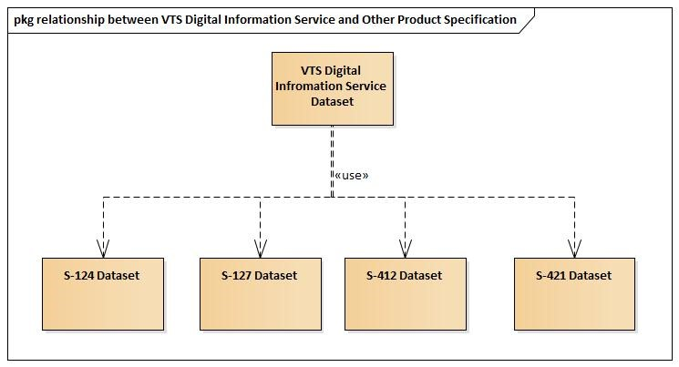

Figure 15-1 relationship between VTS-DIS and Other Product Specification
The VTS Digital Information Service uses S-421 to transmit route information and S-412 to transmit weather and environmental information within the VTS Area. And S-124 is used to transmit navigation warning and S-127 to transmit navigational conditions.
Figure 15-1 shows the relationship between VTS-DIS and S-124, S-127, S-412, and S-421.

Language
The exchange language must be English. Other languages may be used as a supplementary option. National geographic names can be left in their original national language using the complex attribute Feature Name.
Character strings must be encoded using the character set defined in ISO 10646-1, in Unicode Transformation Format-8 (UTF-8). A BOM (byte order mark) must not be used.

Acknowledgements

- Data Classification and Encoding Guide
[The Data Classification and Encoding is currently in a separate document enclosed with this file. See file Annex_A Data Classification and Encoding Guide.]

- Data Product Format (Encoding)
[The Data Format Documentation is currently in a separate document enclosed with this file. See file Annex_B Data Format Documentation. The GML Schema itself is a separate file in the product specification distribution package.
Annex B 1 Data Product Format, Schemas: This package contains the S-100 Part 10b compliant GML schemas for the specification of the data product encoding for S-212 datasets.
Annex B 2 Data Product Format, Schema document: This package contains the documentation of the GML schema in a human readable form, and lists each element with their associations and definitions.]
- NORMATIVE IMPLEMENTATION GUIDANCE
IALA to determine if this annex is needed.

- FEATURE CATALOGUE
[See the accompanying printed feature catalogue Word file Annex_D Feature Catalogue. The XML feature catalogue(VTS-Digital Information Service Annex D1 Feature Catalogue) itself is a separate file in the product specification distribution package.]

- Application Schema Documentation Tables
[See file Annex_E Application Schema Documentation.]

- VTS-DIS dataset validation rules
[To be developed in the next version]

- Portrayal Catalogue
[The package contains the S-212 portrayal catalogue.]

