Input paper: VTS53-8.2.1

Input paper for the following Committee(s): check as appropriate Purpose of paper:
□ ARM □ ENG □ PAP □ Input
□ ENAV X VTS X Information

Agenda item 8.2
Technical Domain / Task Number ² …………………………………
Author(s) / Submitter(s) …………………………………

Expected Influence of MASS on VTS Traffic Management Rules

BACKGROUND
In May 2021, the International Maritime Organization (IMO) adopted the definition of the regulatory framework for Maritime Autonomous Surface Ships (MASS) at the MSC103 meeting, which will provide guidance to interested parties involved in MASS management other than MSC, with a view to producing more new output files. The International Association of Navigation Marks (IALA), as an advisory member of IMO, plays an important role in driving the E-Nav strategy of IMO. Therefore, in the context of the E-Nav strategy, there is a common understanding between the two sides when looking at MASS management issues. As a service and management organization for maritime vessel traffic safety, it is necessary for VTS to consider the risk factors in traffic flow after the emergence of autonomous vessels. A systematic and comprehensive awareness of the problems and development trends, as well as the adjustment of management rules in advance, is conducive to the safety of water traffic during the coexistence of traditional ships and MASS with different levels of autonomy.

URPOSES
Taking into account the concerns of the VTS Committee on MASS and the possibility of developing future guidelines on MASS management, this paper sets out perspectives on influencing future MASS traffic management models from the perspectives of risk analysis, data requirements and technological developments, making the discussion of MASS in Task group Task-1.2.5 more complete and perfect.

Influence of MASS management risks on traffic management rules

Identification of MASS
In the early days of MASS, autonomous vessels were mainly used in ports or in shallow water areas that may be beyond the VTS monitoring area. In addition, MASS's hulls are generally small at the beginning of development, making it difficult to locate and track by radar. These small MASS are difficult to locate accurately by VTS compared to large merchant ships. From the safety point of view, port authorities will require shipping companies to strictly comply with the ship reporting system. But with no crew on board, the IMO and Recognized Organizations (RO) need to set up new mechanisms related to the ship reporting system to ensure that the maritime authorities continuously receive both dynamic and static information about the ship.
Considering the particularity of MASS, it is still under discussion whether MASS should be regarded as an ordinary ship in the future traffic management mechanism. At the 104th Maritime Security Committee meeting of the IMO, China proposed to assign the MMSI exclusive to MASS and mark the autonomy level in the submitted report on the real ship trial of "Jindou Yun" MASS. In addition, it is recommended to distinguish the AIS signals of MASS and stipulate the MASS signal lights and shapes^{[1]}.

MASS Emergency Response
IMO clarifies ship autonomy into four degrees^{[2]}, namely, ship has automatic processing and decision supporting ability, remote control with crew on board, remote control without crew on board, and full autonomy of decision-making and action judgment. The four degrees are not different levels of ship autonomy. For example, a MASS with the highest Degree of autonomy (Degree 4) can decide which degree of autonomy to use according to the sailing waters and operational requirements.
Considering that VTS waters are mostly concentrated areas or restricted waters, from the perspective of safety, it is recommended that the MASS have crews on board for navigation operations. As a result, when VTS faces the MASS fleet in the future, ships with a high degree of autonomy will have fewer personnel on board. In addition, considering the high degree of integration and complexity of MASS remote control and sensing equipment with high degree of autonomy, the emergency recovery process and difficulty will be greater when failure of communication center or equipment occurs to the ship, thus bringing greater pressure to VTS emergency response. Refer to Appendix 1.
Excluding meteorological, hydrological and other dynamic environmental factors in sea areas with different offshore distances and with considering the complexity of ship equipment, the crew number on board and the traffic density nearby (related to distance from shore), it is necessary to consider the risks of MASS with varying degrees of autonomy. At the same time, it is also in line with the future plans of VTS to participate in the IMO MSC to formulate the goal-based documents related to MASS. Refer to Appendix 2.

Influence of MASS data requirements on traffic rules
Now for MASS, remote driving, automatic docking and berth-leaving, and autonomous navigation can be realized by intelligent navigation system equipped. For example, the Revolt autonomous ship project mainly considers sensors, data analysis and increasing channel bandwidth necessary for ship-shore data interaction^{[3]}. Autonomous berthing technology in SVAN, a joint test project of Rolls-Royce and Finnish Ferry, also considers ship-shore interaction of berthing data^{[4]}. At present, in the E-Nav field, the technologies related to VTS ship-shore data interaction mainly focus on the VHF Digital Exchange System (VDES) based on AIS extended applications; VTS Shore-based data interaction focuses on the radar image data interaction of Inter-VTS Exchange Format (IVEF). Future data interaction between MASS and VTS shall consider more data formats, content and data security levels. Mainly involved:
- Regulatory requirements and ship data interaction. The data mainly involves VTS management regulations, such as VTS navigation rules in waters, local port regulations, port interim administrative orders, etc. Low level of secrecy.
- Exchange of technical data and ship data. The data mainly involves meteorological, hydrological and visibility, and severe weather forecast data, with a medium level of confidentiality.
- Voyage information data exchange. Voyage data exchanged between VTS and individual vessels, such as voyage, berthing and anchoring plans, are highly confidential.
VTS needs to apply the above data interaction technology when managing MASS traffic, which means that VTS needs to specify the content and format of ship-shore data interaction when formulating traffic management rules, and determine how VTS communicates with MASS to enable effective interaction with autonomous vessels, and encourage VTS to disclose its MASS traffic management and service capabilities in the future.

Influence of MASS technology development on traffic management rules
The high-speed operation of MASS is likely to break the speed limit set by the current port traffic management regulations. To this, port management rules need to be adjusted. In addition, maritime authorities should be encouraged to formulate new traffic rules for MASS and fully consider the conformity of MASS technology development status and rules. For example, the level of autonomy should MASS adopt when anchoring or sailing in and out of port, the differences of management requirements between traditional ships and MASS, and whether it needs to sail in the exclusive channel, etc.

summary
IMO MSC Circular No. 1638 has defined the management standards involved in different degrees of autonomous vessels. Where MASS related Conventions or rules are concerned, the VTS is directly related to Article 12 of Chapter V of the SOLAS Convention. When formulating guidelines or normative documents related to MASS traffic management, VTS, as a member of Aids to Navigation services provider, VTS should plan the data interaction standard between VTS and MASS through the analysis of MASS in terms of traffic risks, data requirements and technology development when formulating guidelines or normative documents related to MASS traffic management. Meanwhile, the development of MASS technology should be considered,too. It is also expected to be consistent with the IMO's adjustment of MASS related documents.

references
- MSC 104/INF.14 Report on MASS trails,2021(7).
- IMO MSC.1/Circ.1638-Results of work defined by rules for the application of autonomous surface ships at sea,2021(6).
- DNV official website,Source:http://www.dnvgl.com/technology innovation/revolt/index.html
- ROLLS ROYCE official website,Source:https://www.rollsroyce.com/media/press-releases/2018/03-12-2018-rr-and-finferries-demonstrateworlds-first-fully-autonomous-ferry.aspx

Action to be taken by the Commission
These views need to be considered by the VTS Committee when discussing MASS management matters, especially
- Note the influence of MASS on vessel traffic management rules in Section 2,3, and 4.
- Note the gaps between the data interaction requirements of Section 3 and current technological developments of MASS.

Appendix 1
Table 1-MASS operating characteristics with different degrees of autonomy
Degree of autonomy | Crew on board | Degree of integration | Contingency procedure | Dependence on ship-shore data transmission
Degree1 | More | Low | Simple | Low
Degree2 | Few | Medium | General | Medium
Degree3 | None | Fair | Fairly complicated | Fairly High
Degree4 | None | Good | Complicated | High

Appendix 2 MASS traffic risk analysis
Excluding meteorological, hydrological and other dynamic environmental factors in sea areas with different offshore distances, and only considering the complexity of ship equipment, the crew number on board and the traffic density nearby, the risk assignment analysis is carried out when MASS is operated independently to different degrees. The offshore distance is assigned as S1=1(port area), S2=2(coastal area), S3=3 (offshore), and S4=4 (distant ocean). Considering that the closer the offshore distance is, the higher the density of surrounding vessels is, the potential risk value of MASS navigation is higher.That is inversely proportional to the offshore distance.
Secondly, The more autonomous a ship is, the more complex its equipment and procedures are.The more dependent they are on information exchange and equipment reliability, the potential risk of failure or interruption in the operation of the ship is greater. That is, the risk value is higher. Therefore, for MASS with different autonomy degree, L1=1 (partial automation), L2=2 (crew remote control on board), L3=3 (offshore remote control), L4=4 (autonomous navigation) are assigned from low to high.
Furthermore, the potential risks of adopting different degree of autonomy in different sailing waters with the same autonomy level MASS are also different. A ship with an autonomy level of L4 sailing in S1 waters with the highest degree of autonomy is obviously not desirable. In the event of an emergency, the reliability of the ship's autonomous maneuverability and hedging is less effective than remote control or direct intervention by the crew on board. So the value of risk is proportional to the degree of autonomy.Therefore, MASS with a certain degree of autonomy is manipulated with different degrees of autonomy with values D1=1 (Degree1), D2=2 (Degree2), D3=3 (Degree3), and D4=4 (Degree4).
Combined with the above three elements, the risk value of MASS with different autonomy levels is established as L*D/S when it is manipulated with different autonomy degrees in different waters, and the results are shown in Figure 1.
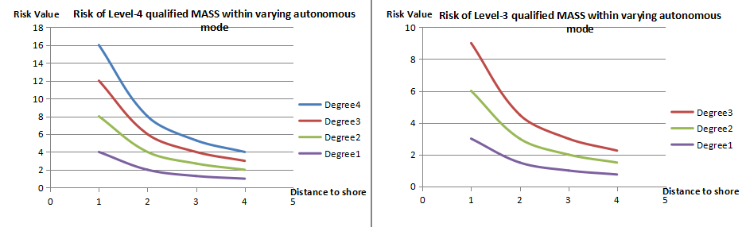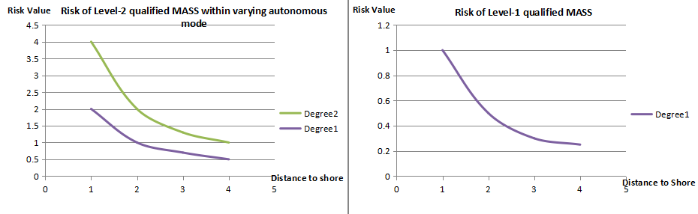
Figure 1- The risk values of MASS with varying degrees of autonomy in different waters

Input document number, to be assigned by the Committee Secretary
Leave open if uncertain

